Erlangen, Bavaria, Germany
Germany's best-preserved Baroque planned city, built for French Huguenot refugees and still shaped by their precise grid streets. River cruise ships dock alongside the canal, giving you an afternoon to explore a walkable, bike-friendly city or hop a quick train to Nuremberg.
⚓ Pier (canal bank) · 🕒 Typical call: 6–9 hrs · 💵 Euro (€) · 🗣️ German (English widely spoken)
✍️ MY DAY IN PORT (FILL IN)
Ship / Date
In port | arrive ______ · all aboard ______
Booked excursion
Notes / meeting point
GETTING ASHORE
- Docking: Pier — canal bank at Lände Erlangen, no tendering
- Walk to center: ~35 min on foot; 10 min by bus or bike
- Best For: Baroque architecture, Franconian beer & food, day trip to Nuremberg
- Don't Miss: Schlossgarten, Huguenot Church, and a Schäufele at a local Biergarten
GETTING AROUND
- 🚕 Taxi: €10–20 — Taxis are available at the port and at Erlangen Hauptbahnhof. A short ride to the city center typically runs €10–20; pre
- 📱 Rideshare: ✅ Bolt, Freenow
TOP THINGS TO DO
- Baroque Huguenot Quarter & Palace Garden — Stroll the symmetrical grid streets of Erlangen's 17th-century Huguenot Neustadt, visit the solemn Huguenot Church on…
- Siemens MedMuseum — Erlangen is the global hub of Siemens medical technology.
- Franconian Beer & Food Tasting — Erlangen was once a major beer-exporting city.
- Day Trip: Nuremberg — Nuremberg is just 15–20 minutes by regional train from Erlangen Hauptbahnhof.
- Botanical Garden & Schlossgarten — Erlangen's university botanical garden adjoins the Schlossgarten, offering alpine plants, tropical greenhouses, and peaceful…
BEST WALKS
- Huguenot Baroque Loop: 2.5 km · ~45 min · Easy · Free — From the canal dock, follow the path east into the city.
- Old Town & Beer Garden Stroll: 3 km · ~1 hr · Easy — Cross from the Baroque Neustadt into the older Altstadt north of the Schwabach River, then swing…
WEATHER · DAYLIGHT · MONEY
Month | High °F | Low °F | Rainy days
May | 66 | 47 | 13
Jul | 77 | 58 | 12
Sep | 68 | 51 | 9
Daylight: May 5:31AM–8:53PM · Jul 5:25AM–9:17PM · Sep 6:52AM–7:28PM
cruiseports.org/erlangen · Confirm terminal & all-aboard time with your ship

Erlangen, Bavaria, Germany — Port Map
Red = walkable sights · Amber = excursions farther out · P = cruise terminal
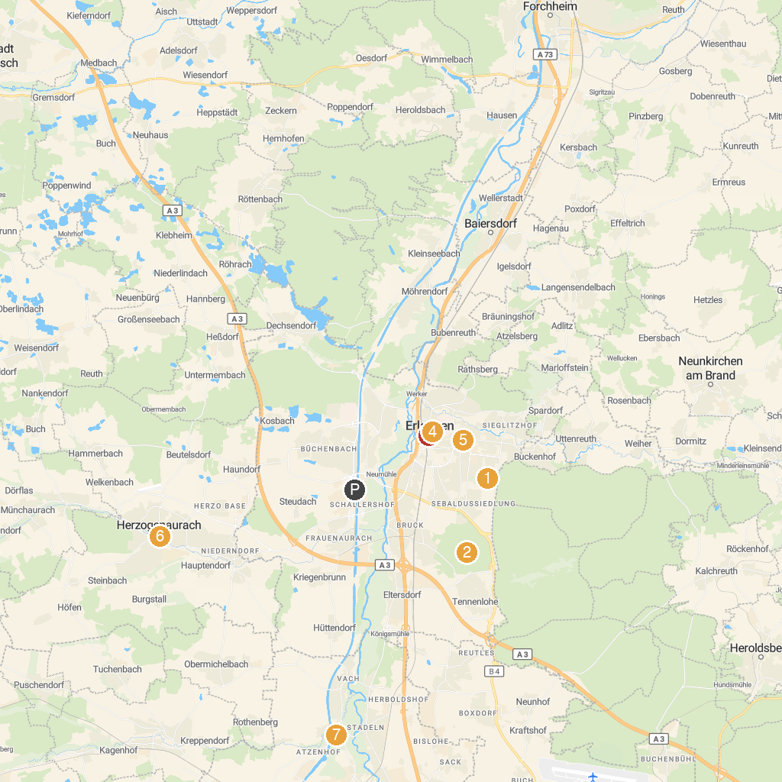
MAP KEY
1. Parade ground | 5. Siemens Healthineers MedMuseum
2. Brucker Lache | 6. Fehnturm
3. Pauli Fountain on the marketplace | 7. Solar mountain
4. Orangerie
P. Cruise port / terminal
Map © MapTiler © OpenStreetMap contributors · cruiseports.org

