Eresfjord, Møre og Romsdal, Norway
A hidden fjord village of ~380 souls where the Eira salmon river flows from Eikesdalsvatnet lake down to the fjord — unspoiled, serene, and dramatically framed by peaks rising straight from the water.
⚓ Tender port · 🕒 Typical call: 6–8 hrs · 💵 NOK (Norway cashless — card everywhere) · 🗣️ Norwegian · 🌊 Fjord & valley scenery
✍️ MY DAY IN PORT (FILL IN)
Ship / Date
In port | arrive ______ · all aboard ______
Booked excursion
Notes / meeting point
GETTING ASHORE
- Docking: Tender — ships anchor in the fjord; boats ferry to the local marina
- Walk to center: 5–10 min from tender landing to Sira Church and Coop store
- Best For: Dramatic fjord scenery, waterfall excursions, and authentic village calm
- Don't Miss: Mardalsfossen waterfall (June 20–Aug 20 only) and the Eira riverside walk
GETTING AROUND
- 🚕 Taxi: ~700 NOK/hr (≈ USD) — Taxis are available in the broader Molde/Romsdal region but are scarce in Eresfjord itself. Norwegian taxi rates are amo
- 📱 Rideshare: ❌ not available
TOP THINGS TO DO
- Mardalsfossen Waterfall Hike — One of Europe's tallest waterfalls with a free-fall of 297 m (975 ft).
- Eikesdalen Valley & Lake Cruise — Drive or boat along Eikesdalsvatnet, a 18 km narrow lake hemmed by 1,800 m walls of rock.
- Aursjøvegen Mountain Road (4×4) — A wild, unpaved mountain road of hairpin turns and vertiginous drops — sometimes called the wilder cousin of Trollstigen.
- Bjørnstjerne Bjørnson's Childhood Home — Nobel Prize-winning Norwegian author Bjørnstjerne Bjørnson grew up at Nesset Vicarage nearby.
- Goksøyra Summit Hike — A full-day hike to the Goksøyra summit (13.5 km out-and-back, 1,220 m elevation gain) with a panoramic view over Eikesdalsvatnet…
BEST WALKS
- Eira River & Village Walk: ~2 km | Easy | 30–45 min — From the marina, follow the flat path alongside the crystal-clear Eira River — famous for Atlantic…
- Fjord Shoreline Stroll: ~1.5 km | Easy | 20–30 min — Walk the fjord-side path with your ship anchored in the water ahead of you, flanked by the peak of…
cruiseports.org/eresfjord · Confirm terminal & all-aboard time with your ship

Eresfjord, Møre og Romsdal, Norway — Port Map
Red = walkable sights · Amber = excursions farther out · P = cruise terminal
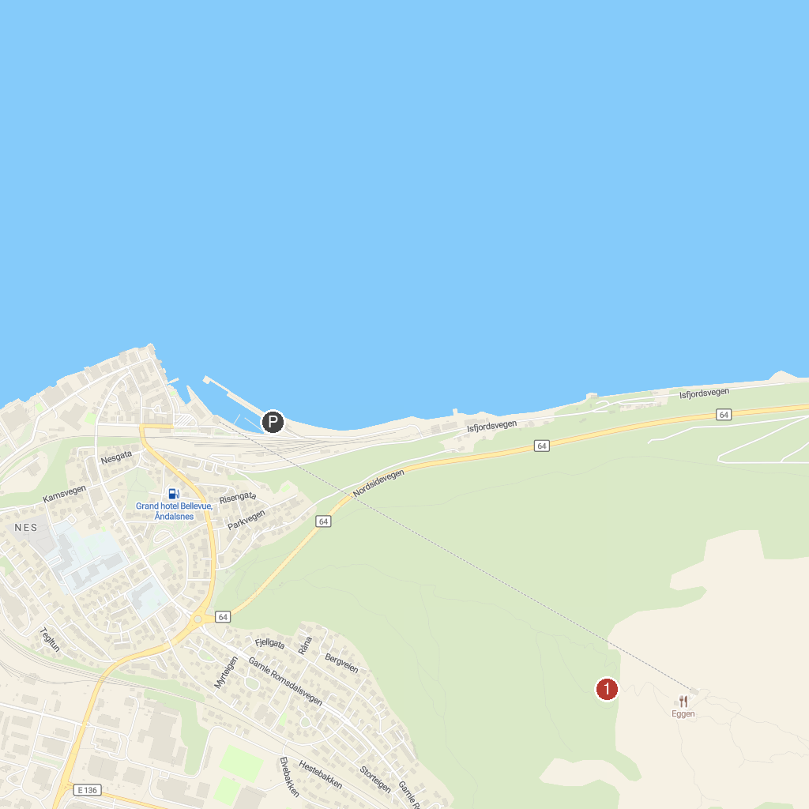
MAP KEY
1. Rampestreken | 2. Mardalsfossen
P. Cruise port / terminal
Map © MapTiler © OpenStreetMap contributors · cruiseports.org

