Enkhuizen, North Holland, Netherlands
Step off the ship and into a living Dutch Golden Age painting. Enkhuizen's canal-laced historic center, the Zuiderzee Museum, and harbors full of historic sailing ships are all a short walk from the pier.
⚓ Pier (docked) · 🕒 Typical call: 6-8 hrs · 💶 Euro (card-friendly) · 🗣️ Dutch (English spoken everywhere)
✍️ MY DAY IN PORT (FILL IN)
Ship / Date
In port | arrive ______ · all aboard ______
Booked excursion
Notes / meeting point
GETTING ASHORE
- Docking: Pier — ships dock at Gependamsteiger in the inner harbor
- Walk to center: 5 min to historic core; Zuiderzee Museum 10 min
- Best For: Dutch history, open-air museum, Golden Age architecture
- Don't Miss: Zuiderzee Museum Buitenmuseum (open-air village)
GETTING AROUND
- 🚕 Taxi: €10–€20 in-town — Uber operates in Enkhuizen per uber.com; traditional taxis are also available. Useful for reaching the train station or
- 📱 Rideshare: ✅ Uber
TOP THINGS TO DO
- Zuiderzee Museum (Open-Air & Indoor) — The crown jewel of Enkhuizen.
- Historic Center & Drommedaris Tower — Wander the canal streets past 350+ national monuments.
- Westerkerk & the Chained Library (Librije) — One of the few surviving 17th-century chained libraries in the world, at the south portal of the Gothic Westerkerk.
- Dike Bike Ride to Hoorn — Rent a bicycle near the train station and ride along the top of the IJsselmeer dike toward Hoorn.
- Dutch Market Lunch & Harbor Dining — The harbor cafes and waterfront restaurants serve local staples: herring (haring) with onion, erwtensoep (split-pea soup), and…
BEST WALKS
- Inner Harbor & Old Town Loop: 1.5 km · ~30 min · flat — From the pier, walk past the Drommedaris tower along the inner harbor, through the Breedstraat…
- Harbor to Zuiderzee Museum: 0.8 km · ~10 min · flat — A direct walk south along the harbor front from the ship to the Zuiderzee Museum entrance.
WEATHER · DAYLIGHT · MONEY
Month | High °F | Low °F | Rainy days
May | 61 | 50 | 12
Jul | 70 | 60 | 13
Sep | 66 | 57 | 11
Daylight: May 5:42AM–9:29PM · Jul 5:33AM–9:55PM · Sep 7:13AM–7:53PM
cruiseports.org/enkhuizen · Confirm terminal & all-aboard time with your ship

Enkhuizen, North Holland, Netherlands — Port Map
Red = walkable sights · Amber = excursions farther out · P = cruise terminal
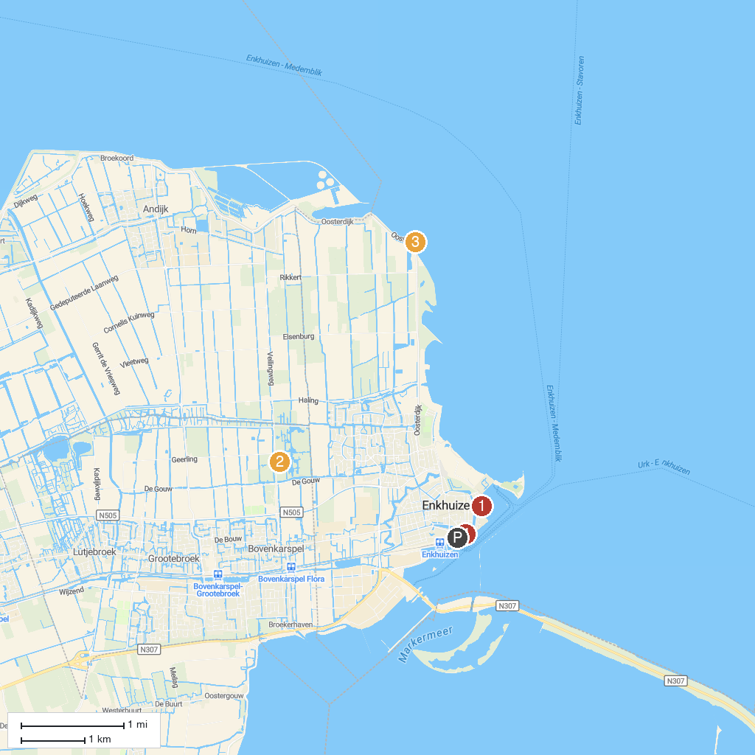
MAP KEY
1. Zuiderzeemuseum | 4. De Ven
2. Climbing park Streekbos | 5. Flessenscheepjes Museum
3. Radboud Castle
P. Cruise port / terminal
Map © MapTiler © OpenStreetMap contributors · cruiseports.org

