Emmerich am Rhein, North Rhine-Westphalia, Germany
Germany's westernmost Rhine town sits just 4 km from the Dutch border — ships dock directly on the famous promenade, steps from Germany's longest road suspension bridge and a relaxed riverfront gastronomic mile.
⚓ Docked (riverside quay) · 🕒 Typical call: 6–8 hrs · 💶 Currency: Euro (€) · 🗣️ German / Dutch widely spoken · 🚲 Flat, cycling-friendly town
✍️ MY DAY IN PORT (FILL IN)
Ship / Date
In port | arrive ______ · all aboard ______
Booked excursion
Notes / meeting point
GETTING ASHORE
- Docking: Docked on Rhine Promenade — no tender required
- Walk to center: 0–10 min; promenade is directly at the gangway
- Best For: Riverside strolling, Rhine bridge views, maritime history
- Don't Miss: Rheinmuseum and the iconic red Emmerich Rhine Bridge
GETTING AROUND
- 🚕 Taxi: €10–20 — Local taxis (Taxi Vels GmbH: 02822 4000; Meenen Arnold Taxi: 02822 6600) can be booked in advance or found near the port
TOP THINGS TO DO
- Emmerich Rhine Bridge Walk — Germany's longest road suspension bridge stretches 803 metres across the Rhine (500 m main span).
- Rheinmuseum (Rhine Museum) — Just steps from the promenade, this engaging museum covers 2,000 years of Rhine shipping with 150+ ship models, a WWII one-man…
- PAN Kunstforum Poster Museum — The former Lohmann chocolate factory now houses one of Europe's great poster-art collections — around 95,000 graphic works from…
- Elten Hill & St. Vitus Church — A short taxi ride takes you to Hoch-Elten, a rare hilltop above the flat Rhine plain, where a Romanesque church offers sweeping…
- Bike to the Dutch Border — The flat Rhine cycle path (*Rheinradweg*) leads across the border in under 30 minutes to the Dutch market town of 's-Heerenberg…
BEST WALKS
- Rhine Promenade Stroll: 2 km · 30–40 min · Flat · Free — Walk the full length of the Lower Rhine's longest riverside promenade from the town center westward…
- Old Town Loop: 1.5 km · 25 min · Flat · Free — From the promenade, cut inland to St.
WEATHER · DAYLIGHT · MONEY
Month | High °F | Low °F | Rainy days
May | 62 | 46 | 11
Jul | 73 | 57 | 12
Sep | 66 | 51 | 9
Daylight: May 5:41AM–9:21PM · Jul 5:34AM–9:46PM · Sep 7:10AM–7:49PM
cruiseports.org/emmerich-am-rhein · Confirm terminal & all-aboard time with your ship

Emmerich am Rhein, North Rhine-Westphalia, Germany — Port Map
Red = walkable sights · Amber = excursions farther out · P = cruise terminal
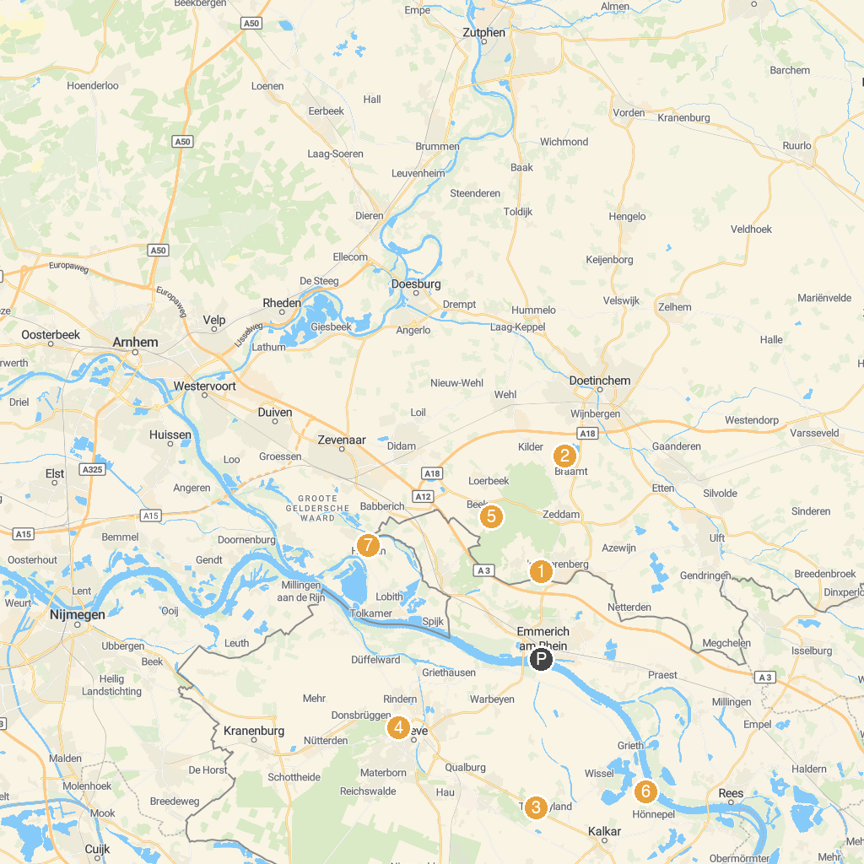
MAP KEY
1. Kasteel Huis Bergh | 5. Museum Wasserburg Anholt
2. Land Jan Klaassen | 6. Bergherbos
3. Museum Schloss Moyland | 7. Wunderland Kalkar Freizeitpark
4. Museum Kurhaus Kleve | 8. Huis Aerdt
P. Cruise port / terminal
Map © MapTiler © OpenStreetMap contributors · cruiseports.org

