Emden, Lower Saxony, Germany
Gateway to East Frisia, Emden pairs a waterside Ratsdelft with the world's highest tea consumption per capita — and a giant cartoon elephant bursting out of a museum wall.
⚓ Central berth (no tender) · 🕒 Typical call: 6-8 hrs · 💶 Euro (€) · 🗣️ German
✍️ MY DAY IN PORT (FILL IN)
Ship / Date
In port | arrive ______ · all aboard ______
Booked excursion
Notes / meeting point
GETTING ASHORE
- Docking: River-cruise berth at the Ratsdelft, in the city center
- Walk to center: You arrive in the center — the Ratsdelft is the heart of the old town
- Best For: Culture, quirky museums, canal strolls, East Frisian tea
- Don't Miss: The East Frisian tea ceremony and the Otto-Ampeln (Otto Waalkes traffic lights)
GETTING AROUND
- 🚕 Taxi: €13–17 — Taxis wait at the cruise terminal. The port (Außenhafen) is roughly 3–4 km from the city center; the ride takes about 6
TOP THINGS TO DO
- East Frisian Tea Ceremony — Experience Germany's most unusual ritual: rock candy cracks as hot black tea hits it, cream clouds billow from a spoon, and you…
- Ostfriesisches Landesmuseum — Housed in Emden's stunning Renaissance-style Rathaus right on the Ratsdelft, this regional museum holds the Rüstkammer — the most…
- Kunsthalle Emden — A world-class modern art museum founded by Henri Nannen, editor of Stern magazine.
- Dat Otto-Huus — Germany's most beloved comedian Otto Waalkes was born in Emden, and the city doesn't let you forget it.
- Bunkermuseum — Emden was almost entirely destroyed in WWII bombing raids.
BEST WALKS
- Ratsdelft & Old Town Loop: ⏱ 1.5-2 hrs · 2.5 km · Flat & easy — Start at the Ratsdelft inner harbor to admire the museum ships and the Renaissance Rathaus.
- Kesselschleuse & Canals: ⏱ 45-60 min · 1.5 km · Easy — Walk to the Kesselschleuse — a rare four-chamber water lock where four canals meet, unique in…
WEATHER · DAYLIGHT · MONEY
Month | High °F | Low °F | Rainy days
May | 61 | 48 | 12
Jul | 70 | 59 | 16
Sep | 66 | 55 | 12
Daylight: May 5:31AM–9:24PM · Jul 5:22AM–9:51PM · Sep 7:05AM–7:46PM
cruiseports.org/emden · Confirm terminal & all-aboard time with your ship

Emden, Lower Saxony, Germany — Port Map
Red = walkable sights · Amber = excursions farther out · P = cruise terminal
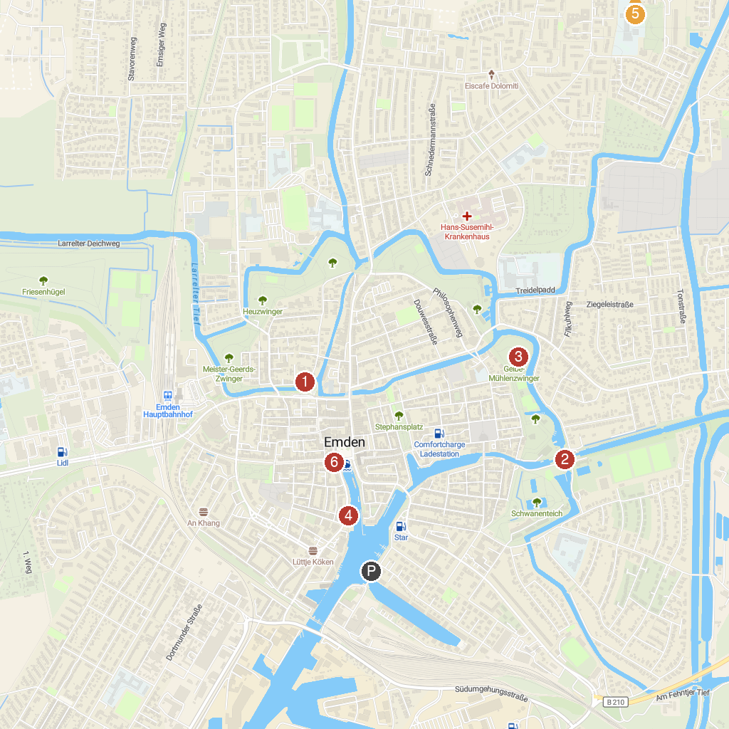
MAP KEY
1. Emden Art Gallery | 5. Hafentor Emden
2. Sandwater | 6. Der schiefe Turm von Suurhusen
3. Crossed Locks in Emden | 7. Dat Otto Huus
4. Emder Wall
P. Cruise port / terminal
Map © MapTiler © OpenStreetMap contributors · cruiseports.org

