Elaphiti Islands, Dalmatia, Croatia
A scattered chain of car-free islands just 30 minutes from Dubrovnik, the Elaphiti offer sandy beaches, Renaissance monasteries, olive groves, and a pace of life that hasn't changed in centuries.
⚓ Tender / anchor (small ships only) · 🕒 Typical call: 6-8 hrs · 💶 Currency: Euro (€) · 🗣️ Language: Croatian
✍️ MY DAY IN PORT (FILL IN)
Ship / Date
In port | arrive ______ · all aboard ______
Booked excursion
Notes / meeting point
GETTING ASHORE
- Docking: Small/expedition ships anchor off Lopud or dock at Šipan's stone pier; large ships call Dubrovnik (Gruž) and ferry out
- Walk to center: 0 min — tender dock lands in the village harbor
- Best For: Sandy beaches, peaceful walking, local seafood, unspoiled Adriatic scenery
- Don't Miss: Šunj Beach on Lopud — one of Croatia's rare natural sandy beaches
GETTING AROUND
- 🚌 Hop-on hop-off: ✅
TOP THINGS TO DO
- Šunj Beach, Lopud — One of Croatia's very few natural sandy beaches — a crescent of warm, shallow water ringed by pine forest.
- Lopud 1483 Franciscan Monastery — A meticulously restored 15th-century fortress-monastery housing a world-class private art collection.
- Koločep Forest Trails & Blue Cave — Hike through dense pine and carob forest on this tiny car-free island.
- Šipan Olive Groves & Village Walk — The largest island, Šipan once held a Guinness record for olive trees per square meter.
- Seafood Lunch on the Waterfront — All three islands have konobas (taverns) serving ultra-fresh seafood.
BEST WALKS
- Lopud Village to Šunj Beach: 1.5 miles • 25 min • Easy paved path — From the tender dock, follow the waterfront promenade past the botanical garden and cafes, then…
- Koločep: Donje Čelo to Gornje Čelo: 1 mile • 30 min • Easy dirt path — A gentle walk between the island's two tiny villages through olive groves and pine forest.
- Šipan Valley Walk: 3 miles one way • 60 min • Flat — Walk the island's fertile valley from Suđurađ (ferry dock) to Šipanska Luka, passing the…
WEATHER · DAYLIGHT · MONEY
Month | High °F | Low °F | Rainy days
May | 71 | 58 | 13
Jul | 86 | 71 | 4
Sep | 78 | 64 | 9
Daylight: May 5:26AM–8:03PM · Jul 5:24AM–8:23PM · Sep 6:28AM–6:57PM
cruiseports.org/elaphiti-islands-croatia · Confirm terminal & all-aboard time with your ship

Elaphiti Islands, Dalmatia, Croatia — Port Map
Red = walkable sights · Amber = excursions farther out · P = cruise terminal
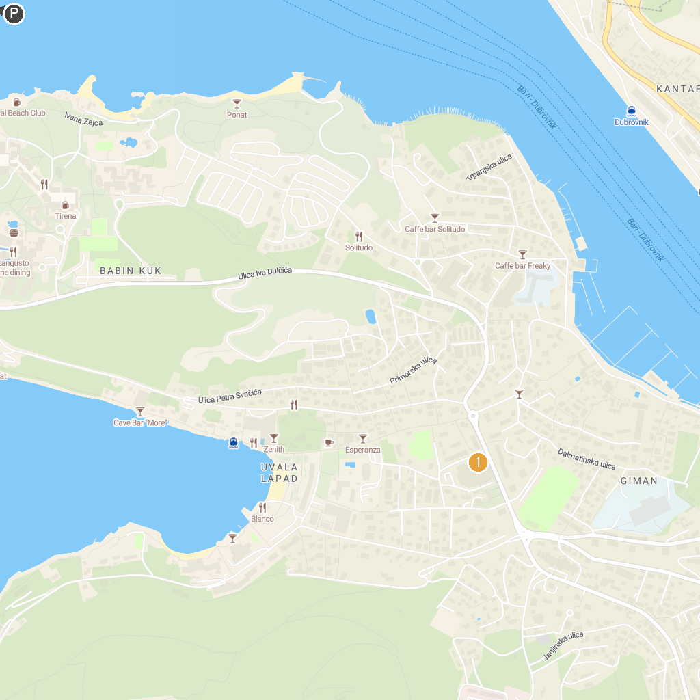
MAP KEY
1. Church of St. Blasius | 5. Merit Casino Libertas
2. Clock Tower of Dubrovnik | 6. Porporela
3. Church of St. Ignatius | 7. Onofrio's Large Fountain
4. Puzzle Punks - Dubrovnik Escape Room | 8. Archeological Museum
P. Cruise port / terminal
Map © MapTiler © OpenStreetMap contributors · cruiseports.org

