El Hierro, Canary Islands, Spain
The smallest and most untamed of the Canary Islands, El Hierro trades beach resorts for ancient laurel forests, surreal wind-twisted junipers, and crystalline volcanic rock pools. A UNESCO Biosphere Reserve running mostly on wind and water power, it rewards curious cruisers willing to venture beyond the pier.
⚓ Pier (Puerto de la Estaca) · 🕒 Typical call: 7-10 hrs · 💶 Currency: Euro · 🗣️ Language: Spanish · 🌿 UNESCO Biosphere Reserve
✍️ MY DAY IN PORT (FILL IN)
Ship / Date
In port | arrive ______ · all aboard ______
Booked excursion
Notes / meeting point
GETTING ASHORE
- Docking: Pier at Puerto de la Estaca (northeast coast)
- Walk to Center: Valverde is 9 km and 600 m uphill — transport required
- Best For: Nature lovers, hikers, divers, off-the-beaten-path explorers
- Don't Miss: El Sabinar twisted junipers & Charco Azul natural pool
GETTING AROUND
- 🚕 Taxi: €9–12 — Taxis wait at Puerto de la Estaca and run metered fares to Valverde (~10 min, ~10 km). Reliable and the fastest way to r
- 📱 Rideshare: ❌ not available
TOP THINGS TO DO
- El Sabinar — The Twisted Junipers — Walk among ancient juniper trees sculpted by trade winds into horizontal, surreal shapes.
- Charco Azul & La Maceta Natural Pools — Turquoise volcanic rock pools on the northwest coast — Charco Azul sits inside a partially open sea cave, while La Maceta is…
- Guinea Ecomuseum & Giant Lizard Center — A preserved stone village showing Bimbaches indigenous and early settler life, combined with a breeding center for the El Hierro…
- Mirador de la Peña — César Manrique's signature viewpoint perched 700 m above the sweeping El Golfo valley.
- Scuba Diving — Mar de las Calmas Reserve — The southern coast's protected Sea of Calms is one of Europe's premier dive sites — volcanic pinnacles, rays, and exceptional…
BEST WALKS
- La Llanía Laurel Forest Loop: 1.5-2 hrs • Easy • Free — A circular trail through ancient mossy laurisilva (laurel forest) — misty, fairy-tale quiet, and…
- Playa de Tacorón Coastal Walk: 1 hr • Easy • Free — A short walk along the southern volcanic coast to a sheltered snorkeling cove with red rock…
WEATHER · DAYLIGHT · MONEY
Month | High °F | Low °F | Rainy days
May | 72 | 65 | 3
Jul | 76 | 70 | 2
Sep | 79 | 72 | 3
Daylight: May 7:22AM–8:53PM · Jul 7:25AM–9:09PM · Sep 7:57AM–8:15PM
cruiseports.org/el-hierro-island · Confirm terminal & all-aboard time with your ship

El Hierro, Canary Islands, Spain — Port Map
Red = walkable sights · Amber = excursions farther out · P = cruise terminal
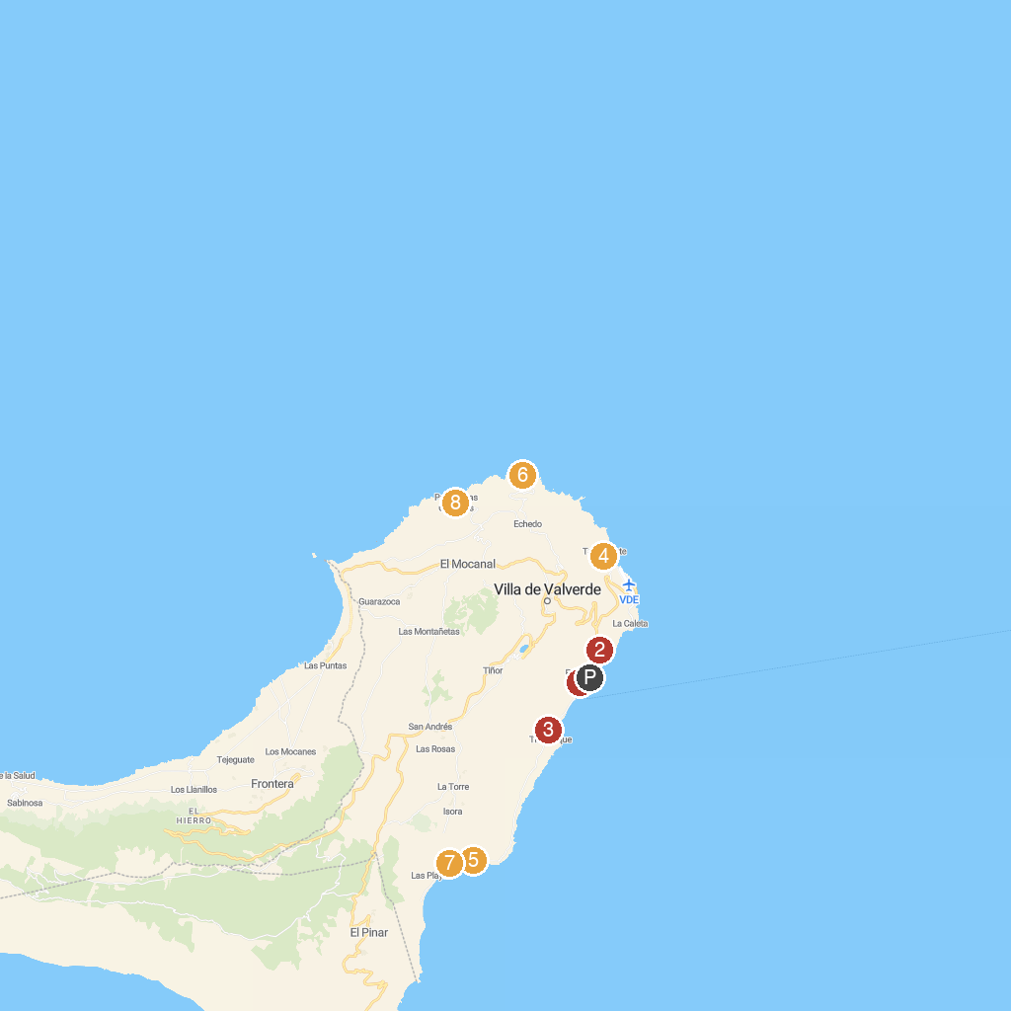
MAP KEY
1. Playa de La Estaca | 5. Mirador Roque de La Bonanza - El Hierro
2. Monumento a la Sabina de El Hierro | 6. El Charco Manso
3. Playa de Timijiraque | 7. Área recreativa de Las Playas
4. Mirador El Tamaduste | 8. Pozo de Las Calcosas
P. Cruise port / terminal
Map © MapTiler © OpenStreetMap contributors · cruiseports.org

