Eilat, Southern District, Israel
At the crossroads of four countries, Eilat delivers a collision of stark desert peaks and a jewel-clear Red Sea teeming with neon-hued tropical fish — all in a duty-free zone that never sleeps.
⚓ Pier (direct dock) · 🕒 Typical call: 8-10 hrs · 💵 Israeli New Shekel (ILS) · 🗣️ Hebrew / English widely spoken · ☀️ Year-round sunshine
✍️ MY DAY IN PORT (FILL IN)
Ship / Date
In port | arrive ______ · all aboard ______
Booked excursion
Notes / meeting point
GETTING ASHORE
- Docking: Pier — ships dock directly at the commercial port, no tender required
- Walk to center: ~2.5 km to North Beach promenade; shuttle or taxi recommended in summer heat
- Best For: Snorkeling, reef diving, Dolphin Reef, duty-free shopping, Petra day trip
- Don't Miss: Coral Beach Nature Reserve — Israel's best snorkeling, ~9 km south of port (taxi or bus)
GETTING AROUND
- 🚕 Taxi: 25–40 ILS to city center — Taxis wait at the port gate. The meter is required by law — confirm it is running. City center and North Beach promenade
TOP THINGS TO DO
- Coral Beach Nature Reserve Snorkel — About 9 km south of the cruise port (taxi or Egged bus line 15).
- Dolphin Reef — A resident pod of bottlenose dolphins roams a protected lagoon.
- Coral World Underwater Observatory — Descend 12 metres below the sea in a glass observatory tower to watch natural reef life without getting wet.
- Timna Park Desert Geology — 25 km north of Eilat, some of the world's oldest copper mines sit beneath towering red sandstone formations.
- Petra Day Trip (Jordan) — The rose-red Nabataean city is a once-in-a-lifetime sight.
BEST WALKS
- Pier to Dekel Beach: 1 km · ~15 min · Flat — A short, mostly flat walk north along the shore from the cruise pier to Dekel Beach, the closest…
- North Beach Promenade Stroll: 2.5 km from pier · Flat · Take taxi or shuttle one way — The main pedestrian esplanade runs along the Gulf of Aqaba waterfront past hotels, restaurants, and…
WEATHER · DAYLIGHT · MONEY
Month | High °F | Low °F | Rainy days
May | 95 | 71 | 0
Jul | 103 | 78 | 0
Sep | 98 | 75 | 0
Daylight: May 5:47AM–7:25PM · Jul 5:50AM–7:41PM · Sep 6:25AM–6:45PM
cruiseports.org/eilat · Confirm terminal & all-aboard time with your ship

Eilat, Southern District, Israel — Port Map
Red = walkable sights · Amber = excursions farther out · P = cruise terminal
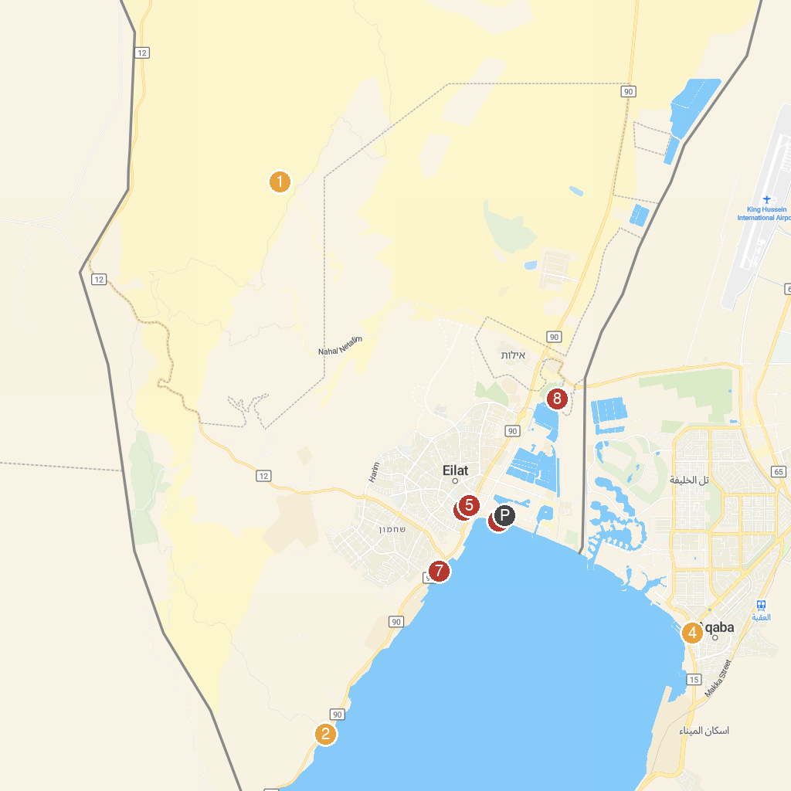
MAP KEY
1. Gai Avud | 5. Musical Fountain Eilat
2. שמורת טבע חוף האלמוגים | 6. Hananya Beach - חוף חנניה ספורט ימי ושייט
3. Nightmare Horror Maze | 7. Dekel Beach
4. Sharif Hussein bin Ali Mosque | 8. Eilat Ornithological Park
P. Cruise port / terminal
Map © MapTiler © OpenStreetMap contributors · cruiseports.org

