Eemshaven, Groningen, Netherlands
A working energy port on the Groningen coast, Eemshaven puts you within reach of one of the Netherlands' liveliest student cities and a UNESCO-listed tidal wilderness — but don't expect tourist infrastructure at the pier itself.
⚓ Pier (docked) · 🕒 Typical call: 8-10 hrs · 💶 Euro (€) · 🗣️ Dutch · 🌊 Wadden Sea UNESCO site nearby
✍️ MY DAY IN PORT (FILL IN)
Ship / Date
In port | arrive ______ · all aboard ______
Booked excursion
Notes / meeting point
GETTING ASHORE
- Docking: Pier — large industrial quays, ships dock directly
- Walk to center: No walkable town at port; Groningen city ~35 km (taxi/bus)
- Best For: Groningen city sightseeing, Wadden Sea, Borkum Island day trip
- Don't Miss: Climb the Martinitoren in Groningen for panoramic views
GETTING AROUND
- 🚕 Taxi: €85–€150 — Fixed-rate taxis cover the 34 km to Groningen city center. Pre-booking recommended; several companies (taxi-eemshaven.co
- 📱 Rideshare: ✅ Uber, Bolt
TOP THINGS TO DO
- Groningen City Highlights — The provincial capital is a lively, compact city with a large student population.
- Wadden Sea Mudflat Walk (Wadlopen) — The Wadden Sea is a UNESCO World Heritage tidal ecosystem stretching along the northern Dutch coast.
- Fortress Bourtange — One of Europe's best-preserved star fortresses, Bourtange is a recreated 18th-century fortified village about 60 km southeast of…
- Borkum Island Day Trip (Germany) — The AG EMS ferry from Eemshaven reaches the German North Sea island of Borkum in about 50 minutes (or ~25 min by catamaran).
- Groningen Canal Cruise — Groningen has an extensive canal network.
BEST WALKS
- Groningen Historic Center Loop: 3-4 km · Easy · ~1 hr — From Groningen Centraal Station, cross to the Groninger Museum, then walk north through Grote Markt…
- Noorderplantsoen Park Stroll: 2 km · Easy · 30 min — A relaxed green escape in the city.
WEATHER · DAYLIGHT · MONEY
Month | High °F | Low °F | Rainy days
May | 60 | 49 | 12
Jul | 70 | 59 | 15
Sep | 66 | 55 | 11
Daylight: May 5:32AM–9:26PM · Jul 5:23AM–9:53PM · Sep 7:06AM–7:47PM
cruiseports.org/eemshaven · Confirm terminal & all-aboard time with your ship

Eemshaven, Groningen, Netherlands — Port Map
Red = walkable sights · Amber = excursions farther out · P = cruise terminal
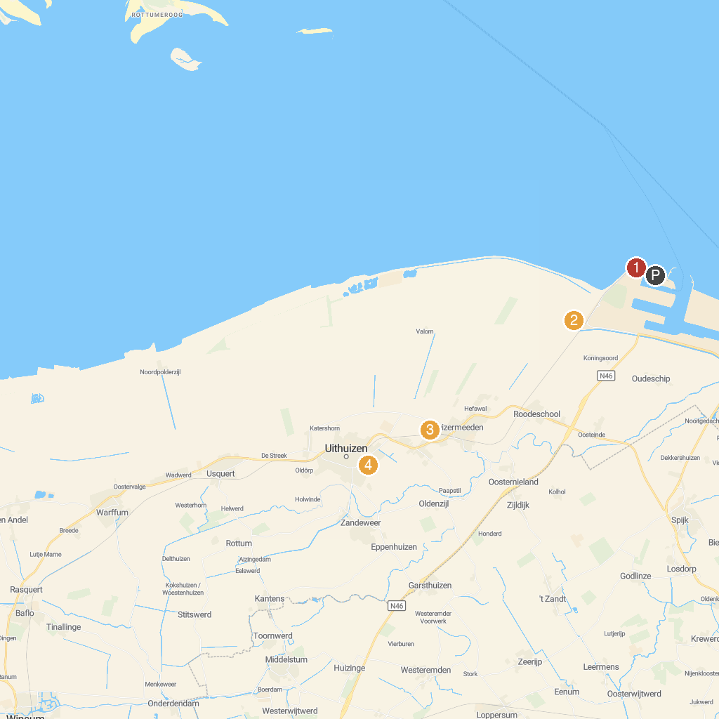
MAP KEY
1. Campen lighthouse | 5. Rensumaborg
2. Museum Møhlmann | 6. Museum Menkemaborg
3. Eemshaven viewpoint | 7. Nationalpark-Schiff Feuerschiff Borkumriff
4. Molen "Goliath"
P. Cruise port / terminal
Map © MapTiler © OpenStreetMap contributors · cruiseports.org

