Edinburgh (South Queensferry), Scotland, UK
Scotland's dramatic capital — a medieval castle on a volcanic crag, a cobbled Royal Mile lined with history, and the iconic trio of Forth Bridges framing your arrival at South Queensferry.
⚓ Docked at Leith or Tender at South Queensferry · 🕒 Typical call: 8–10 hrs · 💷 British Pound (GBP) · 🗣️ English
✍️ MY DAY IN PORT (FILL IN)
Ship / Date
In port | arrive ______ · all aboard ______
Booked excursion
Notes / meeting point
GETTING ASHORE
- Docking: Leith (docked) or South Queensferry (tender)
- City transfer: ~30–45 min by shuttle/taxi
- Best For: History · Castles · Scenic walks
- Don't Miss: Edinburgh Castle & the Royal Mile
GETTING AROUND
- 🚕 Taxi: £30–£45 one-way — Taxis are available at the pier and take about 25–35 minutes to the city center. Pre-booking is recommended as cabs ofte
- 📱 Rideshare: ✅ Uber, Bolt
- 🚌 Hop-on hop-off: ✅
TOP THINGS TO DO
- Edinburgh Castle & the Royal Mile — Scotland's most visited attraction perches on an ancient volcanic plug above the city.
- Palace of Holyroodhouse — The official Scottish residence of the British monarch at the foot of the Royal Mile.
- Royal Yacht Britannia — The decommissioned royal yacht is moored at Leith's Ocean Terminal — five minutes from the cruise berth.
- Arthur's Seat hike — The summit of an extinct volcano rising 251 m above the city, just a short walk from Holyrood.
- Forth Bridges & South Queensferry village — Three bridges across the Forth: the UNESCO-listed Victorian cantilever rail bridge, the 1964 road bridge, and the sweeping 2017…
BEST WALKS
- The Royal Mile — Castle to Holyrood: ~1.6 km · 1.5–2 hrs · easy (one long downhill) — Walk the entire Royal Mile from the Castle Esplanade down through Lawnmarket, the High Street, and…
- Arthur's Seat summit loop: ~7 km · 2–3 hrs · moderate (steep in places) — Start from Holyrood Park, climb through Hunter's Bog to the summit of Arthur's Seat for 360° views…
- South Queensferry waterfront & Forth Bridges view: ~2 km · 1 hr · easy — From the tender pier, stroll along South Queensferry's historic High Street and harbourfront for…
WEATHER · DAYLIGHT · MONEY
Month | High °F | Low °F | Rainy days
May | 57 | 45 | 13
Jul | 65 | 54 | 16
Sep | 61 | 51 | 12
Daylight: May 5:00AM–9:19PM · Jul 4:48AM–9:47PM · Sep 6:45AM–7:29PM
cruiseports.org/edinburgh · Confirm terminal & all-aboard time with your ship

Edinburgh (South Queensferry), Scotland, UK — Port Map
Red = walkable sights · Amber = excursions farther out · P = cruise terminal
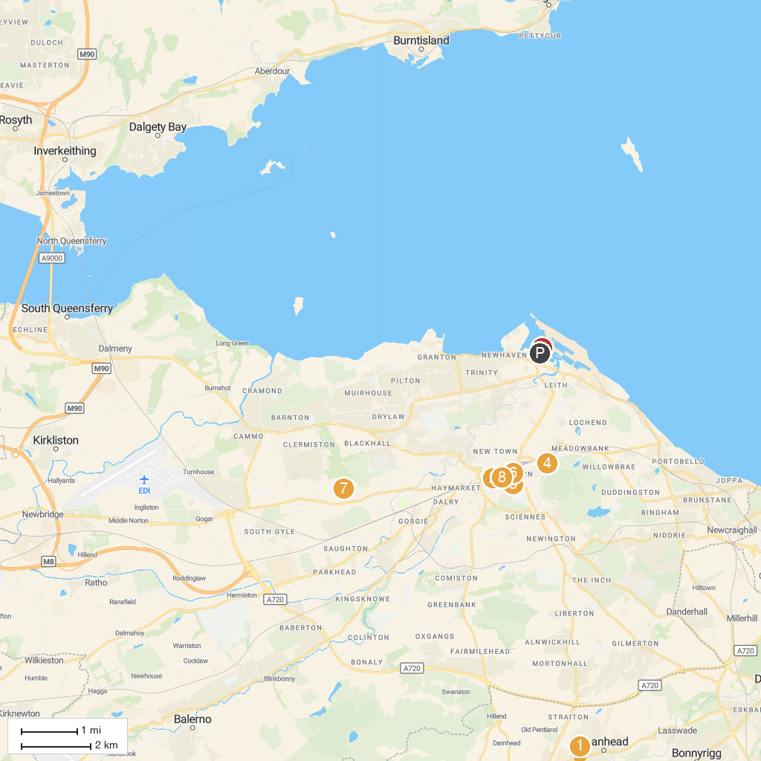
MAP KEY
1. Rosslyn Castle | 5. National Museum of Scotland
2. Edinburgh Castle | 6. The Real Mary King's Close
3. The Royal Yacht Britannia | 7. Edinburgh Zoo
4. Scottish Parliament Building | 8. The Scotch Whisky Experience
P. Cruise port / terminal
Map © MapTiler © OpenStreetMap contributors · cruiseports.org

