Edam-Volendam, North Holland, Netherlands
Old Holland at its most vivid: fishermen's painted houses lining a harbor promenade, the scent of smoked eel and fresh stroopwafels, and medieval Edam sleeping quietly 3 km away.
⚓ River cruise: direct dock; Ocean cruise: excursion from Amsterdam/IJmuiden · 🕒 Typical call: 4–6 hrs · 💶 Euro (€) — Netherlands is nearly cashless · 🗣️ Dutch; English widely spoken
✍️ MY DAY IN PORT (FILL IN)
Ship / Date
In port | arrive ______ · all aboard ______
Booked excursion
Notes / meeting point
GETTING ASHORE
- Docking: River cruise ships dock at Volendam harbor pier. Ocean cruise passengers arrive via bus excursion from Amsterdam (PTA) or IJmuiden — ~30 min drive.
- Walk to Center: Steps from the pier into Volendam's De Dijk promenade. Edam is 3 km away (35–40 min walk, 5 min by bus, 10 min by bike).
- Best For: Dutch culture, cheese, traditional costumes, seafood, canal strolls
- Don't Miss: Kibbeling fish at a harbor stall, a photo in traditional Volendam costume, and peaceful Edam's floating-cellar museum
GETTING AROUND
- 🚕 Taxi: €60–€80 one-way — Taxis from Amsterdam cruise terminals (IJmuiden or Amsterdam Passenger Terminal) to Volendam cost roughly €60–€80 and ta
- 📱 Rideshare: ✅ Uber
TOP THINGS TO DO
- Volendam Harbor & De Dijk Promenade — Stroll the iconic harbor front lined with traditional wooden houses, active fishing boats, fish stalls, and souvenir shops.
- Edam Historic Center — The quieter, more elegant sibling: 17th-century canal houses, the Kwakelbrug drawbridge, Grote Kerk with stunning stained glass…
- Cheese & Seafood Tasting — Sample young Edam cheese at Henri Willig or a local cheese farm, then head back to Volendam for smoked eel from Smit Bokkum (in…
- Volendam–Marken Ferry — A 30-minute ferry ride across the Markermeer to Marken, a peninsula village of green-painted wooden houses on stilts — one of the…
- Zaanse Schans Windmills — An open-air museum village 25 km from Volendam with working 18th-century windmills, clog-making demos, and cheese farms.
BEST WALKS
- Volendam Harbor Loop: 1.5 km · 25 min · Easy — Start at the harbor pier, walk De Dijk promenade east past fish stalls and painted houses, then…
- Dike Path to Edam: 3 km one-way · 35–40 min · Easy — A flat, scenic cycling and walking path along the top of the dike connects the two villages.
WEATHER · DAYLIGHT · MONEY
Month | High °F | Low °F | Rainy days
May | 62 | 49 | 11
Jul | 71 | 59 | 13
Sep | 66 | 55 | 11
Daylight: May 5:43AM–9:29PM · Jul 5:35AM–9:55PM · Sep 7:14AM–7:54PM
cruiseports.org/edam-volendam · Confirm terminal & all-aboard time with your ship

Edam-Volendam, North Holland, Netherlands — Port Map
Red = walkable sights · Amber = excursions farther out · P = cruise terminal
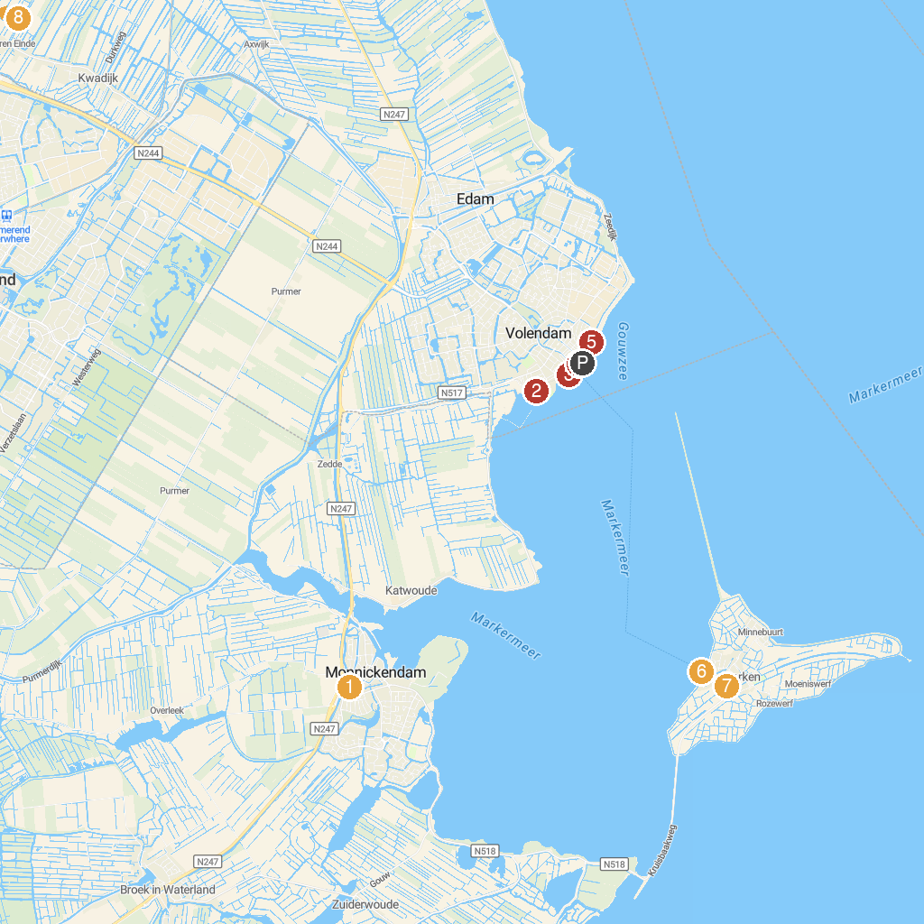
MAP KEY
1. The Great Church | 5. De Dijk van Volendam
2. Slobbeland | 6. Monument Watersnood 1916
3. Experience Volendam: Historical Museum and Photography studio | 7. Stoom Klompenmakerij Marken - NL Online.NL
4. Fotograaf Volendam | 8. Museum Betje Wolff
P. Cruise port / terminal
Map © MapTiler © OpenStreetMap contributors · cruiseports.org

