Eckernförde, Schleswig-Holstein, Germany
A Baltic gem that big ports overshadow — cobblestone lanes, a sweeping sandy beach, and the best smoked sprats you'll ever eat, all steps from the tender dock.
⚓ Tender port · 🕒 Typical call: 6-8 hrs · 💶 Euro (cash handy) · 🗣️ German (English widely spoken) · 🏖️ Beach in town
✍️ MY DAY IN PORT (FILL IN)
Ship / Date
In port | arrive ______ · all aboard ______
Booked excursion
Notes / meeting point
GETTING ASHORE
- Docking: Tender — ships anchor in Eckernförder Bucht; tenders dock at Stadthafen (Town Harbor)
- Walk to center: 1-2 min from tender dock to Old Town; 5-8 min to beach
- Best For: Quiet authentic German Baltic atmosphere, beach, local seafood, historic Old Town
- Don't Miss: Fresh Fischbrötchen at the harbor and the candy-pulling show at Bonbonkocherei
GETTING AROUND
- 🚕 Taxi: €5–€12 — Metered taxis are available at the port area. Official district rates apply: €5 base fare plus ~€2.50/km. Short rides wi
TOP THINGS TO DO
- Viking Museum Haithabu (UNESCO), Schleswig — Take the hourly Line 720 bus about 38 minutes northwest to Schleswig, then connect to Busdorf, and visit the Hedeby (Haithabu)…
- Eckernförde Old Town Walk & Candy Factory — Wander the cobblestone Altstadt, visit St.
- Baltic Beach Day at Kurstrand — Eckernförde's 4 km of fine sand beach runs alongside the town center.
- Harbor Food Tour — Fischbrötchen & Kieler Sprotten — Eckernförde is the true birthplace of Kieler Sprotte (smoked sprats).
- Kiel City & Maritime Museum — Hop the direct regional train about 30 minutes southeast to Schleswig-Holstein's capital.
BEST WALKS
- Harbor to Old Town & St. Nicolai Church: 1.5 km · 30-45 min · Easy — From the tender dock at Stadthafen, walk into the Altstadt's cobblestone lanes.
- Holzbrücke to Kurstrand Beach: 2 km · 40-60 min · Easy — Cross the historic Holzbrücke wooden bascule bridge for great harbor photo views, then follow the…
WEATHER · DAYLIGHT · MONEY
Month | High °F | Low °F | Rainy days
May | 61 | 46 | 11
Jul | 70 | 57 | 14
Sep | 65 | 53 | 11
Daylight: May 5:15AM–9:19PM · Jul 5:05AM–9:46PM · Sep 6:53AM–7:36PM
cruiseports.org/eckernforde · Confirm terminal & all-aboard time with your ship

Eckernförde, Schleswig-Holstein, Germany — Port Map
Red = walkable sights · Amber = excursions farther out · P = cruise terminal
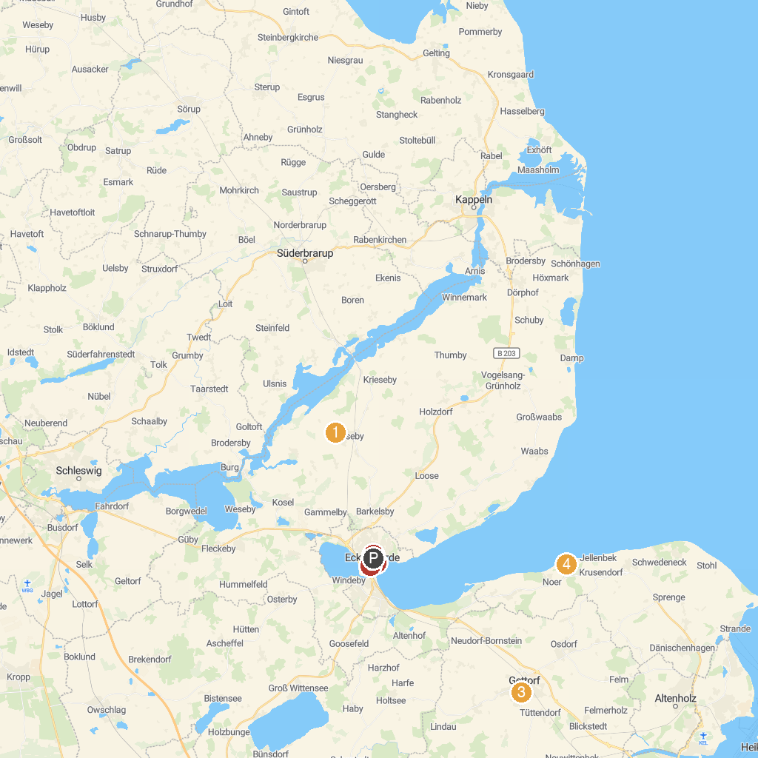
MAP KEY
1. Mühle Anna | 4. Bewaldete Düne bei Noer
2. Aquarium im Ostsee-Info-Center Eckernförde | 5. Museum Eckernförde
3. Gettorf Zoo | 6. Borbyer Kirche
P. Cruise port / terminal
Map © MapTiler © OpenStreetMap contributors · cruiseports.org

