Eastport, Maine, USA
The easternmost city in the United States, Eastport sits on Moose Island where 28-foot tides carve the world's largest whirlpool and Victorian-era brick streets lead straight from the pier to legendary lobster rolls.
⚓ Pier (most ships dock) · 🕒 Typical call: 6–8 hrs · 💵 USD · 🗣️ English · 🌊 Extreme tides — 20–28 ft
✍️ MY DAY IN PORT (FILL IN)
Ship / Date
In port | arrive ______ · all aboard ______
Booked excursion
Notes / meeting point
GETTING ASHORE
- Docking: Breakwater Terminal (City Pier) — most ships dock; larger vessels may tender
- Walk to center: Under 2 min — pier opens directly onto Water Street
- Best For: Maritime history, seafood, tidal wildlife, Canadian border day trips
- Don't Miss: The Old Sow whirlpool boat tour and a lobster roll at Quoddy Bay Lobster
GETTING AROUND
TOP THINGS TO DO
- Old Sow Whirlpool Boat Tour — The largest natural whirlpool in the Western Hemisphere forms where 28-foot tides squeeze through the channel between Moose…
- Whale & Wildlife Cruise — Passamaquoddy Bay hosts Minke, Finback, and Humpback whales, plus bald eagles, harbor seals, and porpoises.
- Water Street Historic Walk — Eastport's 19th-century brick commercial district was once the sardine canning capital of the world.
- Shackford Head State Park Hike — Trails through coastal Maine forest lead to dramatic cliffs above Cobscook Bay.
- Downeast Lobster & Craft Beer — Quoddy Bay Lobster's seasonal deck and the Waco Diner (Maine's oldest, est.
BEST WALKS
- Water Street Stroll: 0.5 mi · 15 min · Easy — Walk the length of Eastport's historic brick main street from the City Pier north through…
- Shackford Head Loop: 3.5 mi rt · 90 min · Moderate — Head west from the pier along Water Street and Deep Cove Road to Shackford Head State Park.
WEATHER · DAYLIGHT · MONEY
Month | High °F | Low °F | Rainy days
May | 63 | 52 | 10
Jul | 79 | 70 | 11
Sep | 73 | 64 | 10
Daylight: May 5:33AM–8:01PM · Jul 5:32AM–8:20PM · Sep 6:32AM–6:59PM
cruiseports.org/eastport-me · Confirm terminal & all-aboard time with your ship

Eastport, Maine, USA — Port Map
Red = walkable sights · Amber = excursions farther out · P = cruise terminal
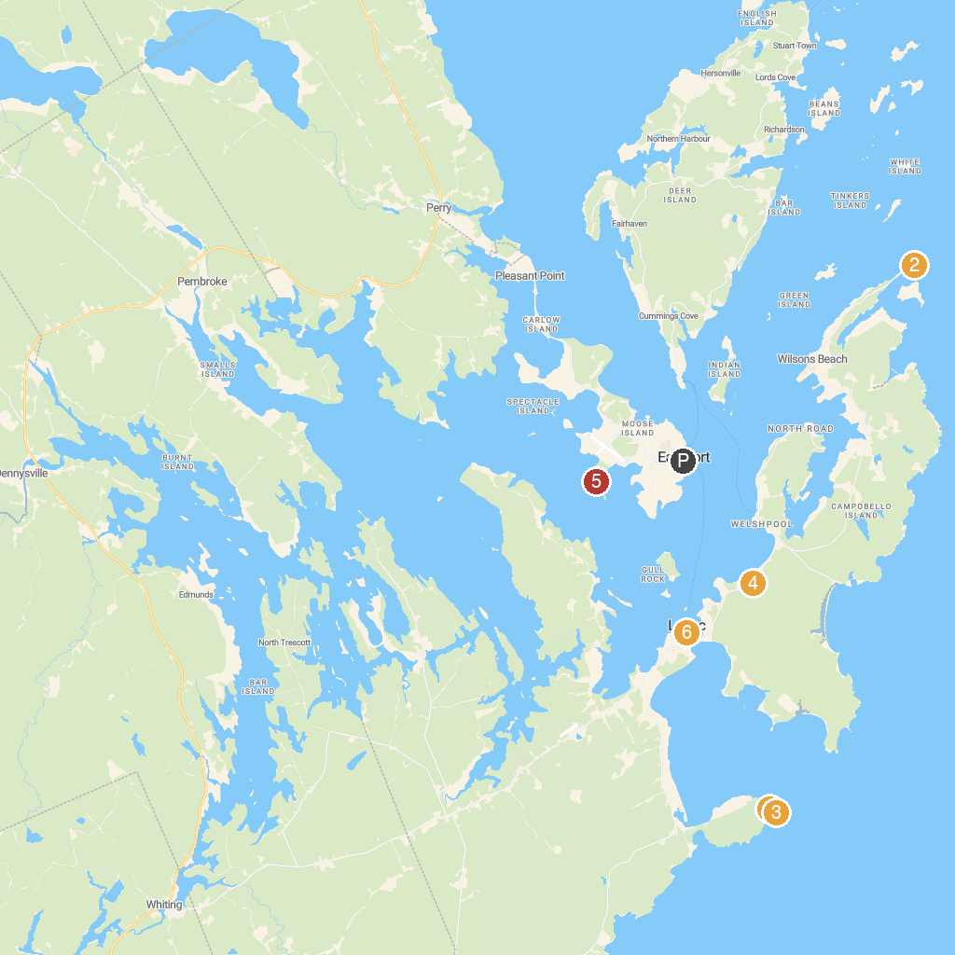
MAP KEY
1. Quoddy Head State Park | 4. Roosevelt Campobello International Park
2. Head Harbour Lightstation | 5. Shackford Head State Park
3. West Quoddy Head Lighthouse | 6. Lost Fisherman's Memorial
P. Cruise port / terminal
Map © MapTiler © OpenStreetMap contributors · cruiseports.org

