East London, Eastern Cape, South Africa
South Africa's only river port trades container ships for cruise passengers chasing the Big Five. Beyond the Buffalo River, world-class surf beaches and Xhosa cultural villages await.
⚓ Pier (docked) · 🕒 Typical call: 8-10 hrs · 💵 South African Rand (ZAR) · 🗣️ English & Xhosa
✍️ MY DAY IN PORT (FILL IN)
Ship / Date
In port | arrive ______ · all aboard ______
Booked excursion
Notes / meeting point
GETTING ASHORE
- Docking: Ships dock at the Port of East London on the Buffalo River — no tendering required
- Walk to centre: ~3 km to Oxford Street; taxis and shuttles available at the terminal
- Best For: Safari day trips, Indian Ocean beaches, Xhosa culture
- Don't Miss: The coelacanth display at East London Museum — the world's best-preserved specimen
GETTING AROUND
- 🚕 Taxi: R80–R150 — Metered taxis are available at the pier. Agree on a fare before departure; city center is roughly 5 km from the port.
- 📱 Rideshare: ✅ Uber, Bolt
TOP THINGS TO DO
- Big Five Safari at Inkwenkwezi or Mpongo — Private game reserves 30–45 minutes from the port offer open-vehicle drives to see lion, leopard, elephant, rhino, and buffalo in…
- Khaya La Bantu Xhosa Cultural Village — An open-air living museum exploring Xhosa heritage through traditional dance, song, beadwork demonstrations, and a reconstructed…
- East London Museum — Home to the world's only known dodo egg and the finest preserved coelacanth specimen — a prehistoric fish rediscovered alive in…
- Orient Beach & East London Aquarium — Orient Beach offers calm Indian Ocean swimming, tidal pools, and a water slide.
- Nahoon Beach & Reef Surfing — Nahoon Reef is one of South Africa's legendary surf breaks, producing fast right-handers that have hosted international…
BEST WALKS
- Oxford Street City Centre Stroll: 1.5 km | 20 min | Flat — Take a taxi to the city centre, then explore Oxford Street on foot.
- Orient Beach Waterfront Walk: 2 km | 30 min | Flat beachfront — From Orient Beach, stroll south along the beachfront promenade past tidal pools to the East London…
WEATHER · DAYLIGHT · MONEY
Month | High °F | Low °F | Rainy days
May | 73 | 59 | 5
Jul | 70 | 54 | 4
Sep | 70 | 57 | 8
Daylight: May 6:52AM–5:17PM · Jul 7:09AM–5:19PM · Sep 6:07AM–6:00PM
cruiseports.org/east-london · Confirm terminal & all-aboard time with your ship

East London, Eastern Cape, South Africa — Port Map
Red = walkable sights · Amber = excursions farther out · P = cruise terminal
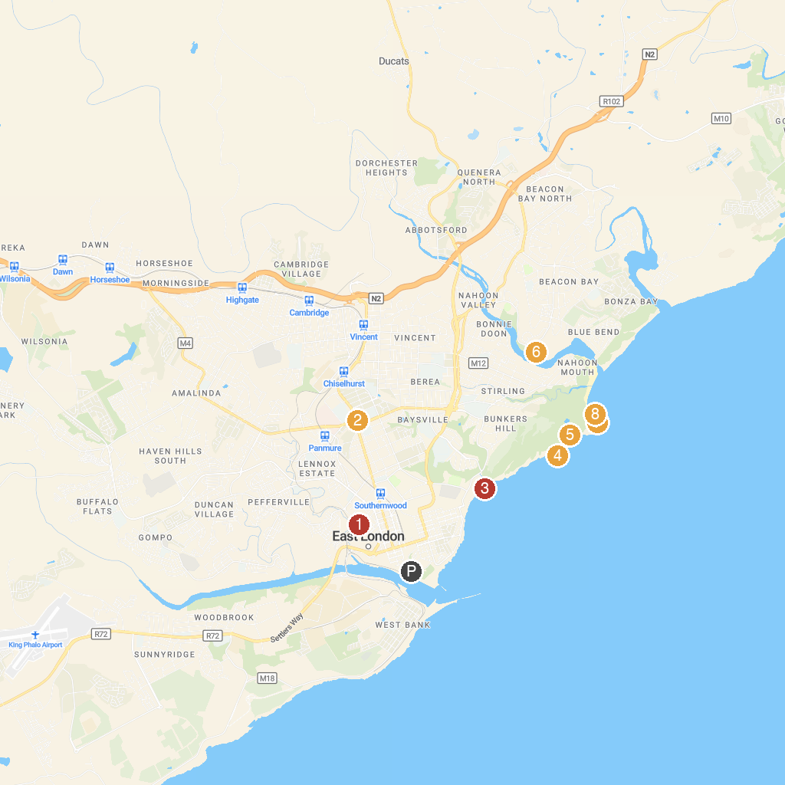
MAP KEY
1. East London Zoo | 5. Nahoon Point Lighthouse
2. East London Museum | 6. Dassie Trail
3. Eastern Beach | 7. Nahoon Reef
4. Bats' Cave | 8. Mermaid's Pool
P. Cruise port / terminal
Map © MapTiler © OpenStreetMap contributors · cruiseports.org

