Dzaoudzi, Petite-Terre, Mayotte
A French territory tucked in the Mozambique Channel, Mayotte offers one of the world's largest enclosed lagoons, nesting sea turtles, and the surreal emerald-green Lac Dziani — all on a small island barely touched by mass tourism.
⚓ Tender port · 🕒 Typical call: 7–9 hrs · 💶 Currency: Euro (€) · 🗣️ French / Shimaore · 🌊 One of the world's largest lagoons
✍️ MY DAY IN PORT (FILL IN)
Ship / Date
In port | arrive ______ · all aboard ______
Booked excursion
Notes / meeting point
GETTING ASHORE
- Docking: Tender — ships anchor in the lagoon; tender to Dzaoudzi Jetty, Petite-Terre
- Walk to center: 5–10 min to Boulevard des Crabes; Lac Dziani needs a taxi (4.5 km)
- Best For: Snorkeling, sea turtles, volcanic scenery, off-the-beaten-path culture
- Don't Miss: Lac Dziani crater hike and a lagoon boat tour for dolphins or humpback whales (Jul–Oct)
GETTING AROUND
- 🚕 Taxi: ~€1.40–€2.10/ride — Shared minivan taxis running fixed routes around the island. The most affordable local transport; daytime fares are arou
- 📱 Rideshare: ❌ not available
TOP THINGS TO DO
- Lac Dziani Crater Hike — Hike to the rim of an ancient volcanic crater to see the startling emerald-green crater lake, its color driven by unique…
- Lagoon Snorkeling & Dolphin Tour — Mayotte's double barrier reef encloses one of the largest lagoons in the world.
- N'Gouja Beach — Turtles & Lemurs — Drive across to Grande-Terre for N'Gouja Beach, where giant green sea turtles graze in the shallows just meters from shore, and…
- Historic Dzaoudzi Rock & MUMA Museum — Walk the old colonial capital: see the former Governor's Palace (a prefabricated metal-frame building by the Moisant workshops, c.
- Moya Beach — Sea Turtle Nesting Site — A pristine, wild crescent beach on Petite-Terre and one of Mayotte's most important sea turtle nesting sites.
BEST WALKS
- Dzaoudzi Heritage Walk: 45 min · Easy · Flat · Free — Stroll from the Dzaoudzi Jetty along Boulevard des Crabes — a causeway lined with cafes and views…
- Pointe Mahabou Sunset Walk: 30 min · Easy · Scenic — A short stroll to Pointe Mahabou on the eastern tip of Petite-Terre, where locals gather for…
WEATHER · DAYLIGHT · MONEY
Month | High °F | Low °F | Rainy days
May | 83 | 77 | 10
Jul | 80 | 73 | 6
Sep | 81 | 73 | 12
Daylight: May 6:09AM–5:40PM · Jul 6:21AM–5:48PM · Sep 5:53AM–5:54PM
cruiseports.org/dzaoudzi · Confirm terminal & all-aboard time with your ship

Dzaoudzi, Petite-Terre, Mayotte — Port Map
Red = walkable sights · Amber = excursions farther out · P = cruise terminal
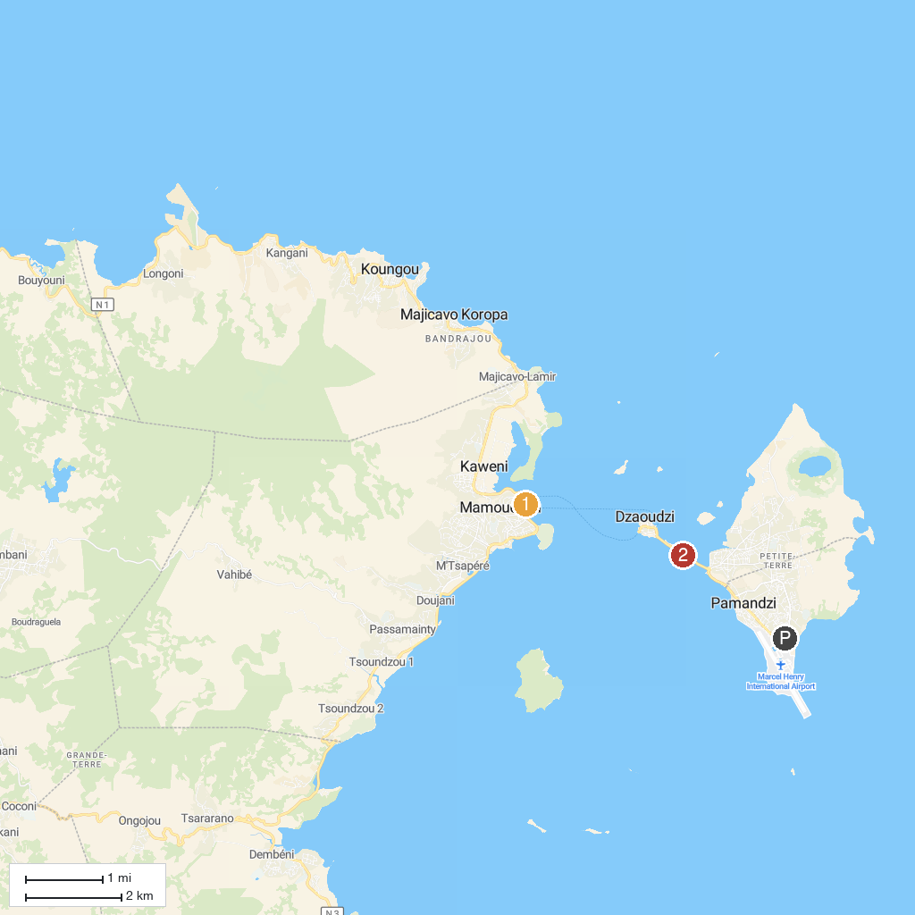
MAP KEY
1. Tourist Office | 2. Plage du Faré
P. Cruise port / terminal
Map © MapTiler © OpenStreetMap contributors · cruiseports.org

