Düsseldorf, North Rhine-Westphalia, Germany
Rhine river cruises dock steps from 260-plus pubs in Europe's most concentrated bar district. Düsseldorf is stylish, flat, walkable, and overflowing with dark Altbier and Frank Gehry architecture.
⚓ River pier (no tender) · 🕒 Typical call: full day · 💶 Euro (€) · 🗣️ German (English widely spoken)
✍️ MY DAY IN PORT (FILL IN)
Ship / Date
In port | arrive ______ · all aboard ______
Booked excursion
Notes / meeting point
GETTING ASHORE
- Docking: River pier along Rheinuferpromenade — ships tie up on the promenade itself
- Walk to Altstadt: 0–10 min from central Burgplatz piers; up to 40 min from northern berths
- Best For: Beer culture, architecture, art museums, shopping
- Don't Miss: Altbier at Uerige brewery, Frank Gehry's Neuer Zollhof at MedienHafen
GETTING AROUND
- 🚕 Taxi: €8–€18 — Metered taxis available dockside. Base fare ~€3.50–€5 plus ~€2–€2.70/km. Short ride to city center or Königsallee shoppi
- 📱 Rideshare: ✅ Uber, Bolt, Free Now
- 🚌 Hop-on hop-off: ✅
TOP THINGS TO DO
- Altstadt Altbier Crawl — The Altstadt is nicknamed 'the longest bar in the world' — more than 260 pubs and breweries in under a square kilometre.
- MedienHafen & Frank Gehry Buildings — Walk 25 minutes south along the Rhine Promenade to Düsseldorf's revitalised Media Harbour.
- Königsallee & Hofgarten Stroll — Germany's most glamorous shopping boulevard runs alongside a tree-lined canal in the city centre.
- K20 / K21 Art Collections — K20 (Grabbeplatz) holds a world-class 20th-century collection — Picasso, Klee, Warhol — while K21 specialises in contemporary work.
- Day Trip to Cologne — Cologne is just 25–35 minutes by regional train (RE5) from Düsseldorf Hauptbahnhof, a 20-minute walk from the central piers.
BEST WALKS
- Rhine Promenade to MedienHafen: 3.5 km one way · Flat · 45 min — Walk south from the Burgplatz piers along the car-free Rheinuferpromenade past the Rheinturm (Rhine…
- Altstadt to Königsallee Loop: 2.5 km loop · Flat · 30–40 min walking — From the Burgplatz piers, explore the Altstadt's medieval lanes and St.
WEATHER · DAYLIGHT · MONEY
Month | High °F | Low °F | Rainy days
May | 65 | 49 | 12
Jul | 75 | 59 | 13
Sep | 69 | 54 | 10
Daylight: May 5:42AM–9:17PM · Jul 5:35AM–9:41PM · Sep 7:08AM–7:46PM
cruiseports.org/dusseldorf · Confirm terminal & all-aboard time with your ship

Düsseldorf, North Rhine-Westphalia, Germany — Port Map
Red = walkable sights · Amber = excursions farther out · P = cruise terminal
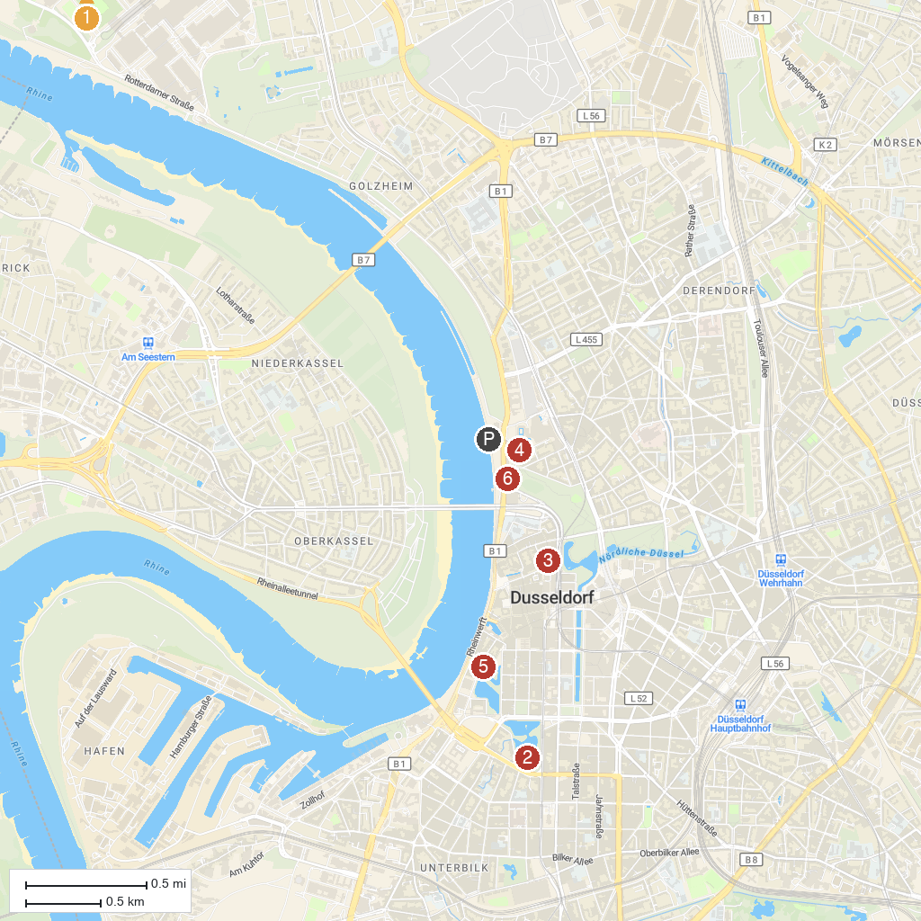
MAP KEY
1. Kaiserpfalz Kaiserswerth | 5. Stadtmuseum Düsseldorf
2. Kunstsammlung | 6. NRW-Forum Düsseldorf
3. Kunstsammlung Nordrhein-Westfalen | 7. Neanderthal Museum
4. Museum Kunstpalast
P. Cruise port / terminal
Map © MapTiler © OpenStreetMap contributors · cruiseports.org

