Durrës, Albania
One of Europe's oldest cities, Durrës drops you at the heart of ancient Roman history, an Albanian beach strip, and a gateway to Tirana — all without ever tendering a single wave.
⚓ Pier (docked) · 🕒 Typical call: 7-9 hrs · 💵 Albanian Lek (ALL); EUR widely accepted · 🗣️ Albanian; Italian widely spoken
✍️ MY DAY IN PORT (FILL IN)
Ship / Date
In port | arrive ______ · all aboard ______
Booked excursion
Notes / meeting point
GETTING ASHORE
- Docking: Pier — ships dock directly; no tender required
- Walk to center: ~10-15 min (1 km) to Freedom Square
- Best For: Roman history, beaches, day trip to Tirana or Krujë
- Don't Miss: Roman Amphitheater — largest in the Balkans
GETTING AROUND
- 🚕 Taxi: ~800 ALL (~$10 USD) — Taxis are available at the port gate for the short ride to the city center. VrapOn and Speed Taxi apps offer transparent
- 📱 Rideshare: ❌ not available
- 🚌 Hop-on hop-off: ✅ HOBUS Albania / Durrës City Tour
TOP THINGS TO DO
- Roman Amphitheater of Durrës — The largest Roman amphitheater in the Balkans, built under Emperor Trajan in the 2nd century AD and seating 20,000.
- Archaeological Museum of Durrës — Albania's largest archaeological museum, recently renovated, displaying Greek, Hellenistic, and Roman artifacts from the city's…
- Day Trip to Tirana — Albania's vibrant, colorful capital is just 40 minutes away by taxi or minibus.
- Krujë Castle & Ottoman Bazaar — Hillside fortress of Albania's national hero Skanderbeg, 50 minutes from port.
- Durrës Beach — A wide sandy arc stretching south from the port, warm shallow Adriatic water, and a row of beach clubs.
BEST WALKS
- Port Gate to Freedom Square & Amphitheater Loop: 2.5 km · ~45 min · Flat with one short hill — Walk from the port gate along the main boulevard to Freedom Square.
- Vollga Promenade to the Sphinx: 2 km · ~30 min · Flat seafront — Head south from the port along the waterfront promenade past seafood restaurants and sculptures to…
WEATHER · DAYLIGHT · MONEY
Month | High °F | Low °F | Rainy days
May | 71 | 58 | 10
Jul | 84 | 71 | 4
Sep | 78 | 66 | 8
Daylight: May 5:23AM–7:53PM · Jul 5:22AM–8:13PM · Sep 6:22AM–6:51PM
cruiseports.org/durres · Confirm terminal & all-aboard time with your ship

Durrës, Albania — Port Map
Red = walkable sights · Amber = excursions farther out · P = cruise terminal
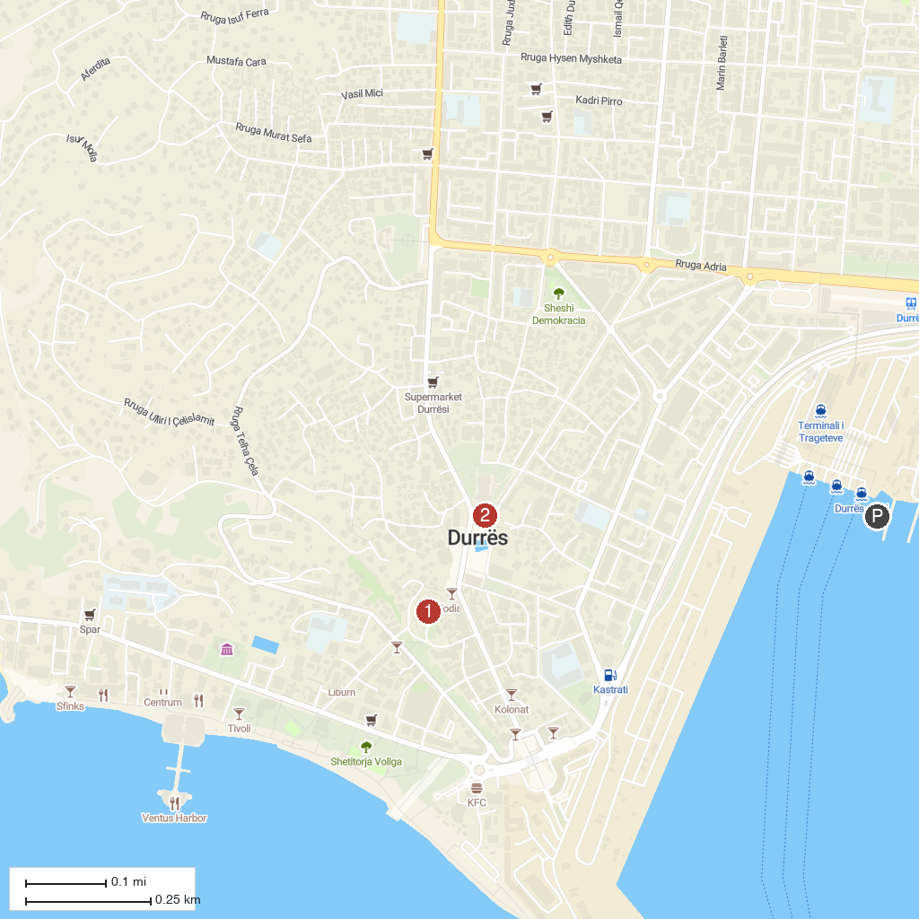
MAP KEY
1. Durrës Amphitheatre | 2. Town Square of Durrës - Sheshi Liria
P. Cruise port / terminal
Map © MapTiler © OpenStreetMap contributors · cruiseports.org

