Dürnstein, Wachau Valley, Austria
A UNESCO-listed village of 800 souls where Richard the Lionheart was once imprisoned — now best known for cobblestone lanes, a blue Baroque spire, and apricot everything.
⚓ Docked (riverside pontoon) · 🕒 Typical call: 5-7 hrs · 💶 Euro · 🗣️ German
✍️ MY DAY IN PORT (FILL IN)
Ship / Date
In port | arrive ______ · all aboard ______
Booked excursion
Notes / meeting point
GETTING ASHORE
- Docking: Direct riverside pontoon — no tender
- Walk to center: 2–5 min from ship to Hauptstraße
- Best For: History, wine tasting, apricot sweets, hilltop views
- Don't Miss: Hike to the 12th-century castle ruins above town
GETTING AROUND
- 🚕 Taxi: €29–€35 to Krems; ~€129 to Vienna Airport — Local taxis (Wachau Taxi) and Uber serve the area for regional excursions. There is no meaningful taxi trip within Dürns
- 📱 Rideshare: ✅ Uber
TOP THINGS TO DO
- Castle Ruins Hike — Climb to the 12th-century Burgruine Dürnstein where King Richard the Lionheart was held for ransom in 1192–93.
- Stift Dürnstein Abbey — The famous blue-and-white Baroque tower belongs to a former Augustinian monastery.
- Wachau Wine & Apricot Tasting — The Wachau is famous for Grüner Veltliner and Riesling.
- Danube Cycle Path Ride — The flat, dedicated Danube Cycle Path runs directly past the ship.
- Hauptstraße Stroll & Café Stop — Wander the medieval main street, browse apricot liqueurs and Wachauer Laberl bread rolls at Bäckerei Schmidl, and settle into a…
BEST WALKS
- Town Gate to Castle Ruins: 1.5 km round trip · 20–30 min up · Moderate (steep, rocky) — From the ship, pass through the medieval Kremser Tor gate and follow the signed castle trail uphill…
- Riverside Promenade & Abbey: 1 km loop · 30–45 min · Easy (flat, paved) — Walk the flat riverside promenade from the ship toward the blue abbey tower, enter the monastery…
WEATHER · DAYLIGHT · MONEY
Month | High °F | Low °F | Rainy days
May | 66 | 51 | 15
Jul | 80 | 63 | 13
Sep | 70 | 55 | 10
Daylight: May 5:18AM–8:31PM · Jul 5:12AM–8:54PM · Sep 6:35AM–7:10PM
cruiseports.org/durnstein · Confirm terminal & all-aboard time with your ship

Dürnstein, Wachau Valley, Austria — Port Map
Red = walkable sights · Amber = excursions farther out · P = cruise terminal
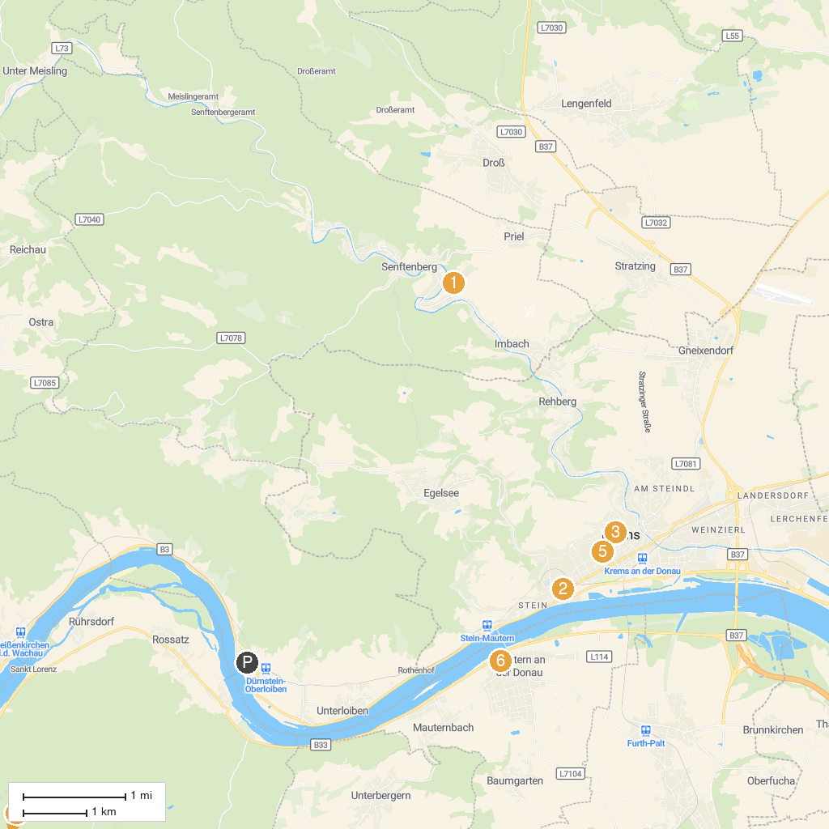
MAP KEY
1. Burgruine Senftenberg | 5. Steinertor
2. Karikaturmuseum Krems | 6. Römermuseum Mautern/Favianis
3. Piarist Church of Our Lady | 7. Urzeitmuseum Nussdorf-Traisental
4. Pfarr- und Wallfahrtskirche Mariae Geburt
P. Cruise port / terminal
Map © MapTiler © OpenStreetMap contributors · cruiseports.org

