Dunkirk, Hauts-de-France, France
Where Allied soldiers were evacuated from the beaches of Operation Dynamo in 1940, Dunkirk now offers cruise passengers a compelling mix of WWII history, free public transport, sweeping North Sea beaches, and hearty Flemish-French cooking.
⚓ Pier (docked) · 🕒 Typical call: 8-10 hrs · 💶 Euro (€) · 🗣️ French (English widely spoken) · 🚌 Free city buses
✍️ MY DAY IN PORT (FILL IN)
Ship / Date
In port | arrive ______ · all aboard ______
Booked excursion
Notes / meeting point
GETTING ASHORE
- Docking: Pier — industrial port, 10–15 km from city center; shuttle bus required
- Walk to center: Not walkable from pier — take ship shuttle or free city bus
- Best For: WWII history, Dunkirk beaches, day trips to Bruges or Lille
- Don't Miss: Musée Dunkerque 1940 in Bastion 32 and Malo-les-Bains beach
GETTING AROUND
- 🚕 Taxi: €40–€50 — Taxis from the cruise port to the city center take about 20 minutes. Metered fares apply; useful when rideshare demand i
- 📱 Rideshare: ✅ Uber, Bolt
TOP THINGS TO DO
- Operation Dynamo: Bastion 32 Museum — The Musée Dunkerque 1940 sits inside Bastion 32, the actual Allied command bunker during the evacuation.
- Malo-les-Bains Beach & Evacuation Shoreline — The wide sandy beach where soldiers waded into the sea in 1940 is today a lively resort with Art Nouveau villas, a sea-dyke…
- Day Trip: Bruges, Belgium — The 'Venice of the North' is just 45 minutes by road.
- Lille City Tour — France's Flemish capital is 45 minutes south — Grand Place, the 17th-century Vieille Bourse, UNESCO belfry, and exceptional…
- WWI Flanders Battlefields & Ypres — Ypres (Ieper) and the Flanders Fields are under an hour away — Menin Gate, Tyne Cot Cemetery, and In Flanders Fields Museum offer…
BEST WALKS
- City Center Heritage Walk: 1.5 km · 30–45 min · Easy, flat — From Place Jean Bart, admire the statue of privateer Jean Bart, then walk to Saint-Éloi Church…
- Malo-les-Bains Promenade: 2 km along the seafront · 40 min · Easy — Hop on free Bus C3 to Malo-les-Bains.
WEATHER · DAYLIGHT · MONEY
Month | High °F | Low °F | Rainy days
May | 61 | 49 | 10
Jul | 71 | 59 | 10
Sep | 68 | 56 | 10
Daylight: May 6:00AM–9:33PM · Jul 5:53AM–9:58PM · Sep 7:26AM–8:04PM
cruiseports.org/dunkirk · Confirm terminal & all-aboard time with your ship

Dunkirk, Hauts-de-France, France — Port Map
Red = walkable sights · Amber = excursions farther out · P = cruise terminal
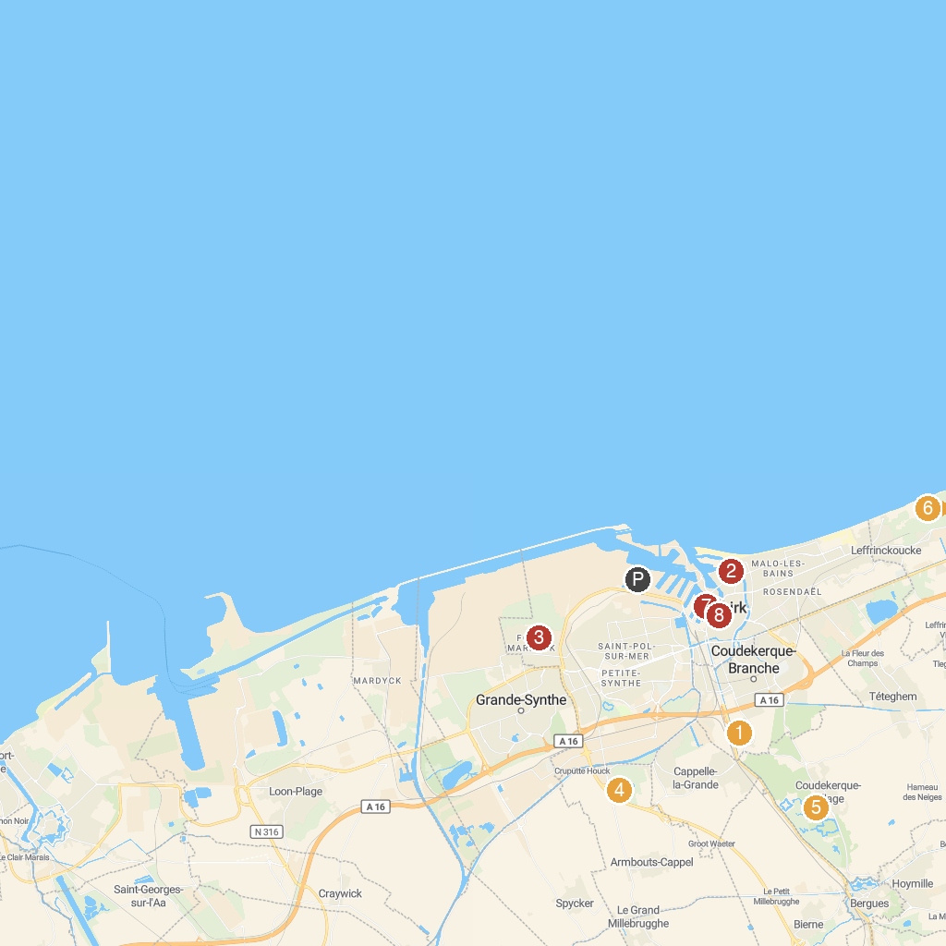
MAP KEY
1. Fort Louis Park | 5. Bois des Forts
2. Museum Dunkerque 1940 Operation Dynamo | 6. Reserve Naturelle Dune Dewulf
3. Bio-Topia Fort-Mardyck - Dunkerque | 7. Port Museum of Dunkirk
4. Lac d'Armbouts-Cappel | 8. Saint-Éloi Catholic Church at Dunkirk
P. Cruise port / terminal
Map © MapTiler © OpenStreetMap contributors · cruiseports.org

