Dunedin, Otago, New Zealand
New Zealand's "Edinburgh of the South" pairs grand gold-rush architecture with world-class wildlife — where royal albatross soar over the ocean just minutes from the city.
⚓ Docked at pier (Port Chalmers) · 🕒 Typical call: 8–10 hrs · 💵 New Zealand Dollar (NZD) · 🗣️ English · 🐧 Wildlife capital of NZ
✍️ MY DAY IN PORT (FILL IN)
Ship / Date
In port | arrive ______ · all aboard ______
Booked excursion
Notes / meeting point
GETTING ASHORE
- Docking: Docked at Port Chalmers wharf (~13 km from city center)
- Walk to center: Not walkable — shuttle or public bus Route 14 required
- Best For: Wildlife, Victorian history, Scottish heritage, local seafood
- Don't Miss: Royal Albatross Centre at Taiaroa Head, Otago Peninsula
GETTING AROUND
- 🚕 Taxi: NZD 45–60 to city center — Taxis are available at the port and take roughly 15 minutes to reach the city center. Fares vary with traffic and demand
- 📱 Rideshare: ✅ Uber
- 🚌 Hop-on hop-off: ✅
TOP THINGS TO DO
- Royal Albatross Centre — Taiaroa Head — The world's only mainland breeding colony of Northern Royal Albatross sits at the tip of the Otago Peninsula.
- Larnach Castle & Gardens — New Zealand's only castle was built in 1871 by politician William Larnach and features ornate Victorian interiors, sweeping…
- Dunedin City Heritage Walk — Dunedin's Victorian and Edwardian core is one of the best-preserved in the Southern Hemisphere.
- Tunnel Beach Coastal Walk — A short but dramatic hike through farmland leads to a hand-carved tunnel opening onto a secluded sandstone beach flanked by…
- Craft Beer & Local Seafood — Emerson's Brewery — a NZ craft-beer pioneer — is a short walk from the University with an excellent restaurant attached.
BEST WALKS
- Port Chalmers Heritage Stroll: 30 min · flat · from pier — Port Chalmers has a compact Victorian main street with cafes, a heritage museum, and harbour views.
- Dunedin Station to Octagon Loop: 1 hr · easy · city center — From the spectacular Flemish Renaissance Railway Station, walk through the Toitū Museum precinct…
WEATHER · DAYLIGHT · MONEY
Month | High °F | Low °F | Rainy days
May | 55 | 42 | 12
Jul | 49 | 38 | 11
Sep | 54 | 41 | 13
Daylight: May 7:51AM–5:16PM · Jul 8:14AM–5:13PM · Sep 6:41AM–6:25PM
cruiseports.org/dunedin · Confirm terminal & all-aboard time with your ship

Dunedin, Otago, New Zealand — Port Map
Red = walkable sights · Amber = excursions farther out · P = cruise terminal
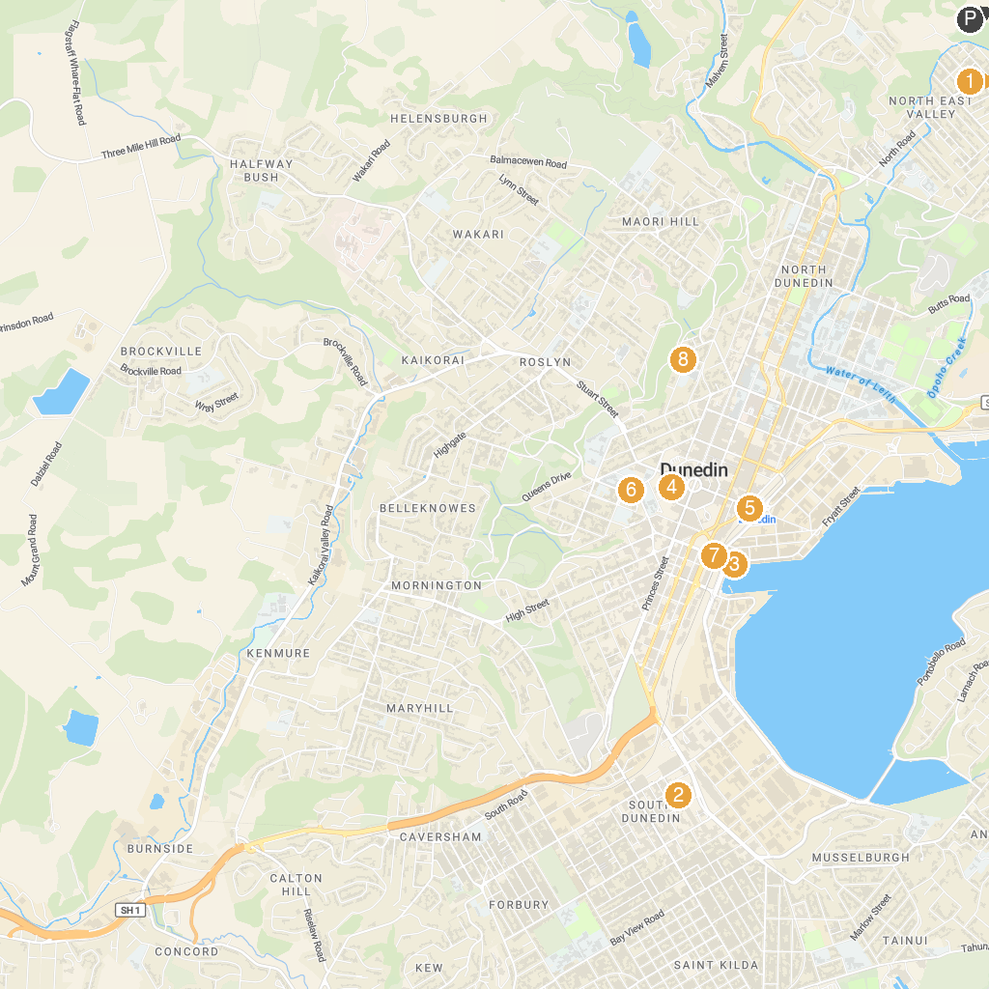
MAP KEY
1. Baldwin Street - The Steepest Street in the World | 5. Otago Art Society
2. Dunedin Gasworks Museum | 6. St. Joseph's Cathedral
3. Monarch Wildlife Cruises & Tours | 7. Lan Yuan, Dunedin Chinese Garden
4. Hair Raiser Tours | 8. Olveston Historic Home
P. Cruise port / terminal
Map © MapTiler © OpenStreetMap contributors · cruiseports.org

