Dundee, Scotland, United Kingdom
The UK's only UNESCO City of Design sits on the River Tay, where Antarctic heroes sailed and Desperate Dan still roams the High Street. One shuttle hop and you're in one of Britain's most energetically reinvented cities.
⚓ Docked (King George V Wharf) · 🕒 Typical call: 8-10 hrs · 💷 GBP — cards accepted everywhere · 🗣️ English
✍️ MY DAY IN PORT (FILL IN)
Ship / Date
In port | arrive ______ · all aboard ______
Booked excursion
Notes / meeting point
GETTING ASHORE
- Docking: Pier (King George V Wharf) — shuttle bus to city centre (~1.5 mi)
- Walk to Centre: Shuttle to waterfront; then all main sights within 15-min walk
- Best For: Design, science, maritime history, Scottish culture
- Don't Miss: V&A Dundee + RRS Discovery back-to-back on the waterfront
GETTING AROUND
- 🚕 Taxi: £5–£8 — Short 5-minute ride from the cruise terminal to Dundee city centre. The walking route passes through an industrial area,
- 🚌 Hop-on hop-off: ✅ Xplore Dundee (Discover Dundee)
TOP THINGS TO DO
- V&A Dundee — Scotland's first design museum, housed in a cliff-like building by Kengo Kuma.
- RRS Discovery & Discovery Point — Board the ship that carried Scott and Shackleton to Antarctica in 1901.
- HMS Unicorn — One of the oldest warships still afloat in the world (third only to HMS Trincomalee and USS Constitution) — a remarkably intact…
- The McManus Art Gallery & Museum — Stunning Victorian Gothic building with eight free galleries covering fine art, natural history, and Dundee's fascinating past…
- Verdant Works Jute Museum — Award-winning museum in a restored Victorian jute mill.
BEST WALKS
- Waterfront & City Centre Loop: 1.5 miles • Easy • 45-60 min — Start at the V&A Dundee, walk east past RRS Discovery and HMS Unicorn, cross into the city centre…
- Dundee Law Panorama: 2 miles round trip • Moderate (steep) • 1 hr — Head north from the city centre to Dundee Law, an extinct volcano peak offering 360-degree views…
WEATHER · DAYLIGHT · MONEY
Month | High °F | Low °F | Rainy days
May | 56 | 43 | 13
Jul | 65 | 52 | 16
Sep | 60 | 49 | 12
Daylight: May 4:56AM–9:21PM · Jul 4:44AM–9:50PM · Sep 6:43AM–7:29PM
cruiseports.org/dundee · Confirm terminal & all-aboard time with your ship

Dundee, Scotland, United Kingdom — Port Map
Red = walkable sights · Amber = excursions farther out · P = cruise terminal
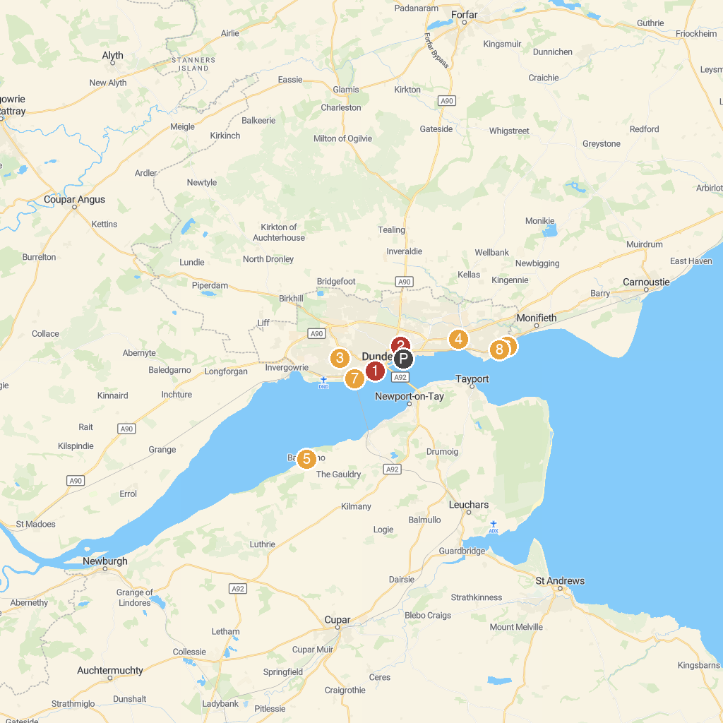
MAP KEY
1. Dundee Contemporary Arts | 5. Balmerino Abbey (National Trust for Scotland)
2. Baxter Park | 6. Barnhill Rock Garden
3. Balgay Park | 7. Magdalen Green
4. Dawson Park | 8. Broughty Ferry Nature Reserve
P. Cruise port / terminal
Map © MapTiler © OpenStreetMap contributors · cruiseports.org

