Dún Laoghaire, County Dublin, Ireland
A handsome Victorian harbour town just 12 km from Dublin city centre, Dún Laoghaire (say 'Dun Leary') offers both a relaxed seaside day of its own and an express DART link straight to Trinity College and the Guinness Storehouse.
⚓ Mostly tender (large ships anchor in Dublin Bay) · 🕒 Typical call: 8–10 hrs · 💶 Currency: Euro (€) · 🗣️ Language: English (Irish on signs)
✍️ MY DAY IN PORT (FILL IN)
Ship / Date
In port | arrive ______ · all aboard ______
Booked excursion
Notes / meeting point
GETTING ASHORE
- Docking: Tender for most ships; smaller vessels dock at Carlisle Pier
- Walk to centre: 5–7 min from St Michael's Pier to George's Street
- Best For: Dublin day trips, Victorian pier walks, literary history
- Don't Miss: East Pier walk + Teddy's ice cream + DART to Dublin
GETTING AROUND
- 🚕 Taxi: €18–€30 — Metered taxis and app-based rides (Uber, Bolt, Free Now) to Dublin city centre take 15–25 min. Bolt e-bikes also availab
- 📱 Rideshare: ✅ Uber, Bolt, Free Now
- 🚌 Hop-on hop-off: ✅ DoDublin
TOP THINGS TO DO
- Dublin City Day Trip by DART — Hop the train for Trinity College's Book of Kells, the Guinness Storehouse, Dublin Castle, and the buzzing Temple Bar district.
- James Joyce Tower & The Forty Foot — A 15-minute coastal walk (or short taxi) brings you to the Sandycove Martello Tower where Ulysses opens, now a small museum.
- National Maritime Museum of Ireland — Housed in a 19th-century Mariners' Church, this compact museum covers deep-sea diving, Titanic artefacts, and the original optic…
- East Pier Walk & Teddy's Ice Cream — Stroll the 1.3 km Victorian promenade to the lighthouse for sweeping views of Dublin Bay and Howth.
- People's Park Sunday Market — If your ship calls on a Sunday, the People's Park hosts the CoCo Market (11am–4pm) — hot food stalls, crafts, local produce, and…
BEST WALKS
- East Pier to the Lighthouse: 2.6 km return • Flat • 45 min • Free — The quintessential Dún Laoghaire walk.
- Sandycove & James Joyce Tower Loop: 3 km one-way • Easy coastal path • 45–60 min • Free — Follow the coastal footpath south from the harbour through Sandycove village to the Martello Tower…
WEATHER · DAYLIGHT · MONEY
Month | High °F | Low °F | Rainy days
May | 58 | 48 | 14
Jul | 67 | 56 | 15
Sep | 63 | 53 | 12
Daylight: May 5:25AM–9:17PM · Jul 5:16AM–9:44PM · Sep 6:58AM–7:39PM
cruiseports.org/dun-laoghaire · Confirm terminal & all-aboard time with your ship

Dún Laoghaire, County Dublin, Ireland — Port Map
Red = walkable sights · Amber = excursions farther out · P = cruise terminal
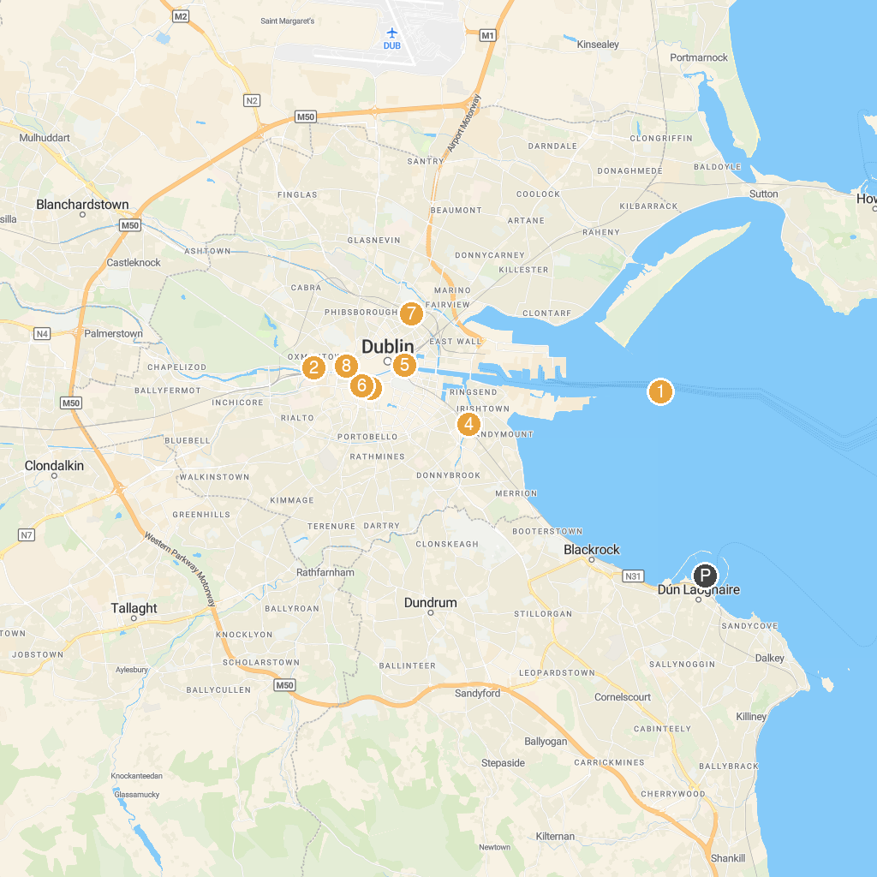
MAP KEY
1. Poolbeg Lighthouse | 5. The Custom House
2. Anna Livia | 6. Christ Church Cathedral
3. Dublin Castle | 7. Croke Park
4. Aviva Stadium | 8. Jameson Distillery Bow St.
P. Cruise port / terminal
Map © MapTiler © OpenStreetMap contributors · cruiseports.org

