Dubai, Dubai, UAE
A city that leapt from fishing village to futuristic skyline in a single generation. Dubai rewards curious cruisers with gold souks, record-breaking towers, desert dunes twenty minutes from the pier — and two world-class cruise terminals.
⚓ Docked — Mina Rashid (Port Rashid) or Dubai Harbour Cruise Terminal · 🕒 Typical call: 8-12 hrs (frequent overnights) · 💵 Currency: UAE Dirham (AED) — USD/major cards widely accepted · 🗣️ Language: Arabic (English universally spoken)
✍️ MY DAY IN PORT (FILL IN)
Ship / Date
In port | arrive ______ · all aboard ______
Booked excursion
Notes / meeting point
GETTING ASHORE
- Docking: Pier berth always — Mina Rashid (Port Rashid) or Dubai Harbour near Palm Jumeirah. Check your itinerary: they are 25 km apart.
- Walk to centre: Neither terminal is walkable. Old Dubai/souks ~15-min taxi from Mina Rashid; Dubai Marina ~10 min from Dubai Harbour.
- Best For: Extraordinary contrasts: 14th-century spice souks beside the world's tallest skyscraper and a real desert ten minutes beyond
- Don't Miss: Crossing Dubai Creek by abra (AED 1) and wandering Al Fahidi Historical Neighbourhood
GETTING AROUND
- 🚕 Taxi: AED 30–45 to Downtown Dubai — RTA metered taxis queue outside the terminal. Starting fare is AED 25; the ride to Downtown Dubai or Dubai Mall area is
- 📱 Rideshare: ✅ Uber, Careem
- 🚌 Hop-on hop-off: ✅
TOP THINGS TO DO
- Burj Khalifa & Dubai Mall — Ride the elevator to the 124th-floor observation deck of the world's tallest building, then explore Dubai Mall — planet's largest…
- Old Dubai: Gold Souk, Spice Souk & Al Fahidi — Cross Dubai Creek by abra for AED 1, browse the covered Gold Souk and aromatic Spice Souk in Deira, then walk across to Al Fahidi…
- Desert Safari — Head into the Arabian Desert for dune-bashing in 4WDs, sandboarding, camel riding, and an optional Bedouin-camp dinner under the…
- Museum of the Future — One of the world's most striking buildings — a torus-shaped tower clad in Arabic calligraphy — houses five immersive floors…
- Jumeirah Beach & Burj Al Arab View — Dubai's public Jumeirah Beach offers warm, calm Gulf water and a direct sightline to the iconic sail-shaped Burj Al Arab hotel.
BEST WALKS
- Bur Dubai Creek Walk: 2-3 km · 45-60 min · Easy · Full sun — go early or late afternoon — Start at Al Fahidi Historical Neighbourhood, walk north along the creek-front promenade past the…
- Al Fahidi Historical Neighbourhood Loop: 1 km · 30 min · Easy · Shaded lanes — The labyrinth of coral-and-gypsum lanes in Bastakiya (Al Fahidi) rewards slow wandering.
WEATHER · DAYLIGHT · MONEY
Month | High °F | Low °F | Rainy days
May | 102 | 76 | 0
Jul | 109 | 86 | 0
Sep | 105 | 81 | 0
Daylight: May 5:34AM–6:56PM · Jul 5:38AM–7:10PM · Sep 6:04AM–6:22PM
cruiseports.org/dubai · Confirm terminal & all-aboard time with your ship

Dubai, Dubai, UAE — Port Map
Red = walkable sights · Amber = excursions farther out · P = cruise terminal
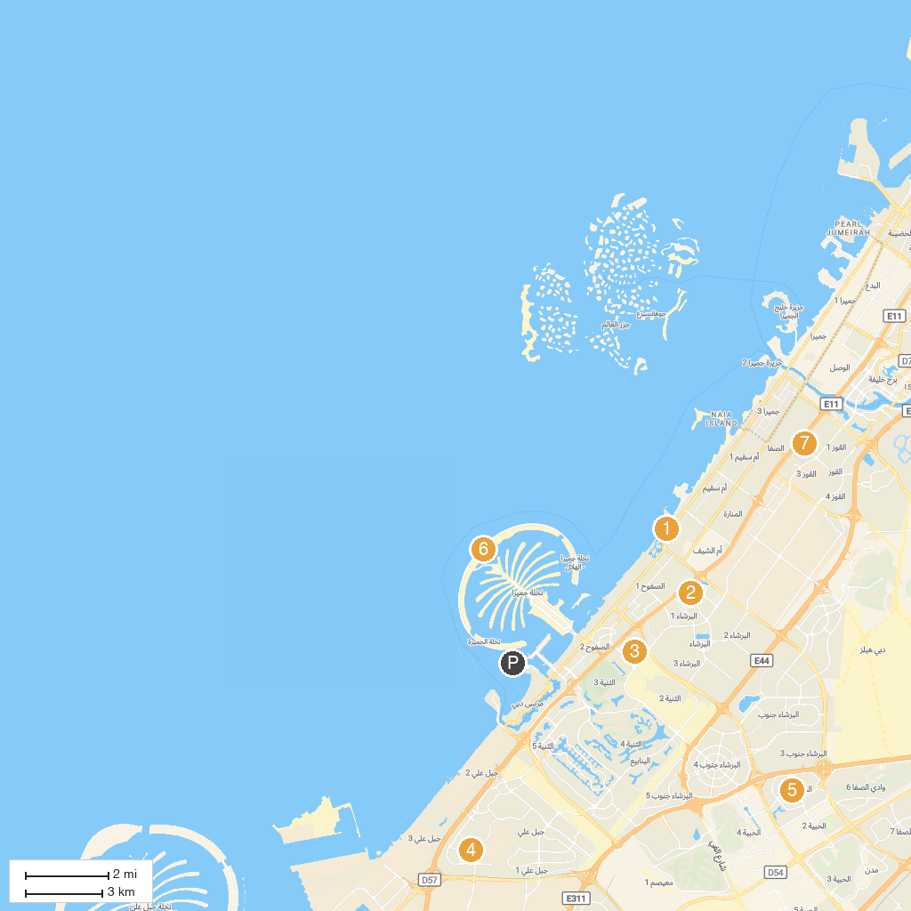
MAP KEY
1. Wild Wadi Waterpark Jumeirah | 5. Dubai Autodrome
2. Ski Dubai | 6. Aquaventure World
3. Quad Biking Dubai and Dune Buggy Ride | 7. Fun City - Oasis Mall
4. Guru Nanak Darbar Gurudwara | 8. Al Safa Park
P. Cruise port / terminal
Map © MapTiler © OpenStreetMap contributors · cruiseports.org

