Dresden, Saxony, Germany
Florence of the Elbe. River cruise ships moor right below Brühl's Terrace, putting Dresden's reconstructed Baroque masterpieces — and the world's oldest paddle-steamer fleet — within a five-minute walk.
⚓ Docked (river pier) · 🕒 Typical call: 8-10 hrs · 💶 Euro (€) · 🗣️ German · 🏛️ UNESCO-level Baroque architecture
✍️ MY DAY IN PORT (FILL IN)
Ship / Date
In port | arrive ______ · all aboard ______
Booked excursion
Notes / meeting point
GETTING ASHORE
- Docking: River pier at Terrassenufer — no tender required
- Walk to Frauenkirche: ~5 min from gangway
- Best For: Art, history, architecture, Saxon cuisine
- Don't Miss: Green Vault (pre-book!), Fürstenzug mural, Canaletto viewpoint
GETTING AROUND
- 🚕 Taxi: €10–20 — Metered taxis start at ~€4.50 base fare plus ~€2.10–3.20/km. Useful for reaching hotels or attractions outside the immed
- 📱 Rideshare: ✅ Bolt, Free Now
- 🚌 Hop-on hop-off: ✅ Stadtrundfahrt Dresden
TOP THINGS TO DO
- Royal Palace & the Green Vault — The former residence of the Saxon kings houses the most dazzling treasury in Europe.
- Zwinger Palace & Old Masters Gallery — Wander the free Baroque courtyards of the Zwinger, then pay to enter the Gemäldegalerie Alte Meister — home to Raphael's Sistine…
- Frauenkirche Dome Climb — The interior of the reconstructed Church of Our Lady is free; pay ~€10 to ride the elevator and climb the dome spiral for…
- Meissen — Porcelain Capital — A 30-minute drive or scenic river cruise upstream to the medieval hilltop town where European hard-paste porcelain was invented.
- Saxon Switzerland National Park — Dramatic Elbe sandstone pillars and pine gorges 40 km southeast of Dresden.
BEST WALKS
- Altstadt Highlights Loop: 2.5 km · ~60-75 min · flat cobblestones — Climb Brühl's Terrace from the pier, follow the promenade to the Frauenkirche, detour to the…
- Canaletto Viewpoint & Neustadt Stroll: 3 km · ~60 min · one river crossing — Walk across the Augustus Bridge to the Neustadt bank, find the Canaletto viewpoint looking back at…
WEATHER · DAYLIGHT · MONEY
Month | High °F | Low °F | Rainy days
May | 65 | 48 | 10
Jul | 77 | 60 | 12
Sep | 69 | 53 | 11
Daylight: May 5:15AM–8:48PM · Jul 5:08AM–9:13PM · Sep 6:40AM–7:18PM
cruiseports.org/dresden · Confirm terminal & all-aboard time with your ship

Dresden, Saxony, Germany — Port Map
Red = walkable sights · Amber = excursions farther out · P = cruise terminal
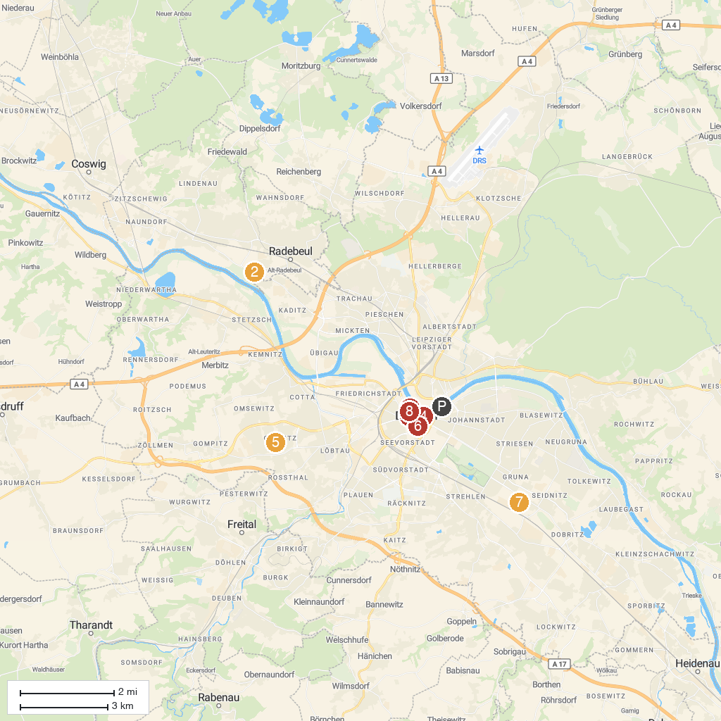
MAP KEY
1. Cholerabrunnen | 5. Elbamare Erlebnisbad
2. Lügenmuseum | 6. Holy Cross Church
3. Semperoper Dresden | 7. Dresden Panometer
4. Frauenkirche Dresden | 8. SKD | Old Masters Picture Gallery
P. Cruise port / terminal
Map © MapTiler © OpenStreetMap contributors · cruiseports.org

