Douarnenez, Brittany, France
One of Brittany's most authentic fishing towns, Douarnenez sits at the edge of a mythic bay, its three harbors brimming with maritime history, world-famous pastries, and the legend of a drowned city beneath the waves.
⚓ Tender port · 🕒 Typical call: 6-8 hrs · 💶 Currency: Euro (€) · 🗣️ Language: French / Breton
✍️ MY DAY IN PORT (FILL IN)
Ship / Date
In port | arrive ______ · all aboard ______
Booked excursion
Notes / meeting point
GETTING ASHORE
- Docking: Tender to Port de Rosmeur
- Walk to center: 5–10 min uphill from tender pier
- Best For: Authentic Breton culture, maritime history, coastal walks
- Don't Miss: Kouign-Amann — invented right here in 1860
GETTING AROUND
- 🚕 Taxi: €3–6 — Local taxis are available near the tender dock. Short in-town trips cost roughly €3–6; the per-km daytime rate is approx
- 📱 Rideshare: ✅ Uber
TOP THINGS TO DO
- Port-Musée Maritime Museum — One of France's finest maritime museums, split across an indoor gallery and a living 'floating museum' in Port-Rhu where you can…
- Les Plomarc'h — Gallo-Roman Ruins & Coastal Path — A 15-minute walk east of the tender pier leads to this protected headland with one of Europe's best-preserved Gallo-Roman…
- Île Tristan at Low Tide — A tidal island just off Port-Rhu, accessible on foot across a sandbar at low tide.
- Kouign-Amann & Sardine Trail — Douarnenez invented kouign-amann in 1860 — caramelised, buttery, impossible to resist.
- Plage des Sables Blancs, Tréboul — Cross the pedestrian footbridge over Port-Rhu into the resort quarter of Tréboul (25–30 min walk) to reach Brittany's finest…
BEST WALKS
- Rosmeur to Port-Rhu Maritime Museum: 1.5 km · 15 min · Easy–Moderate — From the tender quay at Port de Rosmeur, follow the waterfront west past colourful fishermen's…
- Coastal Path to Les Plomarc'h: 1.2 km · 15 min · Easy — Head east from the tender pier along the Sentier des Douaniers coastal path (GR34).
WEATHER · DAYLIGHT · MONEY
Month | High °F | Low °F | Rainy days
May | 62 | 52 | 12
Jul | 69 | 60 | 10
Sep | 67 | 58 | 11
Daylight: May 6:38AM–9:49PM · Jul 6:33AM–10:12PM · Sep 7:54AM–8:29PM
cruiseports.org/douarnenez · Confirm terminal & all-aboard time with your ship

Douarnenez, Brittany, France — Port Map
Red = walkable sights · Amber = excursions farther out · P = cruise terminal
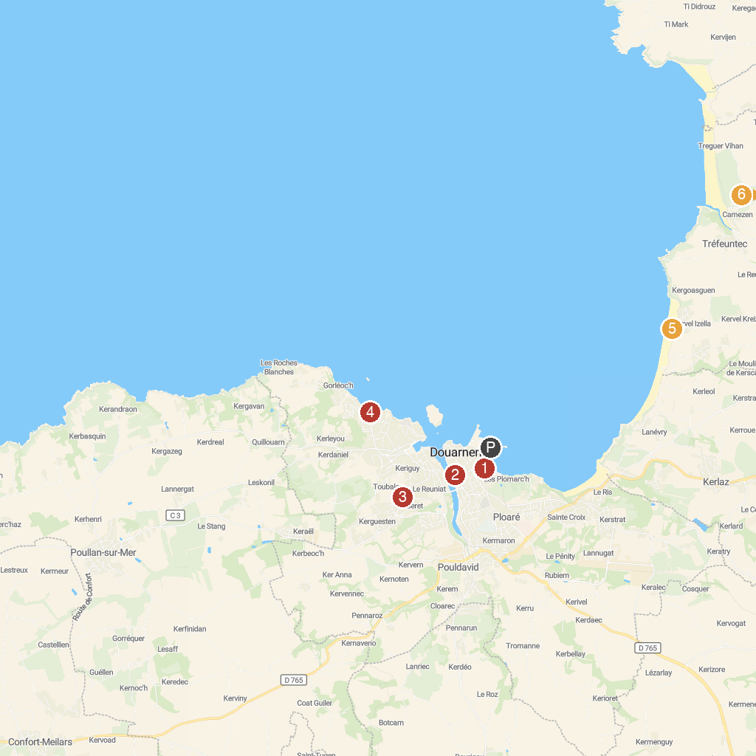
MAP KEY
1. chapelle Sainte-Hélène | 4. Plage des Sables Blancs
2. Port-musée | 5. Plage de Kervel
3. Douarnenez | 6. Chapelle Sainte-Anne-la-Palud
P. Cruise port / terminal
Map © MapTiler © OpenStreetMap contributors · cruiseports.org

