Dordrecht, South Holland, Netherlands
Dordrecht — Dordt to locals — is the oldest city in Holland, born in 1220 on a river island where the Oude Maas, Merwede and Noord converge. Step off the gangway directly onto golden-age cobblestones, with Kinderdijk windmills just 30 minutes away by water.
⚓ Docked (city quay) · 🕒 Typical call: 6–8 hrs · 💶 Euro — nearly cashless · 🗣️ Dutch (English universal) · 🏛️ Holland's oldest city (1220)
✍️ MY DAY IN PORT (FILL IN)
Ship / Date
In port | arrive ______ · all aboard ______
Booked excursion
Notes / meeting point
GETTING ASHORE
- Docking: Docked at city quay — step ashore directly into the historic center
- Walk to center: 0 min — the dock IS the historic center (Groothoofd)
- Best For: History walkers, Dutch Golden Age art, Kinderdijk day trips, canal boats
- Don't Miss: Waterbus to Kinderdijk windmills (UNESCO); Grote Kerk tower views; Huis Van Gijn museum
GETTING AROUND
- 🚕 Taxi: €4–€10 — Local taxis (Taxi Service Drechtsteden, Staxi) use metered fares with a start tariff of ~€4.15 and ~€3.05/km. Useful for
- 📱 Rideshare: ✅ Uber, Bolt
TOP THINGS TO DO
- Kinderdijk Windmills (UNESCO) — Nineteen eighteenth-century windmills in a row — the most photographed scene in the Netherlands.
- Grote Kerk Tower Climb — Climb 275 steps up Dordrecht's leaning Gothic tower (leans 2.25 m) for sweeping views over the river delta and historic rooftops.
- Huis Van Gijn Museum — A perfectly preserved 19th-century canal mansion — the home of banker and collector Simon van Gijn, preserved much as he left it…
- Nationaal Park De Biesbosch — Europe's largest freshwater tidal wetland sits right next to Dordrecht.
- Dordrechts Museum — Dutch Masters — One of the oldest art museums in the Netherlands, featuring Golden Age paintings by pupils of Rembrandt (Ferdinand Bol, Aert de…
BEST WALKS
- Groothoofd to Grote Kerk Loop: ~2 km · 45–60 min · Flat · Free — Start at the Groothoofd Gate where three rivers meet, walk the historic harbor quays…
- Scheffersplein & Old Town Wander: ~1.5 km · 30–40 min · Flat · Free — From the dock, head into Voorstraat (the main shopping street), turn toward Scheffersplein — the…
WEATHER · DAYLIGHT · MONEY
Month | High °F | Low °F | Rainy days
May | 64 | 48 | 12
Jul | 72 | 58 | 14
Sep | 67 | 54 | 10
Daylight: May 5:48AM–9:27PM · Jul 5:40AM–9:53PM · Sep 7:16AM–7:55PM
cruiseports.org/dordrecht · Confirm terminal & all-aboard time with your ship

Dordrecht, South Holland, Netherlands — Port Map
Red = walkable sights · Amber = excursions farther out · P = cruise terminal
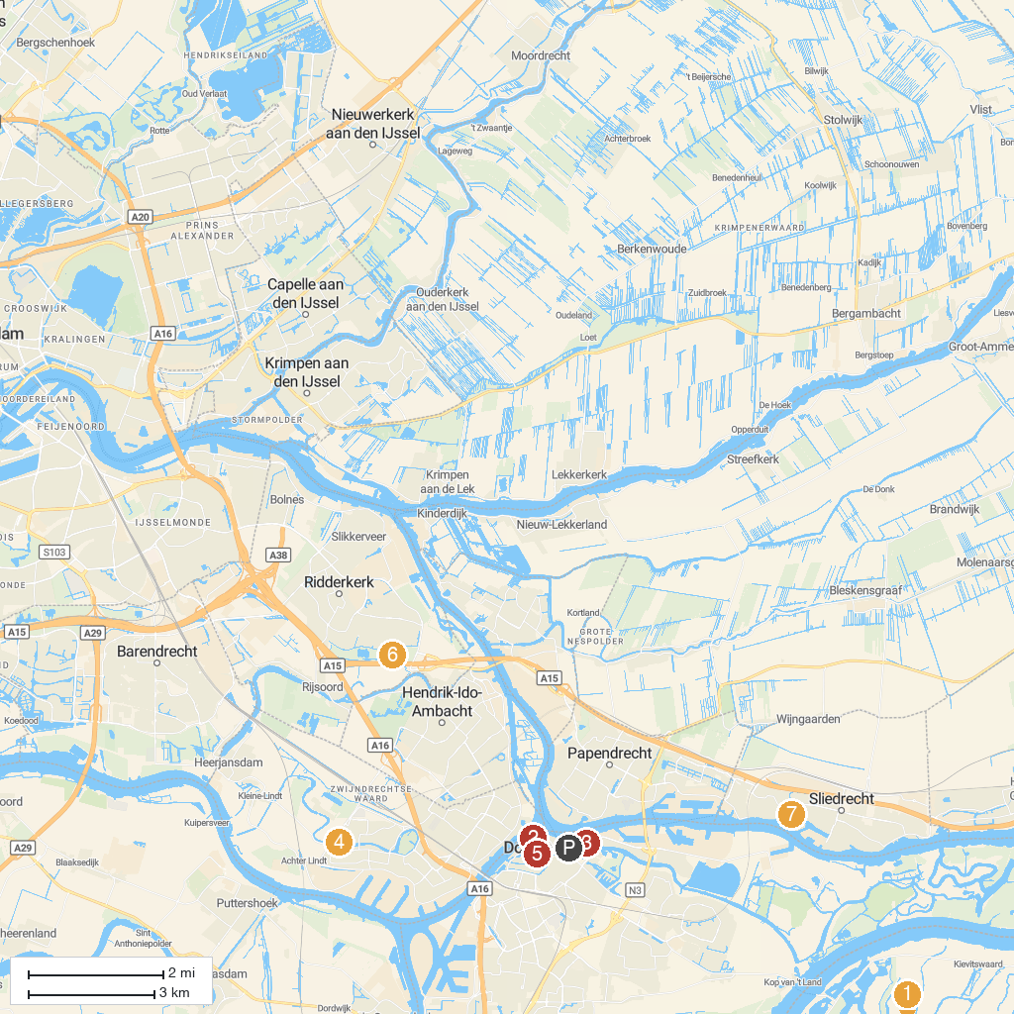
MAP KEY
1. Nationaal Park De Biesbosch | 5. Rondvaart de Dordtevaar
2. Het Dordts Patriciërshuis | Museum Dordrecht | 6. Oosterpark
3. Binnenvaartmuseum | 7. Nationaal Baggermuseum
4. Munnikepark
P. Cruise port / terminal
Map © MapTiler © OpenStreetMap contributors · cruiseports.org

