San Sebastián, Basque Country, Spain
Spain's most beautiful bay city serves up crescent beaches, Belle Époque grandeur, and the world's best bar food — all within easy reach of the tender dock.
⚓ Tender (most ships) or Pasaia pier · 🕒 Typical call: 7-9 hrs · 💶 Currency: Euro (€) · 🗣️ Basque (Euskera) & Spanish
✍️ MY DAY IN PORT (FILL IN)
Ship / Date
In port | arrive ______ · all aboard ______
Booked excursion
Notes / meeting point
GETTING ASHORE
- Docking: Tender to Puerto de San Sebastián harbor; some ships dock at Pasaia, ~10 km east
- Walk to center: 0 min from tender; 15 min by shuttle or taxi from Pasaia
- Best For: Pintxo crawls, La Concha Beach, Belle Époque architecture
- Don't Miss: Parte Vieja pintxo bars and a slice of La Viña's burnt Basque cheesecake
GETTING AROUND
- 🚕 Taxi: €10–€20 — Metered taxis operate 24/7 with officially regulated rates. Short rides within the center run approximately €10–€15; a 5
- 📱 Rideshare: ✅ Uber
- 🚌 Hop-on hop-off: ✅
TOP THINGS TO DO
- Pintxo Crawl — Parte Vieja — The Old Town's dense grid of pintxo bars is the main event.
- Monte Igueldo Funicular — A 1912 wooden funicular climbs to the top of Monte Igueldo for the best panoramic photo of La Concha Bay.
- Monte Urgull Hike — Free forested walk up the hill that anchors the Old Town.
- San Telmo Museum — The best introduction to Basque identity, housed in a stunning 16th-century Dominican convent with modern wings.
- La Concha Beach Day — Often called the best urban beach in Europe — calm, shallow waters, golden sand, and a graceful promenade lined with Belle Époque…
BEST WALKS
- Old Town & Beaches Loop: 3-4 km · 1-1.5 hrs · Easy — From the fishing harbor, walk into Parte Vieja for pintxos at midday, then stroll the La Concha…
- Monte Urgull Summit Walk: 2 km · 45-60 min · Moderate — Start at the base of Monte Urgull near the Old Town, follow shaded wooded paths to the Castillo de…
WEATHER · DAYLIGHT · MONEY
Month | High °F | Low °F | Rainy days
May | 64 | 52 | 12
Jul | 73 | 61 | 8
Sep | 72 | 57 | 9
Daylight: May 5:54AM–6:54PM · Jul 6:00AM–7:07PM · Sep 6:16AM–6:29PM
cruiseports.org/donostia-san-sebastian · Confirm terminal & all-aboard time with your ship

San Sebastián, Basque Country, Spain — Port Map
Red = walkable sights · Amber = excursions farther out · P = cruise terminal
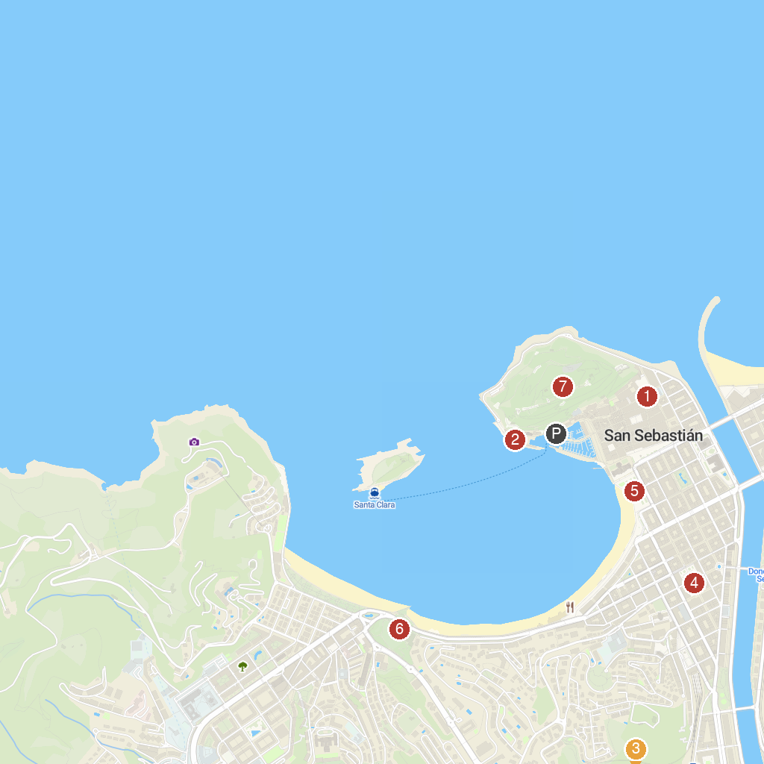
MAP KEY
1. Saint Vincent's Church | 5. Alderdi Eder Park
2. Aquarium San Sebastián | 6. Miramar Jauregia
3. Eureka! Zientzia Museoa | 7. Urgulleko Historiaren Etxea
4. Cathedral Buen Pastor de San Sebastián
P. Cruise port / terminal
Map © MapTiler © OpenStreetMap contributors · cruiseports.org

