Killybegs, County Donegal, Ireland
Ireland's largest fishing port is your launchpad into County Donegal — a wild, windswept corner of the island with Europe's highest sea cliffs, deserted beaches, and pubs full of traditional music.
⚓ Docked (Smooth Point Pier) · 🕒 Typical call: 7-9 hrs · 💶 Euro (€) · 🗣️ English (Irish Gaelic also spoken)
✍️ MY DAY IN PORT (FILL IN)
Ship / Date
In port | arrive ______ · all aboard ______
Booked excursion
Notes / meeting point
GETTING ASHORE
- Docking: Alongside at Smooth Point Pier — no tender required
- Walk to center: 15–20 min walk or shuttle to Killybegs town; 28 km to Donegal Town
- Best For: Slieve League Cliffs, wild scenery, traditional Irish culture
- Don't Miss: Sliabh Liag (Slieve League) — Europe's highest accessible sea cliffs
GETTING AROUND
- 🚕 Taxi: €10–€15 to town centre — Local taxis (e.g. McBrearty Bus & Taxi, Conneely Travel) serve the port but numbers are limited; book ahead if possible.
- 📱 Rideshare: ❌ not available
TOP THINGS TO DO
- Slieve League Cliffs — At 601 metres, Slieve League is one of the highest sea cliffs in Europe — nearly three times the height of the Cliffs of Moher…
- Sliabh Liag Boat Tour — Board a small boat from Teelin Pier and cruise directly to the base of the Slieve League cliffs.
- Donegal Castle & Town — A 28 km drive brings you to the charming town of Donegal, centered on The Diamond square and the beautifully restored…
- Killybegs Carpet Heritage — Killybegs was the world centre for hand-knotted Donegal carpets — woven pieces now lie in the Vatican, the White House, and…
- Fintra Beach — A sheltered Blue Flag beach just 3 km from Killybegs with golden sand and clear Atlantic water.
BEST WALKS
- Killybegs Harbour Walk: 1.5 km · 20 min · Easy · Flat — A flat waterfront stroll from the cruise pier through the working fishing harbor to the town center.
- Donegal Town Riverside Walk (The Bank Walk): 2.5 km loop · 45 min · Easy · Flat — From Donegal Town center, this wooded riverside trail follows the Eske River out to Donegal Bay and…
WEATHER · DAYLIGHT · MONEY
Month | High °F | Low °F | Rainy days
May | 58 | 47 | 17
Jul | 63 | 54 | 21
Sep | 60 | 52 | 19
Daylight: May 5:28AM–9:33PM · Jul 5:17AM–10:00PM · Sep 7:07AM–7:49PM
cruiseports.org/donegal · Confirm terminal & all-aboard time with your ship

Killybegs, County Donegal, Ireland — Port Map
Red = walkable sights · Amber = excursions farther out · P = cruise terminal
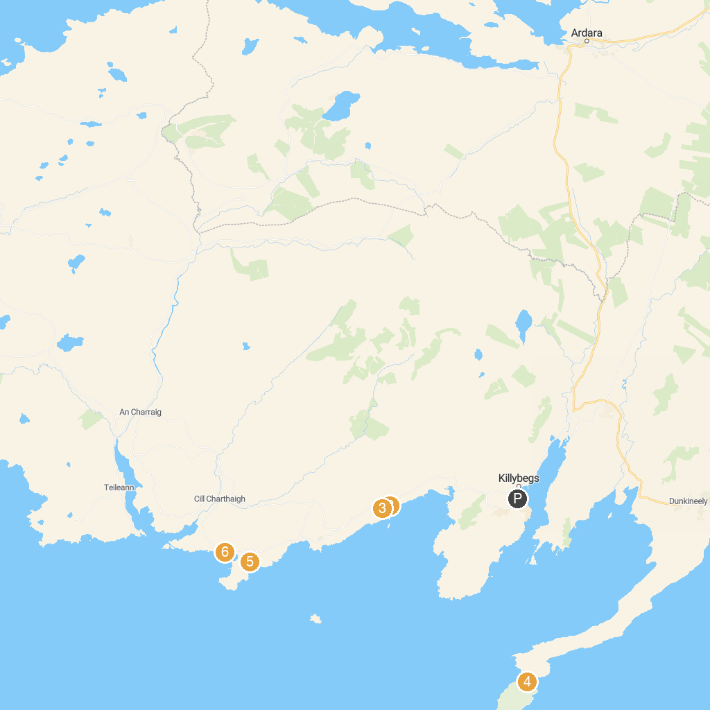
MAP KEY
1. Sliabh Liag Boat Trips | 5. St John's Point Beach
2. Atlantic Coastal Cruises | 6. Trá Bán Beach
3. Secret Waterfall | 7. Wild Atlantic Way Discovery Point @Muckross Head
4. Largy Viewpoint | 8. Salmon Leap
P. Cruise port / terminal
Map © MapTiler © OpenStreetMap contributors · cruiseports.org

