Doha, Qatar
A city where gleaming skyscrapers rise behind dhow-filled harbours and ancient souqs perfumed with oud. Doha packs mosques, museums, sand dunes, and a world-class waterfront into one electric shore day.
⚓ Docked — Grand Cruise Terminal · 🕒 Typical call: 8-10 hrs · 💵 Qatari Riyal (QAR) — USD widely accepted · 🗣️ Arabic (English widely spoken) · 👗 Dress modestly — conservative country
✍️ MY DAY IN PORT (FILL IN)
Ship / Date
In port | arrive ______ · all aboard ______
Booked excursion
Notes / meeting point
GETTING ASHORE
- Docking: Grand Cruise Terminal, Old Doha Port (Corniche) — two berths, docked alongside
- Walk to center: ~10 min walk to Corniche promenade; Souq Waqif 10 min by taxi
- Best For: Islamic art, desert adventures, traditional markets, modern architecture
- Don't Miss: Museum of Islamic Art, Souq Waqif, and a dune-bashing desert safari
GETTING AROUND
- 🚕 Taxi: QAR 13–18 (~$4–5) — Official metered taxis queue outside the terminal. Fare to Souq Waqif or Museum of Islamic Art takes 15–20 minutes; base
- 📱 Rideshare: ✅ Uber
- 🚌 Hop-on hop-off: ✅
TOP THINGS TO DO
- Souq Waqif & Old Doha — Qatar's most atmospheric traditional market, rebuilt to its 19th-century design.
- Museum of Islamic Art — I.M.
- Desert Safari & Inland Sea — The highlight for many visitors: dune-bashing in 4×4s through the sand sea, camel riding, and finishing at Khor Al Adaid — an…
- National Museum of Qatar — Jean Nouvel's desert-rose building is itself a spectacle.
- Dhow Cruise on Doha Bay — Board a traditional wooden dhow for a slow cruise along the Corniche, taking in the mirrored towers of West Bay against the old…
BEST WALKS
- Corniche Waterfront Walk: 2.5 km one-way · Flat · 30-45 min — Exit the terminal and head north along the Corniche promenade.
- Souq Waqif to MIA: 1.5 km · Flat · 20 min walk — Take a taxi to Souq Waqif and explore the market alleyways, then walk south along the waterfront…
WEATHER · DAYLIGHT · MONEY
Month | High °F | Low °F | Rainy days
May | 100 | 80 | 0
Jul | 106 | 87 | 0
Sep | 102 | 83 | 0
Daylight: May 4:49AM–6:11PM · Jul 4:53AM–6:26PM · Sep 5:20AM–5:37PM
cruiseports.org/doha-qatar · Confirm terminal & all-aboard time with your ship

Doha, Qatar — Port Map
Red = walkable sights · Amber = excursions farther out · P = cruise terminal
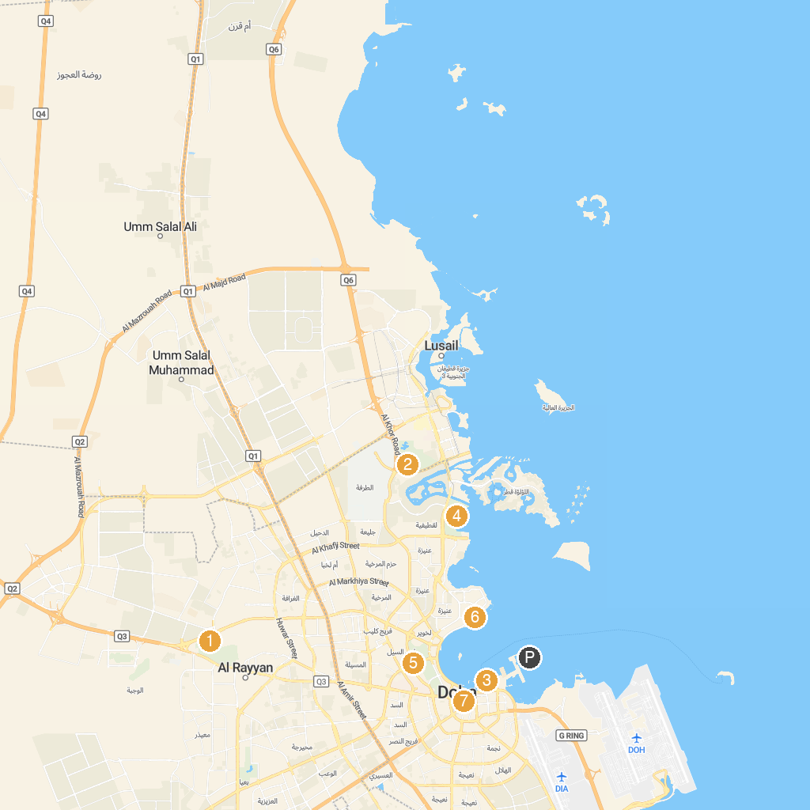
MAP KEY
1. Mathaf: Arab Museum of Modern Art | 5. Fire Station Museum
2. Doha Golf Club | 6. Hotel Park
3. Museum of Islamic Art | 7. Radwani House - Msheireb Museums
4. Katara Multi-Purpose Hall
P. Cruise port / terminal
Map © MapTiler © OpenStreetMap contributors · cruiseports.org

