Djúpivogur, Eastfjords, Iceland
One of Iceland's quietest cruise calls — a Cittaslow fishing village framed by a perfect pyramid mountain, famous for 34 giant egg sculptures along the shore and boat trips to a puffin island most tourists never reach.
⚓ Tender or small pier (varies by ship) · 🕒 Typical call: 6–8 hrs · 💵 Icelandic Króna (ISK) · cards widely accepted · 🗣️ Icelandic (English spoken)
✍️ MY DAY IN PORT (FILL IN)
Ship / Date
In port | arrive ______ · all aboard ______
Booked excursion
Notes / meeting point
GETTING ASHORE
- Docking: Small harbour pier or tender
- Walk to center: 5 min from harbour
- Best For: Scenery · Puffins · Slow travel
- Don't Miss: Eggin í Gleðivík egg sculptures
GETTING AROUND
- 🚕 Taxi: Varies widely — Traditional taxis are scarce in Djúpivogur and must be arranged in advance. Private vehicle transfers are available for
- 📱 Rideshare: ❌ not available
TOP THINGS TO DO
- Eggin í Gleðivík — Eggs of Merry Bay — Thirty-four oversized granite egg sculptures line the harbour shore, each representing a local seabird species.
- Papey Island Puffin Boat Trip — A short boat ride to Papey, a small uninhabited island teeming with Atlantic puffins, eider ducks, and other seabirds.
- Búlandstindur & Eastfjords Scenic Drive — The perfect pyramid of Búlandstindur (1,069 m) looms over the village and is considered a sacred mountain in local lore.
- Vatnajökull & Glacier Day Tour — Djúpivogur sits on the edge of Vatnajökull National Park — Europe's largest glacier is within day-trip range.
BEST WALKS
- Eggin í Gleðivík sculpture trail: ~1.5 km · 25 min · easy, flat — Walk the full egg sculpture trail along the Merry Bay shoreline from the harbour.
- Village & viewpoint stroll: ~2 km · 45 min · easy — A short loop through the tiny village to a viewpoint looking back across the bay towards…
WEATHER · DAYLIGHT · MONEY
Month | High °F | Low °F | Rainy days
May | 45 | 37 | 14
Jul | 55 | 47 | 16
Sep | 51 | 43 | 17
Daylight: May 3:36AM–10:13PM · Sep 6:20AM–7:22PM
cruiseports.org/djupivogur · Confirm terminal & all-aboard time with your ship

Djúpivogur, Eastfjords, Iceland — Port Map
Red = walkable sights · Amber = excursions farther out · P = cruise terminal
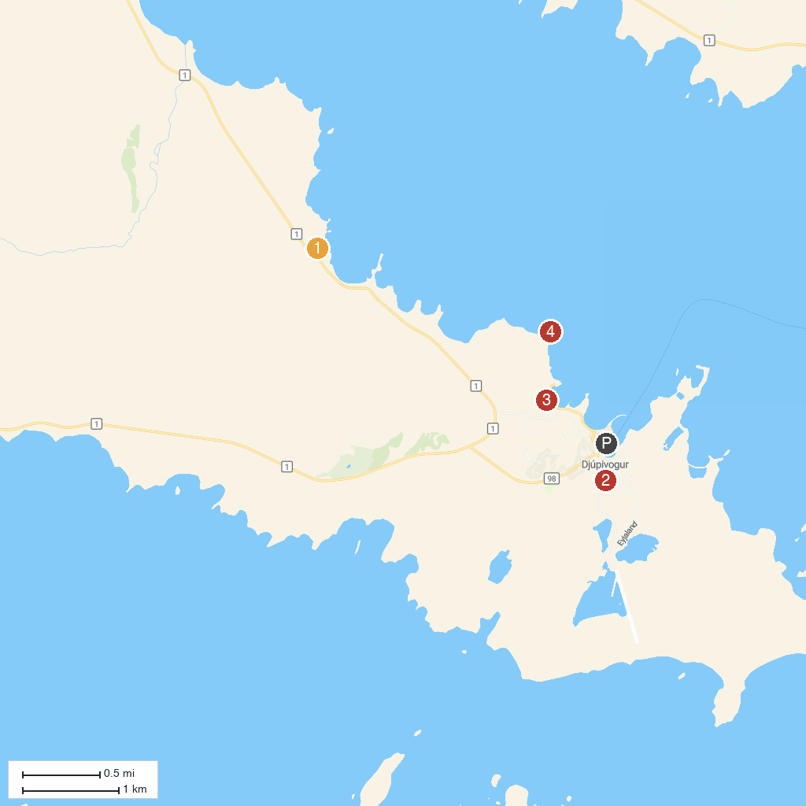
MAP KEY
1. Teigarhorn Natural Monument and Nature Preserve | 4. Djupivogur Lighthouse
2. JFS Handcrafts - Steinasafn - Stonegarden - Free entry | 5. Snædalsfoss (Waterfall)
3. Eggin í Gleðivík
P. Cruise port / terminal
Map © MapTiler © OpenStreetMap contributors · cruiseports.org

