Djúpavík, Westfjords, Iceland
One of the world's most remote cruise calls. A handful of residents, a cathedral-sized herring factory, a tumbling waterfall, and silence so total it rings — Djúpavík is what the edges of the earth actually feel like.
⚓ Tender (Zodiac landing) · 🕒 Typical call: 4–6 hrs · 💳 Cashless (card only) · 🗣️ Icelandic / English · 🧊 Expedition ships only
✍️ MY DAY IN PORT (FILL IN)
Ship / Date
In port | arrive ______ · all aboard ______
Booked excursion
Notes / meeting point
GETTING ASHORE
- Docking: Tender — Zodiacs to a small concrete pier below the factory
- Walk to centre: 1–2 min; everything is within 500 m of the landing
- Best for: Industrial history, photography, dramatic Arctic landscapes
- Don't miss: Inside the old herring factory and the Djúpavíkurfoss waterfall hike
GETTING AROUND
TOP THINGS TO DO
- Old Herring Factory Guided Tour — Step inside the largest concrete building built in Iceland in the 1930s.
- Djúpavíkurfoss Waterfall Hike — A 5-minute walk from the pier reaches the base of this dramatic waterfall tumbling from the cliffs above the village.
- Krossneslaug Geothermal Pool — One of Iceland's most celebrated remote pools at Krossnes, set right on the edge of a stony beach with geothermal water and open…
- Hotel Djúpavík & Local History — The former female workers' dormitory is now a cosy hotel filled with period photos, antique furniture, and Icelandic warmth.
- MS Suðurland Shipwreck & Shoreline Walk — A rusting ship's hull rests on the shoreline just a few minutes' walk from the pier.
BEST WALKS
- Village Loop: Factory, Waterfall & Shipwreck: 1.5 km · 30–40 min · Easy · Free — From the tender pier walk straight ahead to the herring factory entrance (50 m), then follow the…
- Waterfall Summit Trail: 2 km return · 60–90 min · Moderate (steep) · Free — From the waterfall base a marked trail climbs steeply to the plateau above.
cruiseports.org/djupavik · Confirm terminal & all-aboard time with your ship

Djúpavík, Westfjords, Iceland — Port Map
Red = walkable sights · Amber = excursions farther out · P = cruise terminal
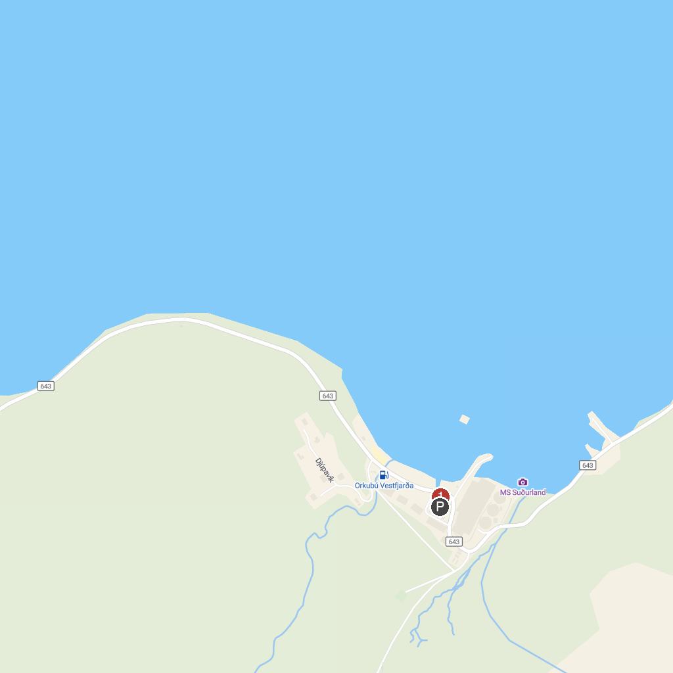
MAP KEY
1. The Sorcerer's Cottage | 3. Djúpavík
2. Whale Watching Hólmavík
P. Cruise port / terminal
Map © MapTiler © OpenStreetMap contributors · cruiseports.org

