Djibouti City, Djibouti
A geopolitical crossroads at the mouth of the Red Sea, Djibouti blends French colonial grandeur, Afar and Somali street life, and otherworldly volcanic landscapes — all from a deep-water industrial port that rarely sees tourists.
⚓ Pier (deep-water port) · 🕒 Typical call: 7-10 hrs · 💵 Djiboutian Franc / USD accepted · 🗣️ French & Arabic · 🌡️ Extremely hot year-round
✍️ MY DAY IN PORT (FILL IN)
Ship / Date
In port | arrive ______ · all aboard ______
Booked excursion
Notes / meeting point
GETTING ASHORE
- Docking: Pier — deep-water berth at Port of Djibouti; mandatory shuttle to city gate
- Walk to center: Not walkable from pier; shuttle to Place Menelik (~10 min)
- Best For: Off-the-beaten-path culture, volcanic day trips, Yemeni cuisine
- Don't Miss: Lake Assal (lowest point in Africa) if ship is in port 8+ hours
GETTING AROUND
- 🚕 Taxi: $5–$15 USD — Taxis wait outside the port and are the primary transport option. Fares are unmetered — agree on the price before you ge
- 📱 Rideshare: ❌ not available
TOP THINGS TO DO
- Lake Assal Day Trip — Africa's lowest point at 155 m below sea level — a hypersaline crater lake surrounded by black lava fields and blinding salt pans…
- Moucha Island Snorkeling — A 30–45 minute boat ride from L'Escale Marina to a pristine desert island with white sand beaches, turquoise water, and healthy…
- Djibouti City Walking Tour — Explore the colonial European Quarter from Place Menelik, the bustling African Quarter markets, and the 1906 Hamoudi Mosque.
- Decan Wildlife Refuge — Thirty minutes outside the city, this refuge shelters endangered African species including cheetahs, caracals, lions, and…
- Yemeni Baked Fish Lunch — Djibouti's iconic dish — fresh sea bass or kingfish split and baked in a clay tandoor oven with spiced red pepper paste.
BEST WALKS
- European Quarter & Hamoudi Mosque Loop: 2 km · 45–60 min · Easy — Start at Place Menelik and take in the whitewashed French colonial architecture.
WEATHER · DAYLIGHT · MONEY
Month | High °F | Low °F | Rainy days
May | 93 | 83 | 5
Jul | 105 | 89 | 2
Sep | 99 | 86 | 1
Daylight: May 5:44AM–6:23PM · Jul 5:51AM–6:35PM · Sep 5:57AM–6:07PM
cruiseports.org/djibouti · Confirm terminal & all-aboard time with your ship

Djibouti City, Djibouti — Port Map
Red = walkable sights · Amber = excursions farther out · P = cruise terminal
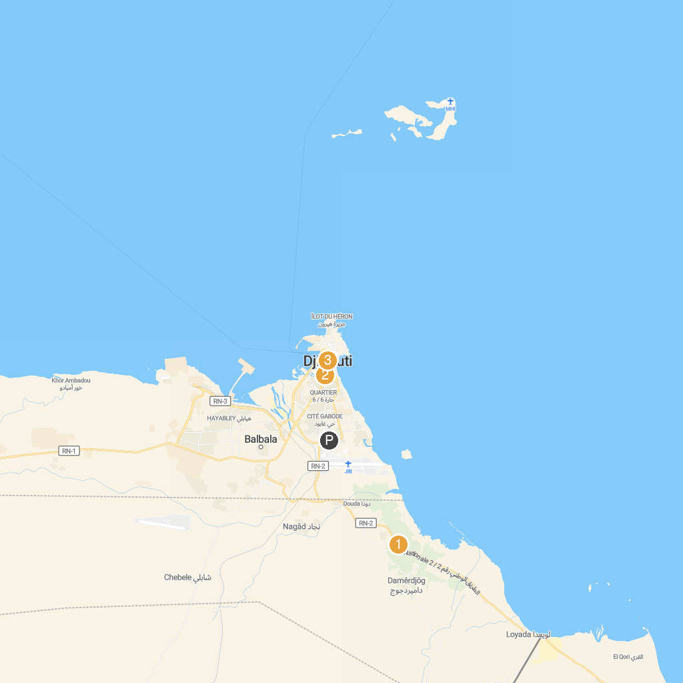
MAP KEY
1. DECAN Refuge | 3. The People's Palace
2. Mosquée Al-Hamoudi
P. Cruise port / terminal
Map © MapTiler © OpenStreetMap contributors · cruiseports.org

