Disney Lookout Cay, Eleuthera, Bahamas
Opened in 2024 on the southern tip of Eleuthera, Disney's second private island puts Bahamian culture center stage — Junkanoo parades, pink-sand beaches, and Disney characters in festival wear.
⚓ Pier (docked) · 🕒 Typical call: 7-9 hrs · 💵 USD / Key to the World card · 🗣️ English · 🏖️ Private island — Disney Cruise Line only
✍️ MY DAY IN PORT (FILL IN)
Ship / Date
In port | arrive ______ · all aboard ______
Booked excursion
Notes / meeting point
GETTING ASHORE
- Docking: Pier — long 0.5–0.8 mi walk from ship, then tram to beach
- Best For: Families, Disney fans, beach days, Bahamian culture
- Don't Miss: Rush! — the live Junkanoo parade at the Goombay Cultural Center
- Exclusive To: Disney Cruise Line (Magic, Dream, Fantasy, Wish, Destiny)
GETTING AROUND
TOP THINGS TO DO
- Rush! — Junkanoo Parade — The heart of Lookout Cay: a live high-energy Bahamian Junkanoo celebration with local performers, brass instruments, and Disney…
- Snorkeling the Reef — Rent snorkel gear and explore the vibrant reef off the Family Beach.
- Serenity Bay (Adults Only) — A quieter, 18+ beach section with its own BBQ buffet, bar, and optional private cabanas.
- Private Cabana — Family cabanas at Mabrika Cove and adults-only cabanas at Serenity Bay include shaded lounge areas, a stocked mini-fridge, and…
- Kayak & Banana Boat — Paddle the calm coves in a kayak or hang on for a laughing, splashing banana boat ride.
BEST WALKS
- Mabrika Cove to Family Beach: ~5 min | Flat | Sun-exposed — Walk from the tram arrival point at Mabrika Cove to the main Family Beach.
- Family Beach to Serenity Bay: ~10 min | Flat | Adults only section — Continue past the Family Beach along the path to the adults-only Serenity Bay at the far end of the…
WEATHER · DAYLIGHT · MONEY
Month | High °F | Low °F | Rainy days
May | 64 | 42 | 11
Jul | 78 | 58 | 10
Sep | 68 | 52 | 10
Daylight: May 5:19AM–8:18PM · Jul 5:16AM–8:39PM · Sep 6:31AM–7:02PM
cruiseports.org/disney-lookout-cay · Confirm terminal & all-aboard time with your ship

Disney Lookout Cay, Eleuthera, Bahamas — Port Map
Red = walkable sights · Amber = excursions farther out · P = cruise terminal
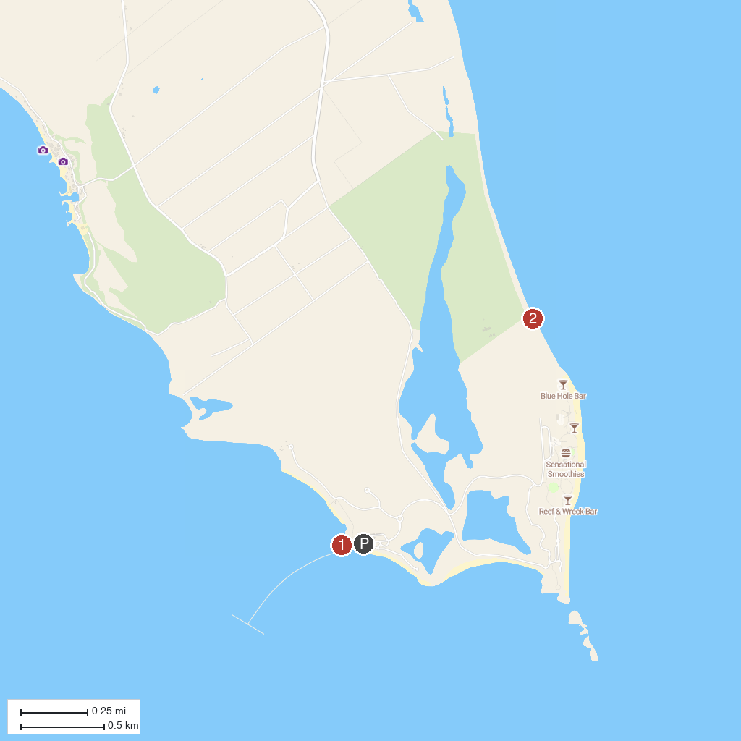
MAP KEY
1. Disney Lighthouse Point Marina | 2. Disney’s Lookout Cay at Lighthouse Point
P. Cruise port / terminal
Map © MapTiler © OpenStreetMap contributors · cruiseports.org

