Castaway Cay, Bahamas
Disney's private Bahamian island is the kind of shore day that makes kids forget they're on a ship — and makes parents forget to worry. Ships dock right at the pier, the BBQ lunch is on the house, and characters show up in their beach clothes.
⚓ Pier (direct dock) · 🕒 Typical call: 7-9 hrs · 💵 USD / Key to the World card · 🗣️ English · 🏖️ Disney Cruise Line exclusive
✍️ MY DAY IN PORT (FILL IN)
Ship / Date
In port | arrive ______ · all aboard ______
Booked excursion
Notes / meeting point
GETTING ASHORE
- Docking: Direct pier — no tenders
- Access: Disney Cruise Line guests only
- Best For: Families, couples, beach days with no hassle
- Don't Miss: Pelican Plunge floating water park (free)
GETTING AROUND
- 📱 Rideshare: ❌ not available
TOP THINGS TO DO
- Family Beach & Pelican Plunge (Included) — The main beach has calm, clear water, complimentary chairs, umbrellas, and towels.
- Serenity Bay Adult Beach (Included) — Adults-only stretch of beach on the far side of the island with its own BBQ lunch spot, bar, and calmer vibe.
- Snorkeling the 22-Acre Lagoon — Explore a purpose-built snorkeling lagoon with sunken Disney-themed surprises — a submarine, a sunken ship, and a Mickey Mouse…
- Castaway Ray's Stingray Adventure — A guided educational experience where you wade into an enclosed lagoon to feed and touch southern stingrays under Cast Member…
- Castaway Cay 5K — A complimentary, self-paced 3.1-mile run or walk along the island's paved paths.
BEST WALKS
- Pier to Family Beach Stroll: ~0.3 miles · 5 min · flat paved path — Walk straight from the gangway past the Kargo Handling tram stop through a lush, themed corridor to…
- Island Explorer Walk to Mount Rustmore: ~1 mile loop · 20 min · flat — From the Family Beach, follow the paved path past Pelican Point toward Mount Rustmore — a giant…
WEATHER · DAYLIGHT · MONEY
Month | High °F | Low °F | Rainy days
May | 79 | 76 | 12
Jul | 84 | 81 | 15
Sep | 84 | 81 | 16
Daylight: May 6:23AM–7:49PM · Jul 6:27AM–8:04PM · Sep 6:56AM–7:13PM
cruiseports.org/disney-castaway-cay · Confirm terminal & all-aboard time with your ship

Castaway Cay, Bahamas — Port Map
Red = walkable sights · Amber = excursions farther out · P = cruise terminal
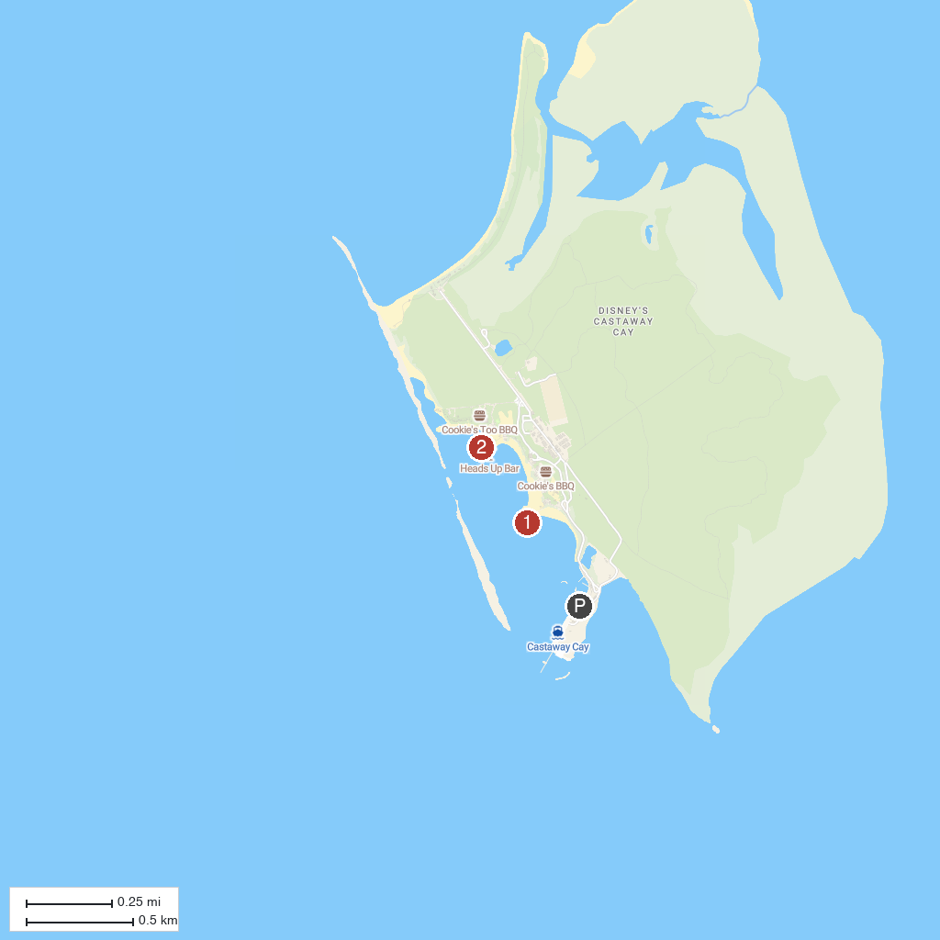
MAP KEY
1. Castaway Ray's Stingray Adventure | 2. Pelican Plunge
P. Cruise port / terminal
Map © MapTiler © OpenStreetMap contributors · cruiseports.org

