Dingle, County Kerry, Ireland
A colorful fishing town tucked into a sheltered bay on Ireland's wild southwest coast, Dingle is all stone pubs, fresh crab, ancient beehive huts, and some of the most dramatic Atlantic scenery on earth.
⚓ Tender port · 🕒 Typical call: 6-8 hrs · 💵 Euro (€) · 🗣️ English & Irish (Gaeilge)
✍️ MY DAY IN PORT (FILL IN)
Ship / Date
In port | arrive ______ · all aboard ______
Booked excursion
Notes / meeting point
GETTING ASHORE
- Docking: Tender — ships anchor in bay, tenders to marina pier
- Walk to center: ~5 min from tender pier to Dingle town center
- Best For: Scenic drives, Irish culture, seafood, archaeology
- Don't Miss: Slea Head Drive & Gallarus Oratory
GETTING AROUND
- 🚕 Taxi: €5–€10 — Licensed taxis wait at Dingle Marina. Short hops within town are typically €5–€10. Longer excursions to Slea Head or the
- 📱 Rideshare: ✅ Uber
TOP THINGS TO DO
- Slea Head Drive — The classic loop around the tip of the Dingle Peninsula takes in towering sea cliffs, Blasket Islands views, Iron Age forts, and…
- Gallarus Oratory & Dunbeg Fort — Visit the perfectly preserved 8th-century dry-stone oratory at Gallarus — one of the best-preserved early Christian buildings in…
- Blasket Islands Boat Trip — Take a boat out to the Great Blasket Island — an uninhabited island with a remarkable literary heritage and abundant wildlife…
- Dingle Distillery Tour — The award-winning Dingle Distillery crafts single malt whiskey, gin, and vodka in small batches.
- Inch Beach — A three-mile Blue Flag beach with dramatic Atlantic surf, Inch Beach is one of Ireland's most photogenic strands — ideal for a…
BEST WALKS
- Dingle Harbour & Town Stroll: ⏱ 45 min · 🚶 Easy · 📍 Flat — A leisurely loop from the marina pier along the harbor front, past the Fungie dolphin statue, up…
- Up to the Conor Pass Viewpoint (by taxi/tour): ⏱ 1.5 hrs · 🚗 Taxi/tour needed · 🏔️ Dramatic views — Take a taxi up to Conor Pass, the highest mountain pass in Ireland, for sweeping views over the…
WEATHER · DAYLIGHT · MONEY
Month | High °F | Low °F | Rainy days
May | 61 | 48 | 13
Jul | 64 | 54 | 15
Sep | 64 | 52 | 15
Daylight: May 5:27AM–6:04PM · Jul 5:34AM–6:16PM · Sep 5:39AM–5:49PM
cruiseports.org/dingle · Confirm terminal & all-aboard time with your ship

Dingle, County Kerry, Ireland — Port Map
Red = walkable sights · Amber = excursions farther out · P = cruise terminal
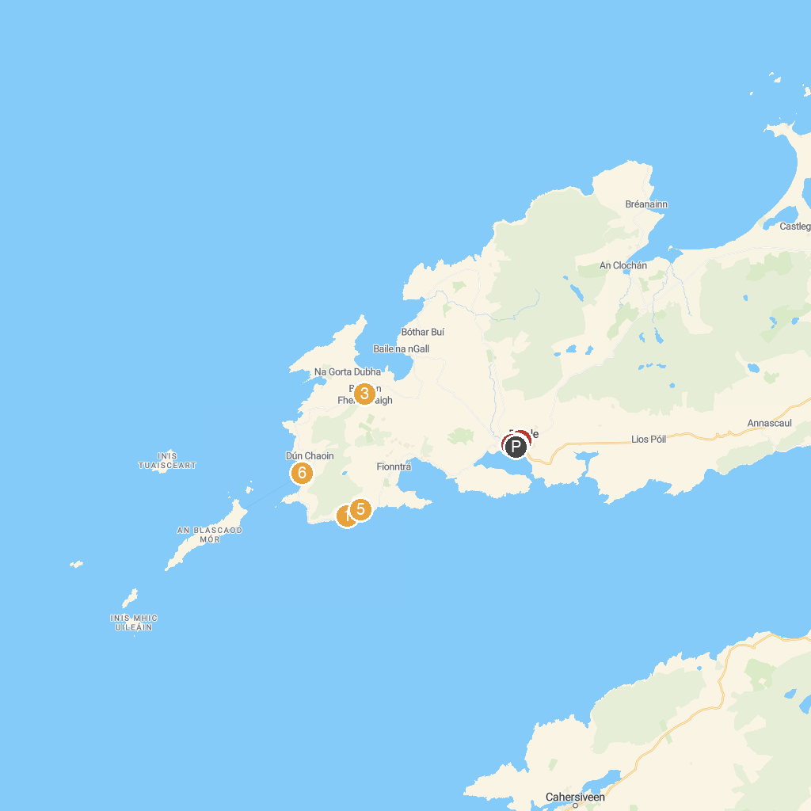
MAP KEY
1. Beehive Hut (Tóchar Maothaithe) | 5. Dingle Sheepdog Demonstrations
2. St. Mary's Church, Dingle | 6. Cé Dhún Chaoin / Dunquin Pier
3. Músaem Chorca Dhuibhne | 7. Dingle Oceanworld Aquarium
4. Dingle Sea Safari
P. Cruise port / terminal
Map © MapTiler © OpenStreetMap contributors · cruiseports.org

