Dili, Timor-Leste
One of the world's youngest nations and most raw cruise destinations, Dili delivers a rare mix of poignant independence history, Portuguese colonial atmosphere, and stunning untouched reef diving — all without a souvenir mall in sight.
⚓ Pier (most ships dock) · 🕒 Typical call: 8-10 hrs · 💵 USD (US Dollar) · 🗣️ Tetum & Portuguese · 🤿 World-class reef diving
✍️ MY DAY IN PORT (FILL IN)
Ship / Date
In port | arrive ______ · all aboard ______
Booked excursion
Notes / meeting point
GETTING ASHORE
- Docking: Pier at Port of Dili for most ships; very large vessels may tender
- Walk to center: 10–15 min (1 km) to city centre along the waterfront
- Best For: History, culture, snorkelling & diving, off-the-beaten-path adventure
- Don't Miss: Cristo Rei statue, Resistance Museum, Tais Market, Timor coffee
GETTING AROUND
- 🚕 Taxi: $5–$15 USD — Most common option; fares are negotiated upfront as meters are rarely used. Agree on a price before getting in — short c
TOP THINGS TO DO
- Cristo Rei of Dili — A 27 m statue of Christ atop a globe at the tip of a headland — a gift from Indonesia in 1996.
- Timorese Resistance Archive & Museum (AMRT) — A world-class museum dedicated to East Timor's 24-year fight against Indonesian occupation.
- Atauro Island Snorkel & Dive — Just 25 km north of Dili, Atauro Island's reefs are recognized by Conservation International as among the most biodiverse in the…
- Tais Market & Old Town Stroll — Browse the open-air Tais Market for hand-woven Timorese textiles, bags, and jewelry — unique, authentic, and bought directly from…
- Santa Cruz Cemetery & Chega! Prison Exhibition — In 1991 Indonesian forces fired on mourners at Santa Cruz Cemetery, killing 250+ — the massacre was filmed and galvanized…
BEST WALKS
- Port to City Centre Waterfront Walk: 1 km · ~15 min · Flat — Head east from the port gates along Avenida de Portugal past the Portuguese embassy quarter…
- City Centre to Resistance Museum: ~1 km from city centre · ~20 min from port · Flat — From the Tais Market, continue inland to the Timorese Resistance Archive and Museum (AMRT).
WEATHER · DAYLIGHT · MONEY
Month | High °F | Low °F | Rainy days
May | 88 | 77 | 11
Jul | 87 | 73 | 5
Sep | 89 | 73 | 6
Daylight: May 6:42AM–6:25PM · Jul 6:53AM–6:33PM · Sep 6:31AM–6:34PM
cruiseports.org/dili · Confirm terminal & all-aboard time with your ship

Dili, Timor-Leste — Port Map
Red = walkable sights · Amber = excursions farther out · P = cruise terminal
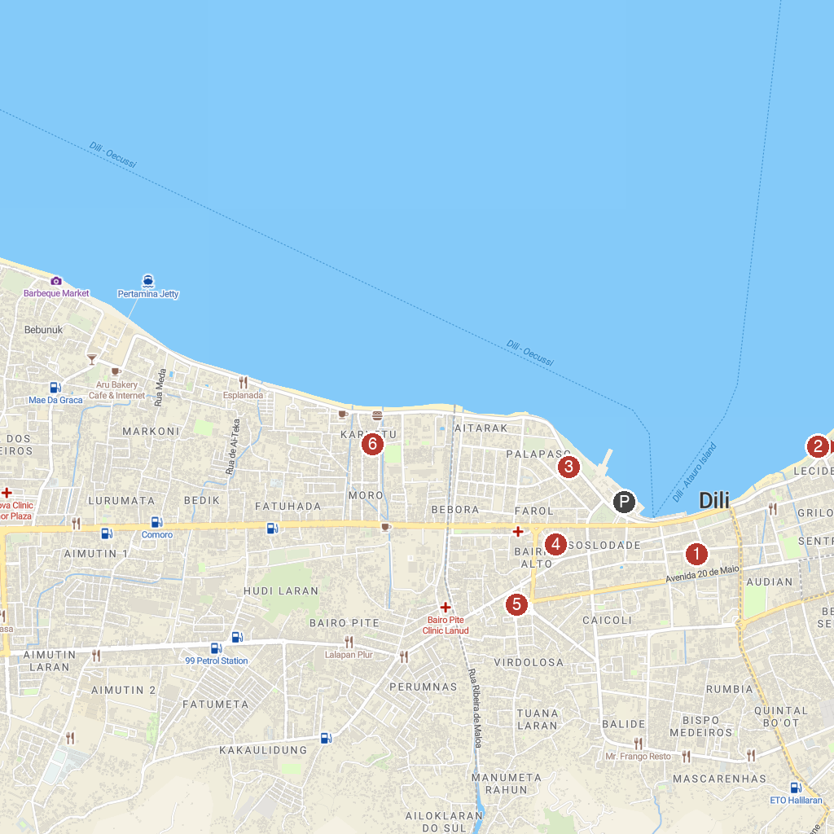
MAP KEY
1. Timorese Resistance Archive & Museum | 4. Tais Market
2. Largo de Lecidere | 5. Immaculate Conception Cathedral
3. Church of Saint Anthony of Motael | 6. An-Nur Mosque
P. Cruise port / terminal
Map © MapTiler © OpenStreetMap contributors · cruiseports.org

