Dieppe, Normandy, France
France's oldest seaside resort perches beneath towering chalk cliffs on the Alabaster Coast — home to a famous WWII raid, the best scallops in Normandy, and a market voted the finest in France.
⚓ Docked (small/mid-size ships only) · 🕒 Typical call: 7-9 hrs · 💶 Currency: Euro (€) · 🗣️ Language: French · 🏖️ Pebble beach
✍️ MY DAY IN PORT (FILL IN)
Ship / Date
In port | arrive ______ · all aboard ______
Booked excursion
Notes / meeting point
GETTING ASHORE
- Docking: Ships up to ~160 m dock at Quai Henri IV / Bassin de Paris; mega-ships cannot enter harbor
- Walk to Center: Steps from the gangway — pier is in the heart of town
- Best For: History buffs, foodies, market lovers, cliff walkers
- Don't Miss: Château-Musée de Dieppe ivory collection and a seafood lunch on Quai Henri IV
GETTING AROUND
- 🚕 Taxi: €10–€14 — Taxis queue at the ferry terminal after arrivals. Roughly €10–12 to the town center (≈2 km, 5–7 min) and €12–14 to the t
- 📱 Rideshare: ✅ Uber
TOP THINGS TO DO
- Château-Musée de Dieppe — A 14th-century cliff-top castle housing one of Europe's finest collections of carved ivory — Dieppe was once the world center of…
- Dieppe Raid Memorial Museum — Housed in a 19th-century theater, this moving museum commemorates the August 1942 Jubilee Raid where over 900 Canadian soldiers…
- Saturday Grand Market — Voted the Finest Market in France in 2020, Dieppe's Saturday market spreads across the town center with Norman cheeses, fresh…
- Alabaster Coast Cliff Walk — Dieppe sits on the famous Côte d'Albâtre — the same dramatic chalk cliffs Monet painted at Étretat.
- Normandy Seafood Lunch on Quai Henri IV — Dieppe is the scallop capital of France — the Quai Henri IV waterfront promenade is lined with seafood brasseries serving fresh…
BEST WALKS
- Town Center & Waterfront Loop: 2-3 km · 45-60 min · Easy · Free — From the pier, walk along the Quai Henri IV marina to the Grande Rue pedestrian shopping street…
- Cliffside Chapel Panorama: 3-4 km · 60-75 min · Moderate (steep stairs) · Free — Head east along the seafront promenade past the pebble beach to the base of the eastern cliff, then…
WEATHER · DAYLIGHT · MONEY
Month | High °F | Low °F | Rainy days
May | 62 | 49 | 12
Jul | 71 | 59 | 10
Sep | 68 | 56 | 12
Daylight: May 6:10AM–9:34PM · Jul 6:04AM–9:58PM · Sep 7:32AM–8:08PM
cruiseports.org/dieppe · Confirm terminal & all-aboard time with your ship

Dieppe, Normandy, France — Port Map
Red = walkable sights · Amber = excursions farther out · P = cruise terminal
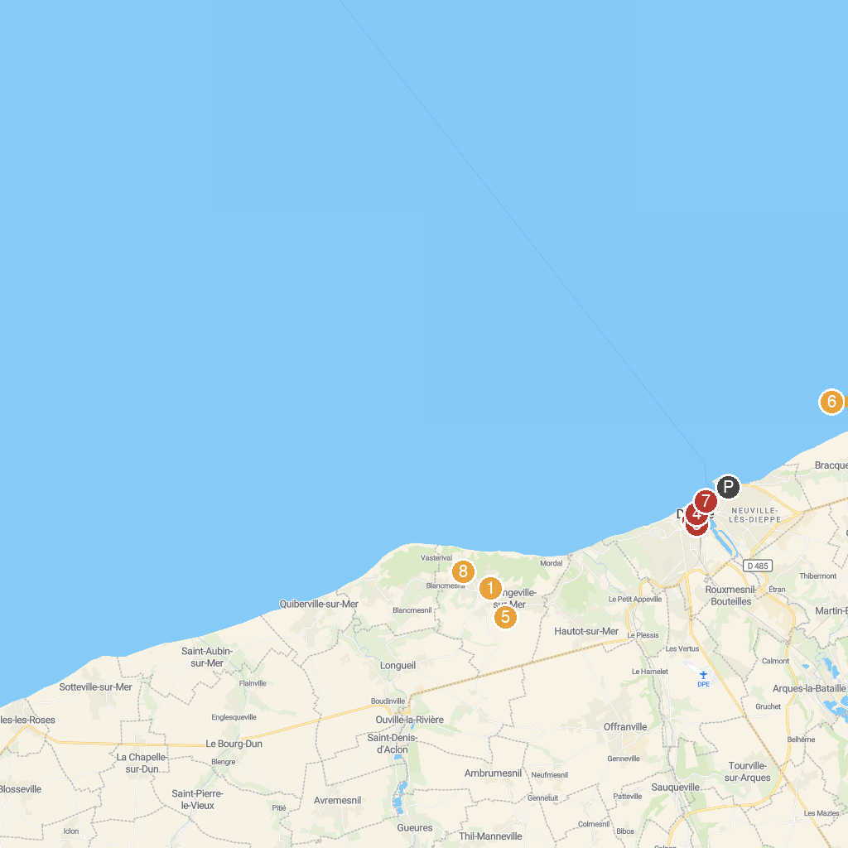
MAP KEY
1. Museum Michel Ciry | 5. Jardin Shamrock
2. Church of Saint Jacques | 6. Museum of the History of Everyday Life
3. Dieppe Ville d'art Et d'histoire | 7. Musée Estran Cité de la Mer
4. Navigation Normandy - Dieppe, Promenade and sea fishing | 8. Bois des Moutiers
P. Cruise port / terminal
Map © MapTiler © OpenStreetMap contributors · cruiseports.org

