Devonport, Tasmania, Australia
Tasmania's northwest gateway blends maritime heritage with wild hinterland — home to ancient Aboriginal rock carvings, a striped lighthouse on volcanic headland, and some of the world's best platypus spotting, all within easy reach of Cradle Mountain.
⚓ Pier port (no tender) · 🕒 Typical call: 6–8 hrs · 💵 Australian Dollar (AUD) · 🗣️ English · 🌿 World Heritage wilderness day trips
✍️ MY DAY IN PORT (FILL IN)
Ship / Date
In port | arrive ______ · all aboard ______
Booked excursion
Notes / meeting point
GETTING ASHORE
- Docking: Pier — East Devonport wharf; shuttle or Torquay Ferry to CBD
- Walk to center: 5 min from West berth; 15–20 min shuttle ride from East
- Best For: Nature, wildlife, heritage railways, Tasmanian food & gin
- Don't Miss: Mersey Bluff Lighthouse & Aboriginal rock carvings
GETTING AROUND
- 🚕 Taxi: A–25 — Regulated taxis serve Devonport with metered fares (flagfall ~A.90, ~A.68/km). The city center is roughly 5–7 km from th
- 📱 Rideshare: ✅ Uber
TOP THINGS TO DO
- Cradle Mountain Day Trip — The crown jewel of Tasmanian wilderness — jagged dolerite peaks reflected in Dove Lake, roaming wombats, and ancient pencil-pine…
- Don River Railway — Volunteer-run heritage railway that steams through bushland along the Don River to Coles Beach.
- Platypus Spotting — Tasmanian Arboretum — The 120-hectare Tasmanian Arboretum in Eugenana (15 min drive) is one of the world's most reliable spots to see wild platypuses.
- Bass Strait Maritime Centre — Explore the treacherous history of the Bass Strait crossing through interactive exhibits — including a ship simulator where you…
- House of Anvers Chocolate & Latrobe — Drive 10 minutes to Latrobe for House of Anvers, a Belgian-style chocolate factory with free tastings and a chocolate museum.
BEST WALKS
- Mersey Bluff & Lighthouse Headland: 3 km one-way | Easy | 45 min — Walk west from the CBD along the river foreshore, past the Bass Strait Maritime Centre, and out to…
- Coles Beach Coastal Pathway: 3.5 km one-way | Easy | 50 min — Continue past the lighthouse along the flat coastal track to Coles Beach — a long stretch of Bass…
WEATHER · DAYLIGHT · MONEY
Month | High °F | Low °F | Rainy days
May | 58 | 45 | 11
Jul | 54 | 42 | 15
Sep | 58 | 43 | 11
Daylight: May 7:15AM–5:05PM · Jul 7:36AM–5:04PM · Sep 6:16AM–6:03PM
cruiseports.org/devonport-tasmania · Confirm terminal & all-aboard time with your ship

Devonport, Tasmania, Australia — Port Map
Red = walkable sights · Amber = excursions farther out · P = cruise terminal
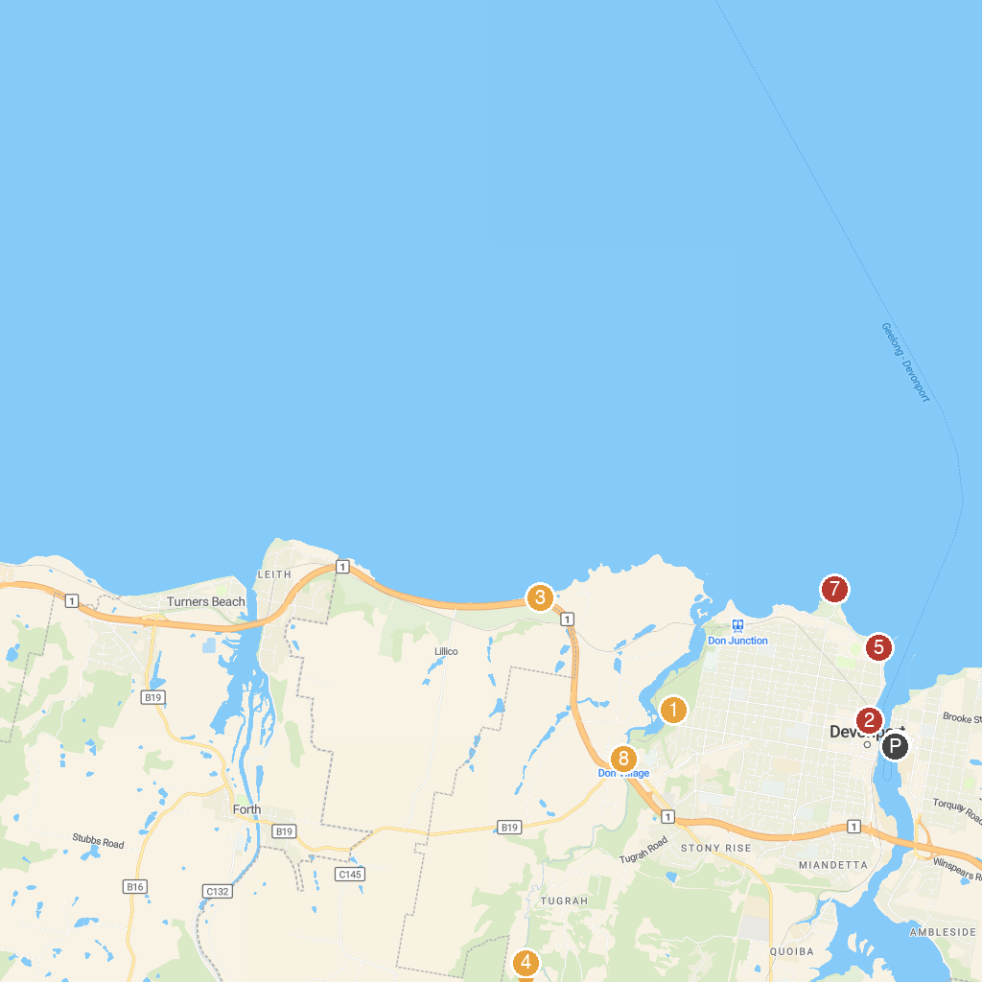
MAP KEY
1. Don Reserve | 5. Bass Strait Maritime Museum
2. Roundhouse Park | 6. Spirit of Tasmania Devonport
3. Penguin Viewing Platform | 7. Mersey Bluff Lighthouse
4. Tasmanian Arboretum | 8. Don River Railway
P. Cruise port / terminal
Map © MapTiler © OpenStreetMap contributors · cruiseports.org

