Deventer, Overijssel, Netherlands
One of the Netherlands' oldest Hanseatic cities, Deventer rewards river cruise passengers with medieval lanes, a lively market square, and a spice-cake tradition stretching back to 1593.
⚓ River quay (docked) · 🕒 Typical call: 6–8 hrs · 💶 Euro (€) · 🗣️ Dutch (English widely spoken)
✍️ MY DAY IN PORT (FILL IN)
Ship / Date
In port | arrive ______ · all aboard ______
Booked excursion
Notes / meeting point
GETTING ASHORE
- Docking: River quayside on the IJssel — no tendering, short walk to the medieval center
- Walk to center: 10–15 min from riverfront to De Brink market square
- Best For: Medieval architecture, Hanseatic history, local food (Deventer koek), leisurely strolls
- Don't Miss: Deventer koek spice cake from a bakery on the Brink, and the foot ferry across the IJssel
GETTING AROUND
- 🚕 Taxi: €8–€12 — Local taxis (Staxi, GoByTaxi) operate in Deventer with a base fare of ~€5 plus €1.80/km. Fixed-rate bookings are availab
- 📱 Rideshare: ✅ Uber
TOP THINGS TO DO
- Bergkwartier Medieval Quarter — The old trading heart of Deventer, the Bergkwartier is a maze of narrow cobblestone streets lined with restored merchants' houses…
- Museum De Waag — Housed in one of the Netherlands' oldest surviving weigh houses on De Brink square, this museum tells the story of Deventer's…
- Speelgoedmuseum (Toy Museum) — Two historic merchant's houses hold the Netherlands' largest toy collection, spanning over a century of Dutch and international…
- St. Lebuinus Church & Tower Climb — The Gothic Lebuinus Church dominates the Grote Kerkhof square.
- Deventer Koek & Brink Terrace — Deventer has been baking its famous spice cake since 1593 — pick up a loaf at a bakery near De Brink, then settle in at an…
BEST WALKS
- Riverfront to Brink — The Essential Deventer Loop: 2–3 km · 45–60 min · Easy, flat cobblestones — From the IJssel quay, follow the riverside promenade north past the Wilhelminabrug bridge, then…
- Foot Ferry & Skyline View: ~1 km round trip · 20 min · Easy — Hop the Pontje foot ferry (a few euros) from the east bank quay to the Worpplantsoen park on the…
WEATHER · DAYLIGHT · MONEY
Month | High °F | Low °F | Rainy days
May | 64 | 48 | 11
Jul | 73 | 58 | 14
Sep | 67 | 53 | 11
Daylight: May 5:40AM–9:23PM · Jul 5:32AM–9:49PM · Sep 7:10AM–7:49PM
cruiseports.org/deventer · Confirm terminal & all-aboard time with your ship

Deventer, Overijssel, Netherlands — Port Map
Red = walkable sights · Amber = excursions farther out · P = cruise terminal
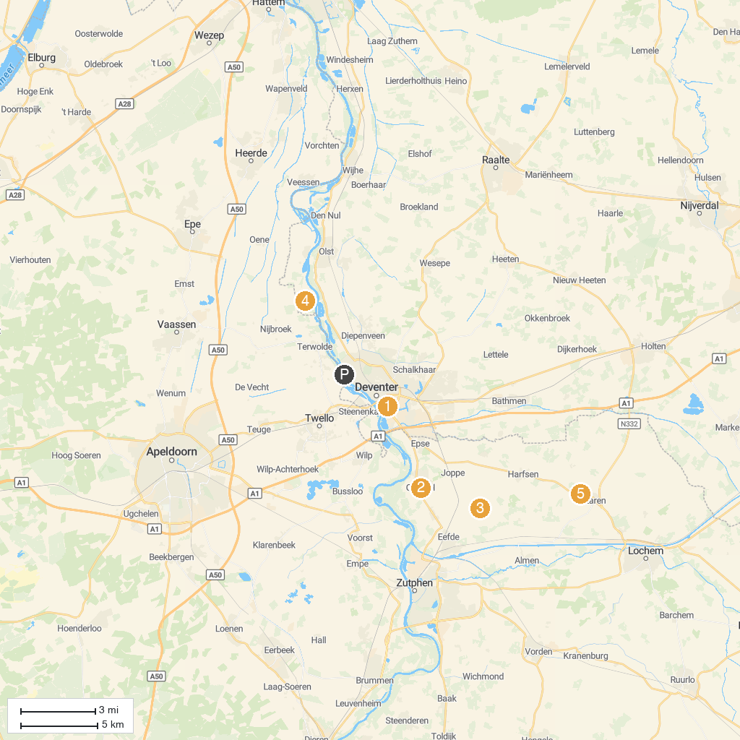
MAP KEY
1. Musea Zutphen | 5. LAACC-Bunker
2. Kunstenlab | 6. Unieke Uitjes
3. MORE Museum | 7. Natuurmuseum Holterberg
4. Gorsselse | 8. Basilica van De Heilige Kruisverheffing
P. Cruise port / terminal
Map © MapTiler © OpenStreetMap contributors · cruiseports.org

