Dessau-Rosslau, Saxony-Anhalt, Germany
Where the modernist genius of Bauhaus meets the sweeping English-style parklands of the Garden Kingdom — all framed by the wild Elbe floodplain. A short Elbe river stop that punches well above its weight.
⚓ Docked (river pontoon pier) · 🕒 Typical call: 6–8 hrs · 💶 Euro (€) · 🗣️ German (English at UNESCO sites) · 🚲 Very bike-friendly
✍️ MY DAY IN PORT (FILL IN)
Ship / Date
In port | arrive ______ · all aboard ______
Booked excursion
Notes / meeting point
GETTING ASHORE
- Docking: Tied alongside river pontoon at Leopoldshafen (Dessau side) or Roßlau pier
- Walk to center: ~2.5 km / 30 min from Leopoldshafen pier through Georgium Park
- Best For: Architecture fans, history buffs, cyclists, UNESCO lovers
- Don't Miss: Kornhaus Bauhaus restaurant right at the pier; Bauhaus Building; Georgium Park
GETTING AROUND
- 🚕 Taxi: €19–29 — Taxis run from the Rosslau cruise dock to Dessau city center (~7 km). Base fare €4, then €2.20–€3.50/km; daytime rates a
TOP THINGS TO DO
- Bauhaus Building & Masters' Houses — The 1925 Bauhaus Building designed by Walter Gropius is the icon of modern architecture — a UNESCO World Heritage Site.
- Bauhaus Museum Dessau — Opened in 2019, this striking 'black box' museum in the city center holds the world's second-largest Bauhaus collection — over…
- Georgium Palace & Park — An English-style landscape park closest to the Leopoldshafen pier, featuring mock-Roman ruins, ponds, and the Anhalt Art Gallery…
- Wörlitz Park & Palace — The crown jewel of the UNESCO Garden Kingdom, 15 km east of the pier.
- Hugo Junkers Technical Museum — Dedicated to Dessau's aviation pioneer Hugo Junkers, creator of the famous Ju 52 aircraft.
BEST WALKS
- Pier to Bauhaus: Georgium Park Stroll: 2.5 km · 30 min · Easy · Flat — From the Leopoldshafen pier, walk through the leafy Georgium Park, passing mock-Roman ruins and the…
- Elbe Riverbank to Kornhaus: Under 1 km · 10 min · Easy — From the ship gangway, walk along the Elbe embankment to the iconic Kornhaus — the Bauhaus-designed…
cruiseports.org/dessau-rosslau · Confirm terminal & all-aboard time with your ship

Dessau-Rosslau, Saxony-Anhalt, Germany — Port Map
Red = walkable sights · Amber = excursions farther out · P = cruise terminal
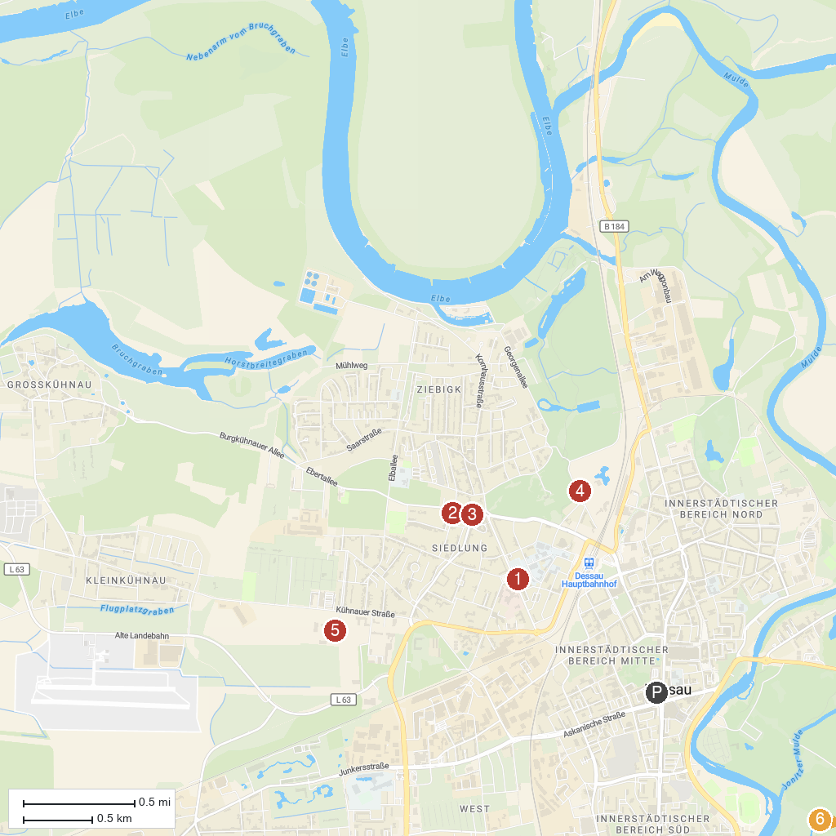
MAP KEY
1. Wörlitzer Park | 5. Falconry "Wörlitzer Park"
2. Bauhaus Dessau | 6. Dessau, Lehrpark für Tier und Pflanzenkunde Zoo
3. Meisterhaus Kandinsky | Klee | 7. Technikmuseum Hugo Junkers
4. Masters' Houses | 8. Middle Elbe Biosphere Reserve
P. Cruise port / terminal
Map © MapTiler © OpenStreetMap contributors · cruiseports.org

