Deshaies, Guadeloupe, French Caribbean
A sun-warmed French fishing village on Basse-Terre's volcanic coast — where Creole soul meets tropical garden and the BBC filmed its hit mystery series. Small, beautiful, and refreshingly unhurried.
⚓ Tender port (no pier) · 🕒 Typical call: 6–8 hrs · 💶 Currency: Euro (€) · 🗣️ Language: French · 🎬 Death in Paradise filming location
✍️ MY DAY IN PORT (FILL IN)
Ship / Date
In port | arrive ______ · all aboard ______
Booked excursion
Notes / meeting point
GETTING ASHORE
- Docking: Tender — ships anchor in the bay; boats land at the village quay
- Walk to center: Immediate — tender pier is on the village waterfront
- Best For: Botanical garden, Grande Anse Beach, authentic Creole dining
- Don't Miss: Jardin Botanique de Deshaies and Grande Anse Beach
GETTING AROUND
- 🚕 Taxi: €85–€129+ per taxi — Taxis wait near the waterfront on port days but supply is limited — pre-booking is advised. Fares to Pointe-à-Pitre run
- 📱 Rideshare: ❌ not available
TOP THINGS TO DO
- Jardin Botanique de Deshaies — A 17-acre tropical garden with waterfalls, exotic birds (flamingos, parrots), and sweeping views over the bay.
- Grande Anse Beach — One of Guadeloupe's most beautiful beaches — broad golden sand, clear turquoise water, and palm-tree shade, about 2.5 km north of…
- Death in Paradise Filming Locations — Deshaies is the real-life 'Honoré' from the long-running BBC mystery series.
- Snorkeling at the Cousteau Reserve — The Jacques Cousteau Underwater Reserve near Malendure (30 min south) offers some of the Caribbean's best protected snorkeling…
- Creole Village Lunch — Deshaies's waterfront restaurants serve authentic Guadeloupean Creole cooking — accras de morue (salt-cod fritters), grilled…
BEST WALKS
- Village to Grande Anse Beach: 2.5 km · 25–30 min · Easy–Moderate — From the village quay, head north along the main road through the village, past the colourful…
- Village waterfront stroll: 0.5 km · 15 min · Easy — Wander the village seafront — the fishing port, the market, and the colourful wooden houses that…
WEATHER · DAYLIGHT · MONEY
Month | High °F | Low °F | Rainy days
May | 86 | 77 | 8
Jul | 86 | 78 | 16
Sep | 86 | 79 | 20
Daylight: May 5:36AM–6:30PM · Jul 5:43AM–6:43PM · Sep 5:55AM–6:08PM
cruiseports.org/deshaies · Confirm terminal & all-aboard time with your ship

Deshaies, Guadeloupe, French Caribbean — Port Map
Red = walkable sights · Amber = excursions farther out · P = cruise terminal
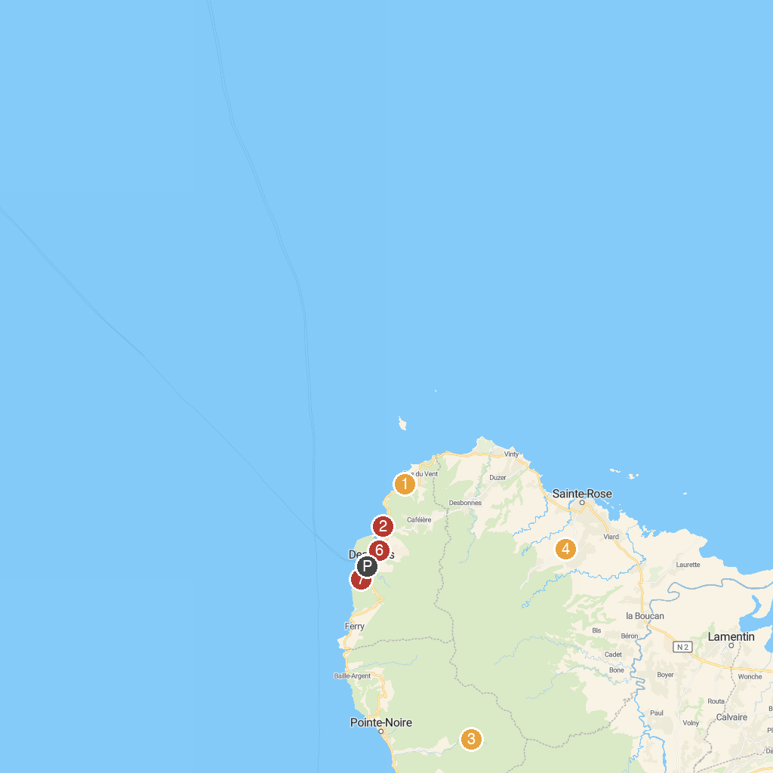
MAP KEY
1. Plage de la Perle | 5. SunBoat
2. Plage de Grande Anse | 6. Pélican Safari
3. Le sanctuaire de Notre Dame des Larmes | 7. Jardin Botanique de Deshaies
4. ECOMUSEE CREOLEART OF GUADELOUPE AND DREAMS OF VILLA
P. Cruise port / terminal
Map © MapTiler © OpenStreetMap contributors · cruiseports.org

