Den Helder, North Holland, Netherlands
Perched at the northernmost tip of North Holland, Den Helder is the Royal Netherlands Navy's home base — a windswept peninsula of Napoleonic forts, Cold War submarines, and a quick ferry hop to the UNESCO Wadden Sea island of Texel.
⚓ Pier (Willemsoord Naval Yard) · 🕒 Typical call: 7-10 hrs · 💶 Currency: Euro (€) · 🗣️ Language: Dutch (English widely spoken) · 🚲 Bike-friendly port
✍️ MY DAY IN PORT (FILL IN)
Ship / Date
In port | arrive ______ · all aboard ______
Booked excursion
Notes / meeting point
GETTING ASHORE
- Docking: Pier at Willemsoord historic naval yard — no tendering
- Walk to center: 10-min flat walk to city center; museums on the dock
- Best For: Naval history, cycling, Texel day trip, North Sea beaches
- Don't Miss: Boarding the Cold War submarine at the Navy Museum
GETTING AROUND
- 🚕 Taxi: €8–€15 — Local taxis (Staxi, ClubTaxi) serve the cruise terminal with fixed pre-book rates. Short ride to city center; pre-bookin
- 📱 Rideshare: ✅ Uber
TOP THINGS TO DO
- Navy Museum & Submarine Tour — Explore three centuries of Dutch naval history at the Marinemuseum in Willemsoord.
- Texel Island Day Trip — Catch the hourly TESO ferry (20 min crossing) to the largest Wadden island.
- Fort Kijkduin & North Sea Aquarium — Cycle 3 km to this Napoleonic fort (built 1811-13) in Huisduinen.
- Huisduinen Beach & Dunes — Ride 4 km to a wide, white-sand North Sea beach backed by rolling dunes.
- National Lifeboat Museum — Also at Willemsoord, this interactive museum tells the stories of Dutch sea rescuers with storm simulators and historic rescue…
BEST WALKS
- Willemsoord to City Center: 1.2 km · 15 min · Flat — Walk east from the pier through the historic Willemsoord naval yard, past the dry docks and…
- Dike Walk to TESO Ferry Terminal: 1.5 km · 20 min · Flat — Head north from Willemsoord along the sea dike for views of the Marsdiep and Texel.
WEATHER · DAYLIGHT · MONEY
Month | High °F | Low °F | Rainy days
May | 58 | 50 | 10
Jul | 68 | 60 | 12
Sep | 65 | 57 | 11
Daylight: May 5:43AM–9:32PM · Jul 5:34AM–9:58PM · Sep 7:15AM–7:55PM
cruiseports.org/den-helder · Confirm terminal & all-aboard time with your ship

Den Helder, North Holland, Netherlands — Port Map
Red = walkable sights · Amber = excursions farther out · P = cruise terminal
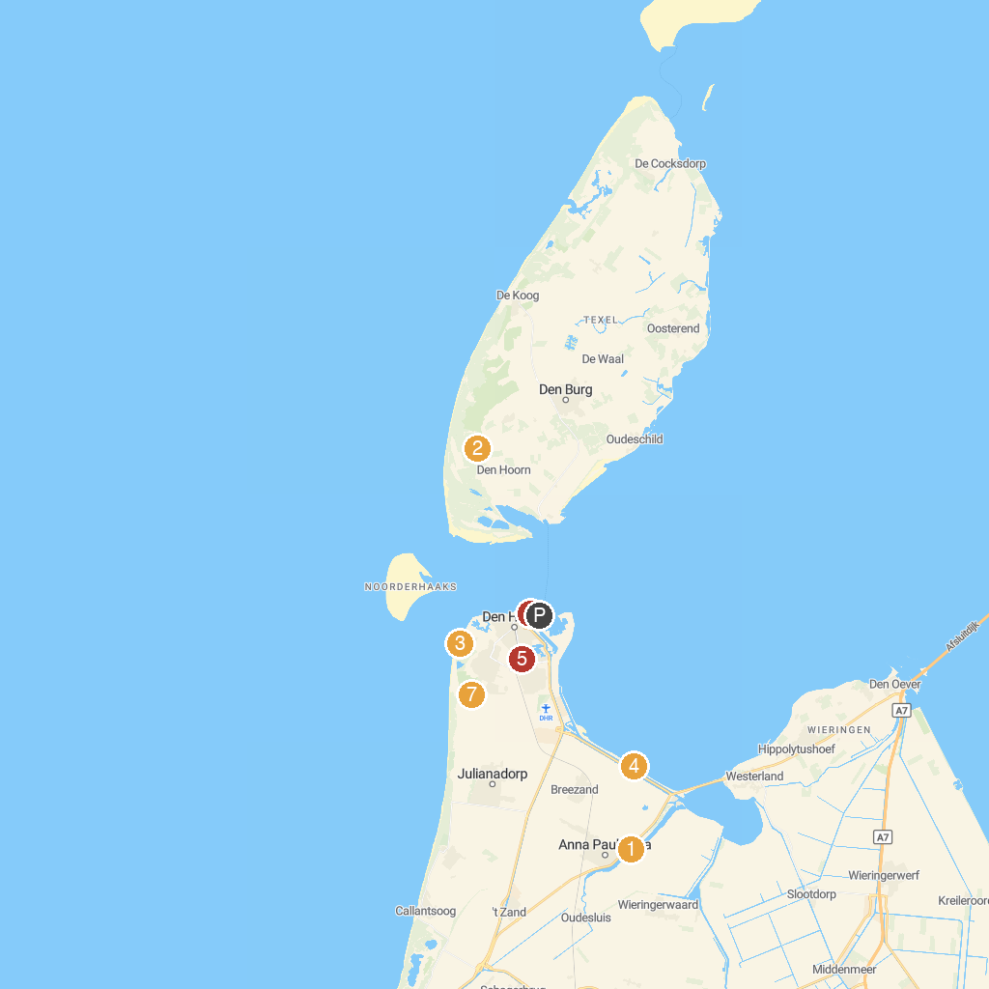
MAP KEY
1. Hoenderdaell Zoo | 5. Balgzand
2. Battery Den Hoorn WWII | 6. Quelderduyn
3. Ecomare | 7. Navy Museum
4. Fort Kijkduin | 8. Mariëndal
P. Cruise port / terminal
Map © MapTiler © OpenStreetMap contributors · cruiseports.org

