Delfzijl, Groningen, Netherlands
A windswept Dutch seaport on the Ems estuary — home to the Inspector Maigret legend, UNESCO Wadden Sea mudflats, and a direct train to vibrant Groningen City.
⚓ Pier (docked — Handelskade) · 🕒 Typical call: 6-8 hrs · 💶 Currency: Euro · 🗣️ Language: Dutch (English widely spoken)
✍️ MY DAY IN PORT (FILL IN)
Ship / Date
In port | arrive ______ · all aboard ______
Booked excursion
Notes / meeting point
GETTING ASHORE
- Docking: Ships dock at Handelskade quay, steps from town
- Walk to center: ~5 min (500 m) to Landstraat pedestrian street
- Best For: Authentic Dutch culture, day trip to Groningen City
- Don't Miss: Inspector Maigret statue & MuzeeAquarium Delfzijl
GETTING AROUND
- 🚕 Taxi: €5–€15 — Local taxis serve the port; the short distance to city center means fares are low. Dutch taxis typically charge ~€3.90 b
- 📱 Rideshare: ✅ Uber
TOP THINGS TO DO
- Groningen City Day Trip — Board the train at Delfzijl Station and reach Groningen's lively city center in 37 minutes.
- MuzeeAquarium Delfzijl — This compact triple-threat museum covers maritime history, Wadden Sea archaeology (fossils and finds), and a live aquarium…
- Appingedam Hanging Kitchens — Just 4 km away, Appingedam is a medieval gem where kitchens were built suspended over the Damsterdiep canal due to historic space…
- Wadden Sea Dike Walk — Climb the massive sea dikes protecting Delfzijl and walk the Eemsboulevard.
- Inspector Maigret Walk — Detective fiction history was made in Delfzijl.
BEST WALKS
- Harbor & Town Loop: 2 km · 30 min · flat — Walk from the Handelskade quay across the lock gates to Landstraat, past the Vestinggracht moat…
- Dike & City Beach Walk: 2.5 km · 35 min · breezy — Head north along the Eemsboulevard dike for panoramic views over the Ems estuary toward Germany.
WEATHER · DAYLIGHT · MONEY
Month | High °F | Low °F | Rainy days
May | 61 | 48 | 12
Jul | 70 | 58 | 16
Sep | 66 | 54 | 11
Daylight: May 5:32AM–9:25PM · Jul 5:23AM–9:52PM · Sep 7:06AM–7:47PM
cruiseports.org/delfzijl · Confirm terminal & all-aboard time with your ship

Delfzijl, Groningen, Netherlands — Port Map
Red = walkable sights · Amber = excursions farther out · P = cruise terminal
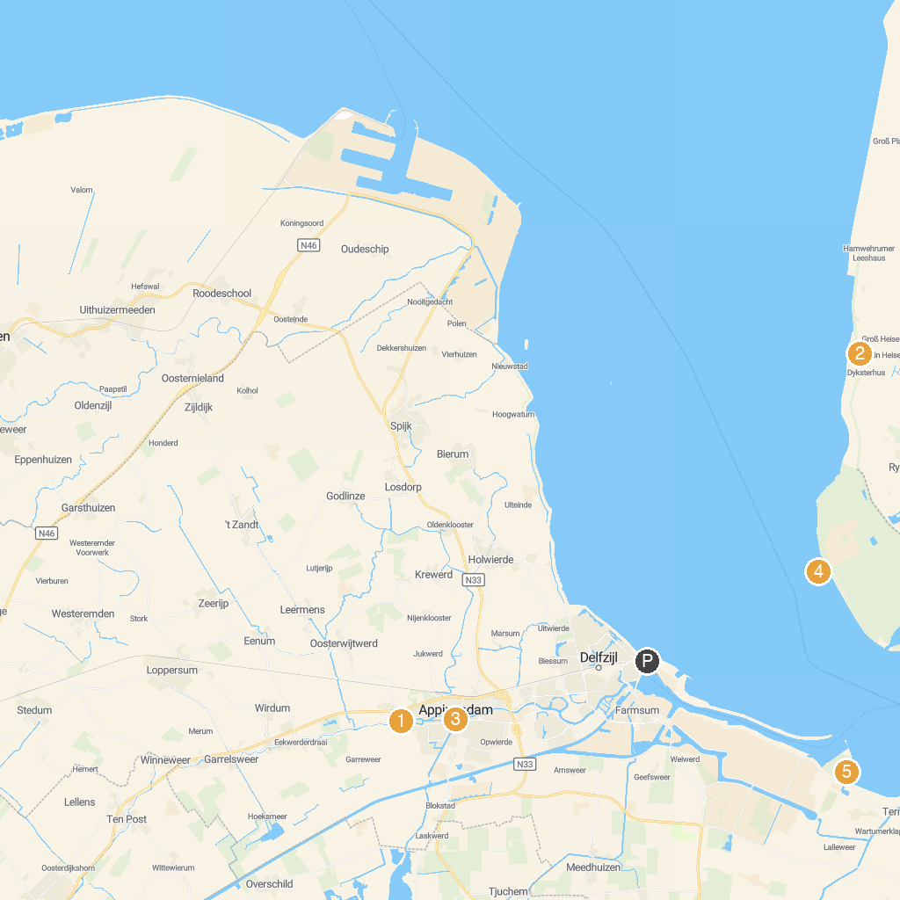
MAP KEY
1. 't Roegwold | 4. Museum Stad Appingedam
2. Museum Møhlmann | 5. Steg am Nordseestrand
3. Campen lighthouse | 6. Oterdummer pier
P. Cruise port / terminal
Map © MapTiler © OpenStreetMap contributors · cruiseports.org

