Deggendorf, Bavaria, Germany
The self-styled 'Gateway to the Bavarian Forest,' Deggendorf offers a genuine slice of Lower Bavarian life — a medieval Stadtplatz, one of Bavaria's prettiest Baroque steeples, and flat riverside cycling paths that stretch in both directions along the Danube.
⚓ Docked (riverside quay) · 🕒 Typical call: 6–8 hrs · 💶 Euro (€) · 🗣️ German / Bavarian dialect · 🏞️ Bavarian Forest gateway
✍️ MY DAY IN PORT (FILL IN)
Ship / Date
In port | arrive ______ · all aboard ______
Booked excursion
Notes / meeting point
GETTING ASHORE
- Docking: Ships dock at Deggendorf quay on the left bank of the Danube, ~10 min walk to Stadtplatz
- Walk to center: ~10–12 min on foot from quay to Market Square
- Best For: Authentic Bavarian culture, river cycling, Metten Abbey day trip
- Don't Miss: The Basilika St. Peter und Paul's Baroque tower and a Weißwurst breakfast before noon
GETTING AROUND
- 🚕 Taxi: €9–12 — Local taxis are available near the quay. Day rate is roughly €4.40 base + €2.40/km; the train station and most sights ar
TOP THINGS TO DO
- Benedictine Monastery of Metten — Just 5 km west, Kloster Metten houses one of the finest Baroque libraries in Germany — over 45,000 volumes surrounded by ceiling…
- Passau: City of Three Rivers — An hour by train or coach, Passau sits where the Inn, Ilz, and Danube converge.
- Bavarian Forest National Park — Germany's oldest national park begins a short drive east of Deggendorf.
- Danube Cycle Path (Donauradweg) — Rent a bike at the center and pedal the flat, paved Donauradweg.
- Regensburg UNESCO Old Town — About 80 km upstream, Regensburg's well-preserved medieval center is a UNESCO World Heritage Site.
BEST WALKS
- Quay to Stadtplatz Town Walk: 1.5–2 hrs · Easy · Flat — Walk from the riverside quay along the Danube promenade to the Stadtplatz.
- Riverside & Kapuzinerstadl Loop: 45 min · Easy · Flat — A short loop from the quay north along the river, then inland to the Kapuzinerstadl cultural center…
WEATHER · DAYLIGHT · MONEY
Month | High °F | Low °F | Rainy days
May | 65 | 48 | 13
Jul | 76 | 58 | 11
Sep | 68 | 51 | 9
Daylight: May 5:26AM–8:43PM · Jul 5:21AM–9:06PM · Sep 6:45AM–7:20PM
cruiseports.org/deggendorf · Confirm terminal & all-aboard time with your ship

Deggendorf, Bavaria, Germany — Port Map
Red = walkable sights · Amber = excursions farther out · P = cruise terminal
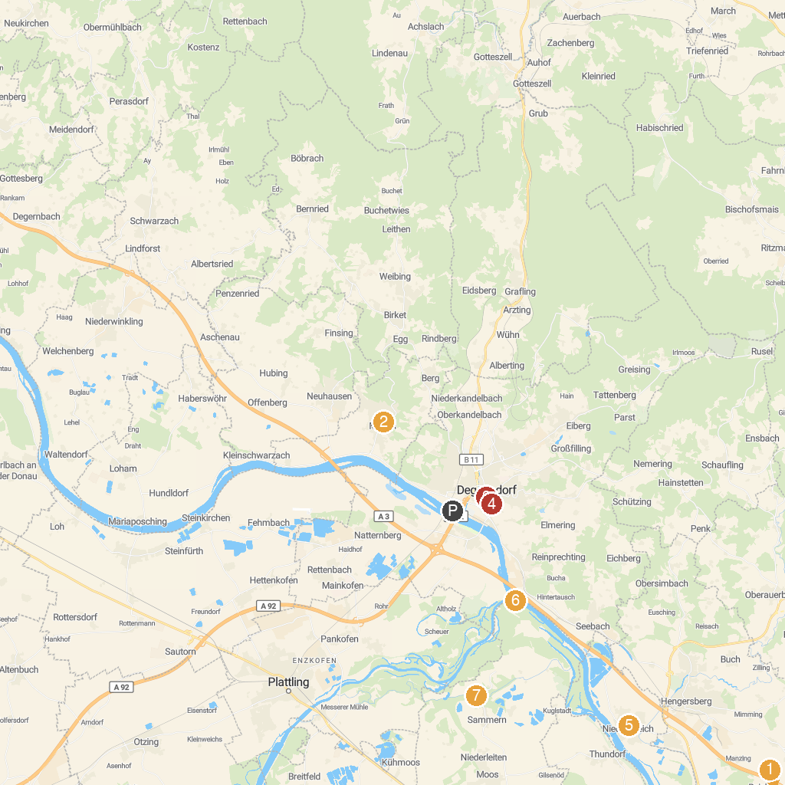
MAP KEY
1. Ziegel und Kalk Museum | 5. Handwerksmuseum Deggendorf
2. Prälatengarten | 6. Gerhard Neumann Museum
3. Feng Shui Kurpark Lalling | 7. Isarmündung
4. Altes Rathaus Deggendorf | 8. Infozentrum Isarmündung - Dr. Georg Karl Haus -
P. Cruise port / terminal
Map © MapTiler © OpenStreetMap contributors · cruiseports.org

