Decatur, Alabama, USA
Known as The River City, Decatur sits on the Tennessee River with Victorian neighborhoods, world-famous Alabama White BBQ sauce, and a surprisingly world-class natural science museum.
⚓ Pier (docked) · 🕒 Typical call: 6-8 hrs · 💵 US Dollar · 🗣️ English · 🚌 Shuttle to downtown recommended
✍️ MY DAY IN PORT (FILL IN)
Ship / Date
In port | arrive ______ · all aboard ______
Booked excursion
Notes / meeting point
GETTING ASHORE
- Docking: Pier-docked at Rhodes Ferry Park or Ingalls Harbor — no tendering
- Walk to center: 1.5–2 miles from dock; cruise shuttles provided to Bank Street
- Best For: Southern BBQ, Civil War history, Victorian architecture, birdwatching
- Don't Miss: Big Bob Gibson Bar-B-Q — birthplace of Alabama White Sauce since 1925
GETTING AROUND
- 🚕 Taxi: $5–$15 — Local taxi service (Johnny Cab) offers a flat $15 rate anywhere within Decatur city limits. Short rides from Rhodes Ferr
- 📱 Rideshare: ✅ Uber, Lyft
TOP THINGS TO DO
- Cook Museum of Natural Science — A world-class interactive museum featuring a 15,000-gallon saltwater aquarium, live bee colony, terrariums, and hands-on earth…
- Old Decatur & Albany Historic Districts — Stroll two of Alabama's best-preserved Victorian neighborhoods — Old Decatur dates to the 1830s railroad era, while Albany…
- Big Bob Gibson Bar-B-Q Pilgrimage — This legendary pit was the birthplace of Alabama White Sauce — a tangy mayo-and-vinegar creation from 1925 that's won multiple…
- Wheeler National Wildlife Refuge — One of the Southeast's most important refuges, with wetlands, forests, and open fields.
- Civil War Decatur Walking Tour — Decatur changed hands multiple times during the Civil War, with only four brick buildings surviving near-total destruction.
BEST WALKS
- Bank Street & Old Decatur Historic Loop: ~1.5 miles · 30-45 min · Easy — From the shuttle drop at Bank Street, walk through the commercial historic district, past the…
- Rhodes Ferry Park Riverfront Walk: ~0.75 miles · 20 min · Easy — A short stroll along the Tennessee River waterfront from the dock area through Rhodes Ferry Park…
WEATHER · DAYLIGHT · MONEY
Month | High °F | Low °F | Rainy days
May | 73 | 55 | 12
Jul | 84 | 68 | 12
Sep | 78 | 62 | 7
Daylight: May 5:40AM–8:04PM · Jul 5:40AM–8:22PM · Sep 6:37AM–7:03PM
cruiseports.org/decatur-al · Confirm terminal & all-aboard time with your ship

Decatur, Alabama, USA — Port Map
Red = walkable sights · Amber = excursions farther out · P = cruise terminal
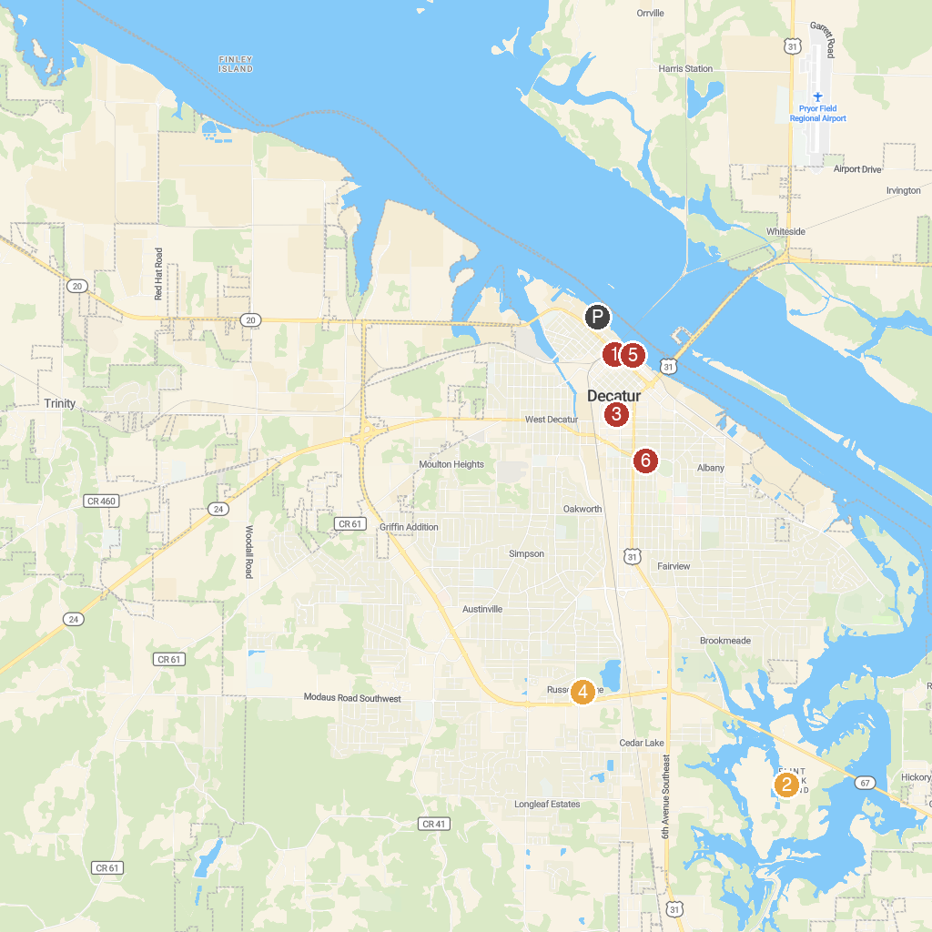
MAP KEY
1. Old State Bank | 5. Cook Museum of Natural Science
2. Wheeler National Wildlife Refuge Visitor Center | 6. Wilson Morgan Park
3. Veterans Park | 7. Rhodes Ferry Park
4. Cave Springs | 8. Delano Park
P. Cruise port / terminal
Map © MapTiler © OpenStreetMap contributors · cruiseports.org

