Davenport, Iowa, USA
The Quad Cities' crown jewel sits right on the Mississippi with no floodwall in the way — river cruise ships dock steps from jazz history, world-class art, and Iowa's quirkiest pizza.
⚓ Pier Dock (River Heritage Park) · 🕒 Typical call: 6–9 hrs · 💵 USD · 🗣️ English
✍️ MY DAY IN PORT (FILL IN)
Ship / Date
In port | arrive ______ · all aboard ______
Booked excursion
Notes / meeting point
GETTING ASHORE
- Docking: Pier — tied directly to River Heritage Park seawall, gangway to flat paved path
- Walk to center: 2–5 min to downtown Davenport; Figge Art Museum 5 min
- Best For: Jazz & arts lovers, Mississippi River history, regional food culture
- Don't Miss: Quad Cities-style pizza (cut in strips, spicy pork sausage) and Front Street Brewery
GETTING AROUND
- 🚕 Taxi: $10–$20 — Local cabs (Lucky Cab, Good To Go Taxi) serve the riverfront. Call ahead for a quote; most trips to central Davenport ar
- 📱 Rideshare: ✅ Uber, Lyft
TOP THINGS TO DO
- Figge Art Museum — A striking glass building by architect David Chipperfield houses Grant Wood's legacy collection (painter of American Gothic)…
- Bix Beiderbecke Museum — Honor the Davenport-born jazz pioneer at this intimate downtown archive (112 W 2nd Street) — rare instruments, photographs, and…
- Davenport Skybridge — A 575-foot pedestrian bridge suspended 50 feet over River Drive (Highway 67), offering panoramic views of the Mississippi River…
- German American Heritage Center — Housed in an 1860s immigrant hotel right by the bridge, this museum chronicles the German settlers who founded Davenport and…
- Riverfront & LeClaire Park Walk — Davenport's open, floodwall-free riverfront is unique on the Mississippi — stroll paved paths past the historic bandshell, watch…
BEST WALKS
- Riverfront to Downtown Core: 1.2 mi / ~25 min / Flat — Walk north from the dock along the paved Mississippi River Trail past LeClaire Park, the Skybridge…
- East Davenport Village Stroll: Historic brick streets / Short drive or shuttle — The Village of East Davenport is a preserved 1850s logging district with brick streets, boutique…
WEATHER · DAYLIGHT · MONEY
Month | High °F | Low °F | Rainy days
May | 72 | 54 | 13
Jul | 84 | 67 | 10
Sep | 77 | 61 | 8
Daylight: May 5:43AM–8:14PM · Jul 5:42AM–8:34PM · Sep 6:43AM–7:10PM
cruiseports.org/davenport-ia · Confirm terminal & all-aboard time with your ship

Davenport, Iowa, USA — Port Map
Red = walkable sights · Amber = excursions farther out · P = cruise terminal
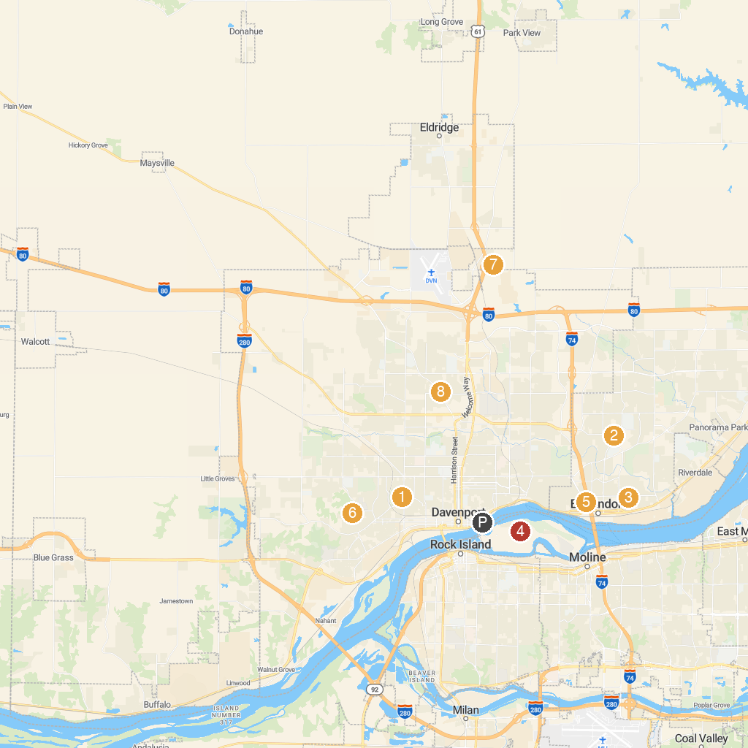
MAP KEY
1. Putnam Museum and Science Center | 5. McManus Park
2. Family Museum | 6. Schuetzen Park
3. Lincoln Park | 7. Crow Creek Wildlife Management Area
4. Rock Island Arsenal Museum | 8. Slattery Park
P. Cruise port / terminal
Map © MapTiler © OpenStreetMap contributors · cruiseports.org

