Dark Island, New York, USA
A fortress rising from the St. Lawrence. Dark Island's Singer Castle is one of the most dramatic Gilded Age landmarks in the Thousand Islands — a medieval-style castle built for a sewing machine heir and now open for guided tours.
⚓ Tendered (island dock) · 🕒 Typical call: 4–6 hrs · 💵 US Dollar · 🗣️ English · 🏰 Historic castle
✍️ MY DAY IN PORT (FILL IN)
Ship / Date
In port | arrive ______ · all aboard ______
Booked excursion
Notes / meeting point
GETTING ASHORE
- Docking: Tender / small boat to island dock (400+ ft of dock space)
- Walk to castle: Steps from the dock — Singer Castle is right at the waterfront
- Best For: History lovers, Gilded Age architecture, river scenery
- Don't Miss: Singer Castle guided tour including secret passages and dungeon
GETTING AROUND
- 🚕 Taxi: Quote-based — 1000 Island Taxi serves the Clayton, Alexandria Bay, and surrounding area for mainland transfers. Contact them directly
TOP THINGS TO DO
- Singer Castle Guided Tour — Explore the Gothic Revival fortress built by Frederick Bourne (president of Singer Sewing Machine Co.) in 1905.
- Thousand Islands Scenic Cruise — Many cruise itineraries pair Dark Island with a narrated pass through the archipelago — 1,864 islands straddling the US-Canada…
- Boldt Castle Day Trip (Heart Island) — A short boat ride away, Boldt Castle on Heart Island is the other great Thousand Islands landmark — built as a Valentine's gift…
BEST WALKS
- Singer Castle Grounds & Dock Walk: Easy | 10–15 min | Flat — From the dock, walk around the castle exterior, take in river views, and photograph the dramatic…
WEATHER · DAYLIGHT · MONEY
Month | High °F | Low °F | Rainy days
May | 66 | 46 | 12
Jul | 79 | 62 | 11
Sep | 70 | 53 | 12
Daylight: May 6:41AM–8:20PM · Jul 6:44AM–8:36PM · Sep 7:19AM–7:39PM
cruiseports.org/dark-island-ny · Confirm terminal & all-aboard time with your ship

Dark Island, New York, USA — Port Map
Red = walkable sights · Amber = excursions farther out · P = cruise terminal
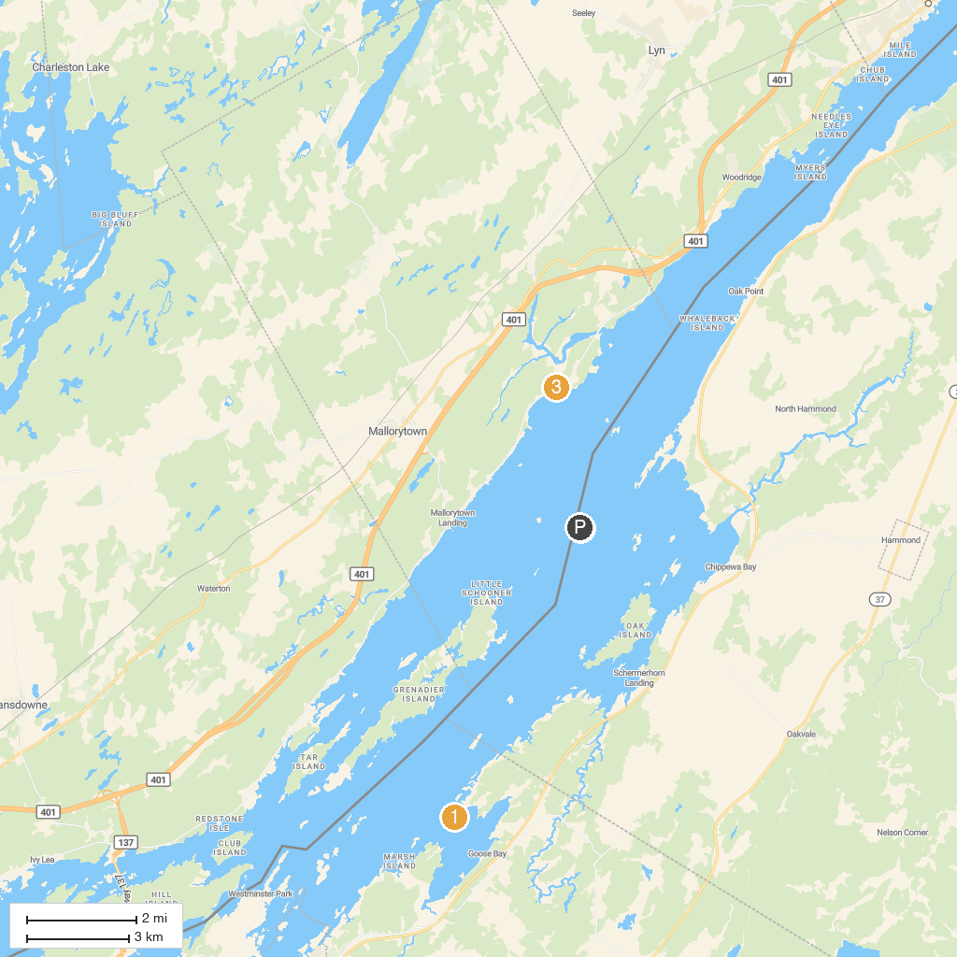
MAP KEY
1. Kring Point State Park | 4. Boldt Castle Yacht House
2. Lyn Valley Conservation Area | 5. Jones Creek Trails - Thousand Islands National Park
3. Singer Castle on Dark Island
P. Cruise port / terminal
Map © MapTiler © OpenStreetMap contributors · cruiseports.org

