Dalyan, Muğla, Turkey
Ancient tombs carved into cliffsides, a protected turtle nesting beach, and boats gliding through reed lagoons — Dalyan is one of the Aegean's most rewarding off-the-beaten-track stops.
⚓ Tender port · 🕒 Typical call: 6–8 hrs · 💵 Turkish Lira (EUR/USD accepted) · 🗣️ Turkish · 🐢 Eco-protected area
✍️ MY DAY IN PORT (FILL IN)
Ship / Date
In port | arrive ______ · all aboard ______
Booked excursion
Notes / meeting point
GETTING ASHORE
- Docking: Tender — ships anchor offshore; no cruise pier
- Walk to center: Short — Dalyan town is very compact once ashore
- Best For: Ancient history, nature, river cruising, mud baths
- Don't Miss: Lycian Rock Tombs viewed from the river, Iztuzu Turtle Beach
GETTING AROUND
- 🚕 Taxi: Metered / negotiated — Traditional metered taxis are available in Dalyan for point-to-point transfers. Agree on a price beforehand for longer t
TOP THINGS TO DO
- Dalyan River Cruise & Lycian Rock Tombs — Board a traditional piyade and drift along the Dalyan River past the dramatic Lycian rock tombs carved into cliff faces circa 400…
- Iztuzu Turtle Beach — A 4.5 km crescent of golden sand — one of the Mediterranean's most important loggerhead sea turtle (Caretta caretta) nesting sites.
- Dalyan Mud Baths & Thermal Springs — Stop at the Sultaniye sulfur mud baths on the shores of Köyceğiz Lake.
- Ancient City of Kaunos — An ancient Carian port city with origins around the 10th century BC, Kaunos features a well-preserved Greco-Roman theatre seating…
- Blue Crab & Riverside Dining — Dalyan's culinary signature is the blue crab (mavi yengeç) caught in the delta channels.
BEST WALKS
- Dalyan Town Riverside Promenade: 30–45 min · Flat · Free — Stroll the paved riverside path from the main boat dock along the Dalyan River.
- Kaunos Ruins Walk (after ferry crossing): 45–60 min · Uphill · Rough path — Take the short rowboat ferry across the Dalyan River (a few lira), then follow the dirt path uphill…
WEATHER · DAYLIGHT · MONEY
Month | High °F | Low °F | Rainy days
May | 80 | 62 | 7
Jul | 97 | 75 | 0
Sep | 90 | 70 | 2
Daylight: May 5:58AM–8:06PM · Jul 5:58AM–8:24PM · Sep 6:47AM–7:12PM
cruiseports.org/dalyan · Confirm terminal & all-aboard time with your ship

Dalyan, Muğla, Turkey — Port Map
Red = walkable sights · Amber = excursions farther out · P = cruise terminal
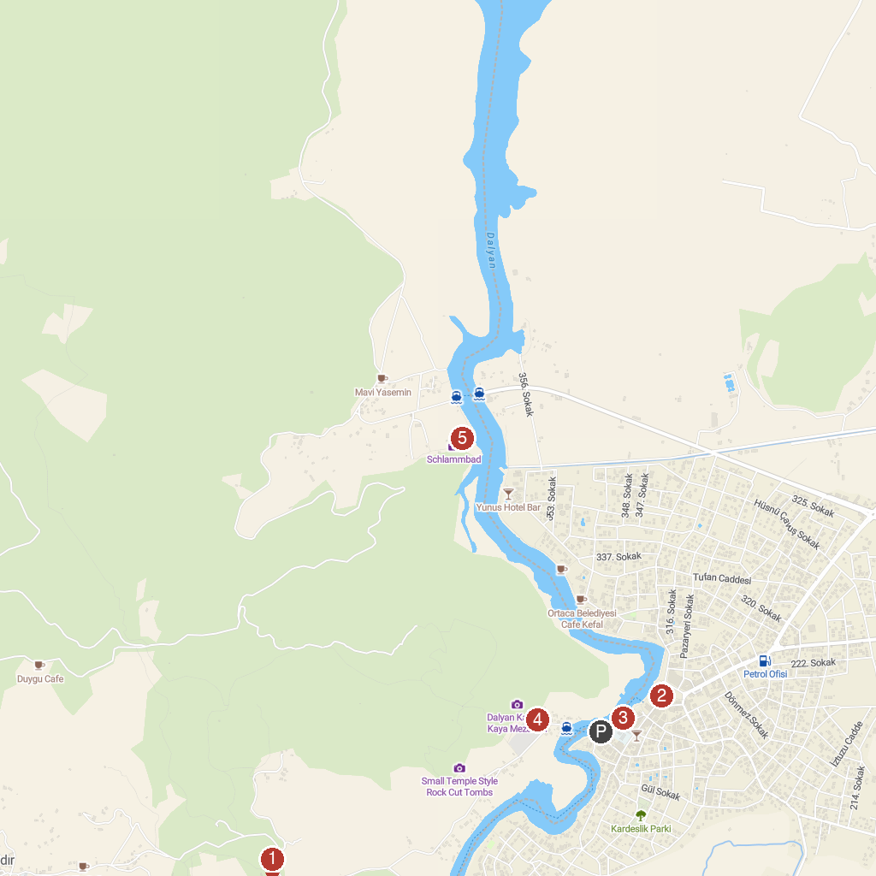
MAP KEY
1. Aşı Koyu | 4. Captain Boris boat trips
2. Kaunos Ancient City | 5. Caunos Tombs of the Kings
3. Dalyan Cami | 6. Mud bath Dalyan
P. Cruise port / terminal
Map © MapTiler © OpenStreetMap contributors · cruiseports.org

