Dakar, Senegal
West Africa's vibrant Atlantic capital — the haunting history of Gorée Island, a colossal hilltop monument, teeming markets, and the rhythms of Senegalese music and teranga hospitality.
⚓ Docked (central port) · 🕒 Typical call: 8–10 hrs · 💵 West African CFA Franc (XOF) · 🗣️ French · Wolof · some English
✍️ MY DAY IN PORT (FILL IN)
Ship / Date
In port | arrive ______ · all aboard ______
Booked excursion
Notes / meeting point
GETTING ASHORE
- Docking: Port of Dakar (central)
- To Gorée ferry: Short walk/taxi
- Best For: History · Culture
- Don't Miss: Gorée Island
GETTING AROUND
- 🚕 Taxi: 2,000–5,000 XOF (~$3–8 USD) — Unmetered taxis wait just outside the Mole 1 port gate. Always agree on the fare before getting in — drivers often quote
- 📱 Rideshare: ✅ Yango, Heetch
TOP THINGS TO DO
- Gorée Island — The UNESCO-listed island offshore — the House of Slaves and its 'Door of No Return,' pastel colonial houses, and a profoundly…
- African Renaissance Monument — The colossal 49 m bronze statue on a hilltop — taller than the Statue of Liberty — with sweeping views over Dakar and the…
- City & Sandaga Market — Downtown Plateau, the Independence Square, the Grand Mosque, and the teeming Sandaga and Kermel markets — color, textiles, music…
- Lake Retba (Pink Lake) — The famous rose-colored salt lake northeast of the city, where salt collectors work the shallows — a striking, otherworldly…
BEST WALKS
- Plateau & Independence Square: ~2 km · 1.5 hrs · easy — The downtown core — Place de l'Indépendance, the colonial-era Gouvernance and cathedral, and the…
- Kermel Market: ~1 km · 1 hr · easy — The atmospheric covered market in a restored colonial hall — flowers, crafts, spices, and…
- Corniche viewpoints: short taxi · 1 hr · easy — The coastal Corniche road with Atlantic views, the Mosque of the Divinity at Ouakam, and the…
WEATHER · DAYLIGHT · MONEY
Month | High °F | Low °F | Rainy days
May | 78 | 70 | 0
Jul | 84 | 77 | 6
Sep | 85 | 79 | 12
Daylight: May 6:42AM–7:30PM · Jul 6:48AM–7:42PM · Sep 6:58AM–7:10PM
cruiseports.org/dakar · Confirm terminal & all-aboard time with your ship

Dakar, Senegal — Port Map
Red = walkable sights · Amber = excursions farther out · P = cruise terminal
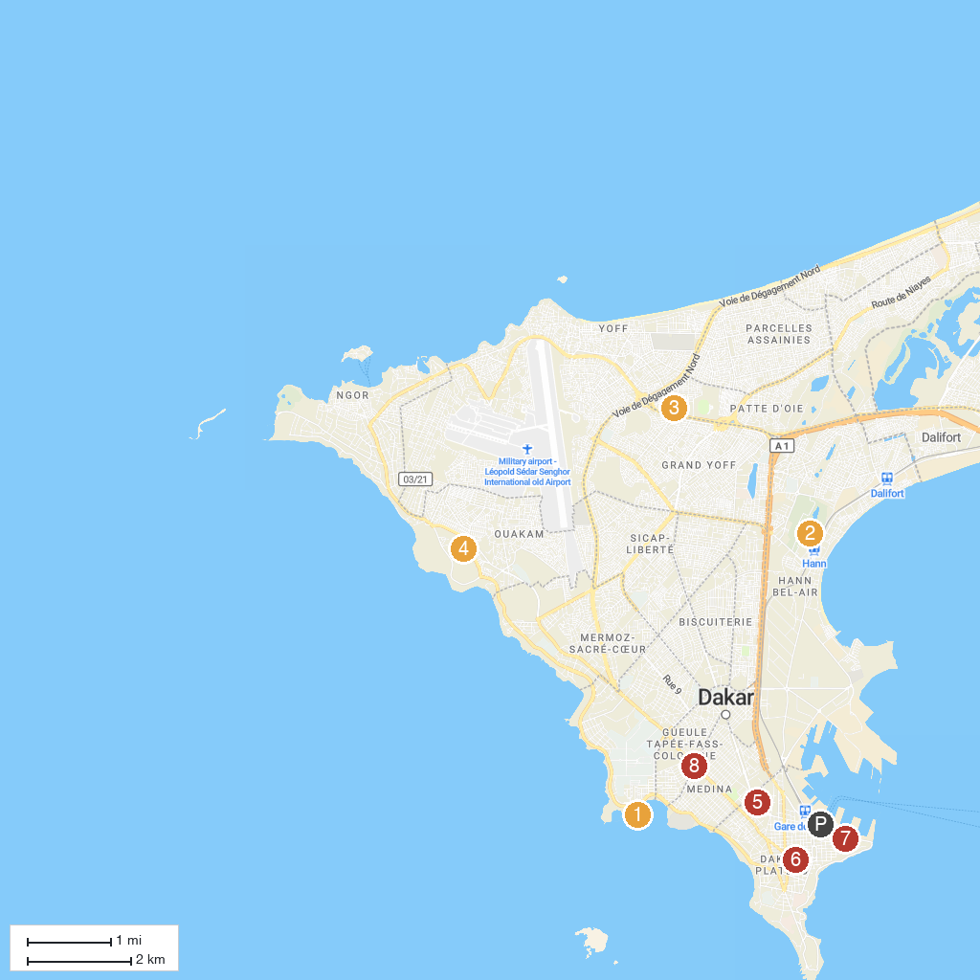
MAP KEY
1. Magic Land | 5. Grand Mosque of Dakar
2. Hann Zoological Park | 6. Leopold Sedar Senghor French Institute
3. Village Des Arts | 7. Casino du Port
4. African Renaissance Monument | 8. Rond-Point Sahm
P. Cruise port / terminal
Map © MapTiler © OpenStreetMap contributors · cruiseports.org

