Cuxhaven, Lower Saxony, Germany
Where the Elbe surrenders to the North Sea, Cuxhaven offers wild tidal flats, a landmark wooden beacon, and Germany's second-largest city just 90 minutes away by train.
⚓ Pier (docked) · 🕒 Typical call: 8-10 hrs · 💶 Currency: Euro (EUR) · 🗣️ Language: German · 🌊 UNESCO Wadden Sea
✍️ MY DAY IN PORT (FILL IN)
Ship / Date
In port | arrive ______ · all aboard ______
Booked excursion
Notes / meeting point
GETTING ASHORE
- Docking: Pier — Europe Quay or Humber Quay; no tender
- Walk to Center: 10-15 min on foot from the cruise quay to Alte Liebe / town center
- Best For: Wadden Sea mudflat walks, ship-spotting, Hamburg day trip
- Don't Miss: Standing at the Kugelbake where the Elbe officially ends
GETTING AROUND
- 🚕 Taxi: €10–€20 — Metered taxis available at the cruise terminal. Base fare €6.30 plus €2.60/km — the port is close to the city center, ma
- 📱 Rideshare: ❌ not available
- 🚌 Hop-on hop-off: ✅ Cuxliner
TOP THINGS TO DO
- Wadden Sea Mudflat Walk — At low tide, a guided Wattwanderung takes you across the seabed of the UNESCO World Heritage Wadden Sea — Europe's largest tidal…
- Hamburg City Day — Hop a direct train to Hamburg Hauptbahnhof (~90 min) and spend the day exploring the Speicherstadt warehouse district, HafenCity…
- Neuwerk Island Horse-Cart Crossing — When the tide allows, traditional Wattwagens (horse-drawn carts) ferry visitors 10 km across the seabed to the medieval…
- Steubenhöft Emigrant Hall & Exhibition — This historic Hapag departure hall sent hundreds of thousands of emigrants off to America from the 'Quay of Tears.' Today the…
- Windstärke 10 Shipwreck & Fishery Museum — Cuxhaven's standout indoor attraction covers 100 years of fishing history and the dangers of North Sea seafaring, with dramatic…
BEST WALKS
- Waterfront Promenade: Quay to Kugelbake: 3 km one-way | Flat | 45-60 min — Walk west from the cruise quay along the Elbe waterfront, passing the Semaphor signal tower, the…
- Old Town & Ritzebüttel Castle: 1.5 km loop | Easy | 30-40 min — From the town center, stroll to Schloss Ritzebüttel — a 14th-century castle that served as the seat…
WEATHER · DAYLIGHT · MONEY
Month | High °F | Low °F | Rainy days
May | 59 | 49 | 12
Jul | 69 | 60 | 17
Sep | 65 | 56 | 13
Daylight: May 5:23AM–9:21PM · Jul 5:13AM–9:47PM · Sep 6:59AM–7:40PM
cruiseports.org/cuxhaven · Confirm terminal & all-aboard time with your ship

Cuxhaven, Lower Saxony, Germany — Port Map
Red = walkable sights · Amber = excursions farther out · P = cruise terminal
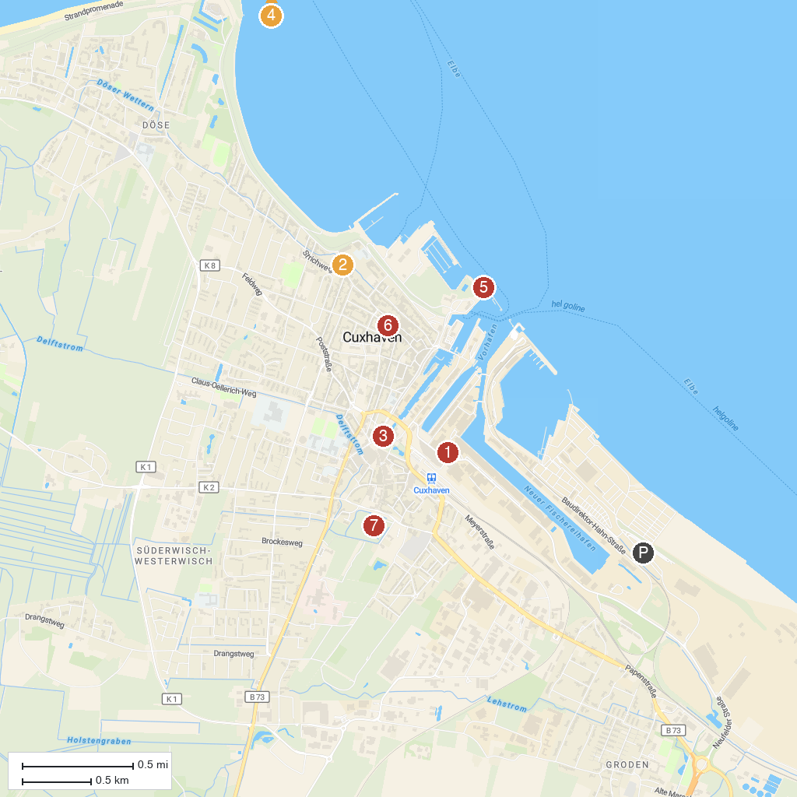
MAP KEY
1. Windstärke 10 - Wrack- und Fischereimuseum Cuxhaven | 5. Alte Liebe in Cuxhaven
2. Filialkirche Herz Jesu | 6. Lotsenviertel Cuxhaven
3. Hermine | 7. Schloss Ritzebüttel
4. Kugelbake | 8. Leuchtturm Neuwerk
P. Cruise port / terminal
Map © MapTiler © OpenStreetMap contributors · cruiseports.org

